The Zenith Program

FAMU-FSU College of Engineering

2525 Pottsdamer Street
Tallahassee, FL 32310

9/19/2022

Table of Contents
1 General Information 3
1.1 Team Mentors 3
1.2 Educators 4
1.3 Student Team Leader 4
1.4 Safety Officer 4
1.5 Senior Design Team Members 5
2 Team Structure 6
2.1 Number of students involved 6
2.2 Team hierarchy 6
2.3 Duties of Managerial Positions 7
3 NAR/TRA Coordination 9
3.1 Purpose 9
3.2 Affiliated NAR and TRA Sections 9
4 Facilities and Equipment 10
4.1 Facilities 10
4.2 Equipment 14
5 Safety 15
5.1 Safety Plan 15
6 Preliminary Vehicle Design 30
6.1 Airframe 30
6.2 Propulsion 32
6.3 Recovery System 35
6.4 Payload 37
6.5 Risk Assessment – Vehicle 39
6.6 Technical Assessment 41
7 Stem Engagement 42
7.1 Engagement Plan 42
7.2 Evaluation Criteria 44
8 Project Plan 45
8.1 Development Schedule / Work Breakdown Structure 45
8.2 Budget 46
8.3 Funding 48
9 Continuity Plan 48
9.1 Maintaining Partnerships 48
9.2 Funding Continuity and Expansion 49
9.3 Future Engagement 49
10 Appendices 50
Appendix A. Safety Agreement A-1
Appendix B. Chemical Safety Sheet B-1
Appendix C. Personnel Safety Briefing C-1
Appendix D. NAR High Power Rocket Safety Code D-1
Appendix E. TRA Safety Code for High Power Rocketry E-1
Appendix F. Budget Sheet F-1
Appendix G. Work Breakdown Structure G-1
Appendix H. OSHA Laboratory Safety Guidance H-1

General Information

Team Mentors

Mr. Tom McKeown
- Title: Board Member, Spaceport Rocketry Association (NAR #342 / TRA #73)
- Email: mckeownt@ix.netcom.com
- Phone: 321-266-1928
- NAR Flyer Number: 57205
- TRA Flyer Number: 01922
- NAR/TRA Certification Level: Level 2
Mr. McKeown has been an aerospace engineer for 35 years, graduating from Kansas State with his B.S. in mechanical engineering. He attended graduate school at Missouri S&T for mechanical engineering, focusing on metal fatigue and fracture dynamics. His prior employers include McDonnell Douglas, Boeing, and Leonardo DRS. On the amateur rocketry front, Mr. McKeown is Level 2 certified and is a board member for the Spaceport Rocketry Association, which is both a National Association of Rocketry (NAR #342) and Tripoli Rocketry Association (TRA #73) organization. He has previously mentored three teams: the Florida Institute of Technology team for two separate competitions, a high-school team out of Seattle, WA, and another team for only their final launch in place of their sponsor of record.

Mr. Adam Nehr
- Title: Board Member, Regional Orlando Applied Rocketry (NAR #795)
- Email: gnur1956@gmail.com
- Phone: 407-694-1392
- NAR/TRA Certification Level: Level 3
Mr. Adam Nehr is a pilot, experimental aircraft designer, and engineer with over 40 years of experience. He attended the Eerie County Technical School completing the General Electric Apprentice Program, in which he specialized in tooling and dye making. Mr. Nehr found his way into engineering with the development of high-velocity imaging and data acquisition systems at McDonnell Douglas Missile Systems, Bionetics Photo Services, and QinetiQ North America. On the amateur rocketry front, Mr. Nehr is a National Association of Rocketry (NAR) Level 3 certificate holder, and previously worked at Earthrise Space Systems, a non-profit which mentored local university rocketry teams competing for the google Lunar X-Prize. He currently operates InvenTech, LLC, an organization focused on mentoring student teams of all levels in rocketry and aviation competitions.

Educators

Dr. Shayne McConomy
- Title: Mechanical Engineering Senior Design Professor
- Email: smcconomy@eng.famu.fsu.edu
- Phone: 850-410-6624
Dr. Shayne McConomy is a member of the Teaching Faculty in the Mechanical Engineering Department at the FAMU-FSU College of Engineering. He earned his M.S. and Ph.D. degrees in automotive engineering from Clemson University. Dr. McConomy is the official senior design professor for mechanical engineering students at the FAMU-FSU College of Engineering.

Dr. Chiang Shih
- Title: Aero, Mechatronics, and Propulsion (AME) Center Director, American Institute of Aeronautics and Astronautics (AIAA) Advisor
- Email: shih@eng.famu.fsu.edu
- Phone: 850-410-6321
Dr. Chiang Shih is a Professor and Chair of Mechanical Engineering Department at the FAMU-FSU College of Engineering. He received his Ph.D. degree from the Aerospace Engineering Department at University of Southern California in 1988. Dr. Chiang Shih will serve as an auxiliary advisor to the team when additional feedback regarding aerodynamic design is requested.

Student Team Leader
- Name: Zachary Isriel
- Email: zli17@fsu.edu

Safety Officer
- Name: Atzimba Avellaneda
- Email: aa20gx@fsu.edu

Senior Design Team Members

Jedreck Acquissa
- University: Florida State University
- Specialization Track: Thermal Fluids
- Email: ja18f@fsu.edu

Peyton Breland
- University: Florida State University
- Specialization Track: Aeronautics
- Email: pcb20y@fsu.edu

Dylan Gardner
- University: Florida A&M University
- Specialization Track: Thermal Fluids
- Email: dylan1.gardner@famu.edu

Mark Ioffredo
- University: Florida State University
- Specialization Track: Aeronautics
- Email: mai19@fsu.edu

Zachary Isriel
- University: Florida State University
- Specialization Track: Aeronautics
- Email: zli17@fsu.edu

Team Structure

Number of students involved
- 15 (approximate)

Team hierarchy

NOTE: Although the Project Director is responsible for supervising the Safety Officer and their implementation of the Safety Plan, the Safety Officer holds final say on all safety matters. The Project Director is expected to defer to the guidance of the Safety Officer and may not overrule their directives for any reason whatsoever.

Duties of Managerial Positions

[Project Director] Zachary Isriel – zackisriel@gmail.com – 305.607.0835
- Assign, monitor, and assist with work of technical leads as needed
- Create team development schedule and budget
- Plan, manage, delegate, and complete work to adhere to schedule
- Coordinate with team leads on required hardware to adhere to budget
- Conduct final review and preparation of all deliverables
- Act as point of contact and handle all external communications on behalf of team
- Ensure the Safety Officer implements the safety plan, defer to Safety Officer on safety matters

[Propulsion Lead] Peyton Breland – peytonbreland@gmail.com – 850.832.3294
- Maintain final authority over motor selection and purchase
- Develop models to project vehicle performance with known motor and changing vehicle parameters
- Develop and test motor housing to affix motor to airframe
- Liaise with College of Engineering Facilities and FSU Environmental Health and Safety for the shipping, receiving, storage, and access of solid rocket fuels or commercial off the shelf (COTS) motors
- Appraise Facilities and Environmental Health and Safety of any testing using solid motors, oxidizers, or other combustibles and adhere to any guidance and regulations received
- Coordinate with Safety Officer to implement safety plan while working with motors, oxidizers, and while communicating with College of Engineering personnel

[Avionics Lead] Mark Ioffredo – markioffredo1@gmail.com – 407.461.0060
- Maintain final authority over avionics unit component selection and purchase
- Develop avionics unit to monitor and transmit vehicle performance during flight
- Test avionics unit performance during simulated and actual test flights
- Comply with all applicable Student Launch regulations regarding redundancy in the flight control system
- Ensure constant and accurate telemetry transmission and reception across the entire flight profile
- Develop rover control system and telemetry transmission/reception
- Coordinate with Safety Officer to implement safety plan

[Recovery Lead] – Jedreck Acquissa – acquissajedreck@gmail.com – 407.927.0062
- Maintain final authority over recovery system component selection and purchase
- Develop recovery system to safely return launch vehicle from apogee
- Comply with all student launch regulations concerning the operation and capability of the recovery system
- Liaise with the Avionics Lead on the flight computer’s control and deployment sequence of the recovery system
- Ground test recovery system deployment with simulated aerodynamic drag forces applied to all airframe sections to be separated
- Ensure safe and proper separation of the nosecone and deployment of the drogue and main parachutes within their manufacturer-stated deployment velocity margins
- Coordinate with Safety Officer to implement safety plan

[Airframe Lead] – Dylan Gardner – dylangardner0106@gmail.com – 954.707.9958
- Maintain final authority over airframe design, material selection, and fabrication method
- Develop fabrication method and tooling to create airframe
- Create subscale models of proposed airframe for testing and evaluation
- Run stress models and aerodynamic simulations for proposed and in-development airframes, to include subscale models
- Coordinate with Safety Officer to implement safety plan

[Safety Officer] – Atzimba Avellaneda
- Implement the safety plan
  - Outlined in detail in Section 5
- Coordinate with College of Engineering Facilities and Environmental Health and Safety to ensure fabrication shop is within standards
- Coordinate with College of Engineering Facilities for the storage of solid motors, oxidizers, or other combustibles

NAR/TRA Coordination

Purpose

Coordination with NRA and TRA sections is meant to facilitate student mentoring, vehicle, subsystem design review, and launch assistance/infrastructure.

Affiliated NAR and TRA Sections

Spaceport Rocketry Association (NAR #342 / TRA #73)
The Spaceport Rocketry Association operates through both NAR and TRA out of Palm Bay, Florida. This organization will support Zenith Program operations with launch site operations and personnel for test launches. Mr. Tom McKeown, a NAR and TRA Level 2 certificate holder, will act as the team sponsor assisting the design team with restricted material purchasing (motor) and vehicle design review.

[ https://www.nar.org/local_club/spaceport-rocketry-association-sra-342/ ]

Regional Orlando Applied Rocketry (NAR #795)
Regional Orlando Applied Rocketry is an NAR section operated out of Orlando, FL. This organization will support Zenith Program operations with mentorship, guidance, and design review. Mr. Adam Nehr, an NAR level 3 certificate holder, will act as a technical advisor to the team. The ROAR launch facility may also be used by the team for sub-scale test flights and launch operations assistance / range safety personnel will be provided by ROAR.

[ https://www.nar.org/local_club/regional-orlando-applied-rocketry-roar-795/ ]

Facilities and Equipment

Facilities

College of Engineering Campus
The College of Engineering campus is open to students 24 hours, seven days a week for access to college computers and study areas. Areas of College of Engineering main campus relevant to Zenith Program work are computer labs and common area computers for access to Computer Aided Design (CAD), Computational Fluid Dynamics (CFD), or other design and simulation software required for vehicle development.

College of Engineering Hazardous Materials Storage
College of Engineering Hazardous Material Storage is accessed through the College of Engineering Facilities coordinator, Donald Hollett, from 8 AM – 5 PM on university working days. Hazardous material storage is comprised of 1) outdoor pressure cylinder containment, subdivided into combustible, inert, and oxidizer cylinders; 2) Indoor fire-proof storage subdivided by solid/liquid and combustible/explosive. Hazardous materials are only to be accessed for transport to testing or launch facilities and are not to be handled anywhere on College of Engineering, FSU, or FAMU property.

Florida Center for Advanced Aero Propulsion (FCAAP) Low-Speed Wind Tunnel
A unique resource available to College of Engineering students is a generally unoccupied low-speed wind tunnel. This wind tunnel is capable of Mach 0.4 in a 1x1’ test section. The team plans to make extensive use of this tunnel by fabricating a scale model and testing for our axial and side Cd values, and evaluating different fin, nose cone, and braking concepts. The team has access to the facility during standard business hours year-round. The facility is equipped with the following:
- Particle Image Velocimetry (PIV) laser
- Pressure Sensitive Paint (PSP)
- Schlieren Photography
- Shadowgraphy
- Dynamic pressure measurement

College of Engineering Machine Shop
The Machine Shop provides fabrication assistance to students during the fall, spring, and summer semesters from Monday – Friday during business hours. The machine shop is equipped with the following:
- Birmingham Turret Milling Machine (2)
- Morton FEL-1304G Engine Lathe (2)
- ACRA “Saw King” KB-45 Vertical Band Saw
- Solberga Drill Press
- Baldor Grinder-Buffer
- Supermax CNC Mill YCM-30
- Kalamazoo Belt Sander
- Pexto 36” Shear
- Kalamazoo Horizontal Bandsaw
- JET 10-ton Hydraulic Press
- DI-ACRO 24” Brake
- MSC Complex Milling & Drilling Machine RF-30
- Delta Scroll Saw
- Milwaukee 14” Abrasive Cut-Off Saw
- Makerbot 3D Printer (3)

High-Performance Materials Institute (HPMI) Manufacturing Bay
HPMI is a multidisciplinary research institute at Florida State University with a strong focus on the development and processing of composite structures. The students will have access to the following machinery and supplies at the facility, which will be primarily used for composite fabrication as well as machining, during standard business hours year-round. HPMI is equipped with:
- GERBER conveyorized fiber cutter (GTxL Multi-Ply Cutter)
- Waterjet cutter, OMAX 55100/30
- Computer numerical control (CNC) machine, HAAS, VF2
- Autoclave, ASC, Econoclave EC3X6
- Additive manufacturing 3-D printer, Objet 30
- Hot presses (6"x6", 12"x12" and 24"x24")
- Ovens (various)
- Composite Fabrication Supplies (vacuum bagging, breather cloth, tacky tape, etc.)

Vertical Test Stand
The Vertical Test Stand (VTS) is located in Alumni Village in Innovation Park, adjacent to the College of Engineering. Alumni Village access control is administered by FSU Police Department, as the grounds are used as a police station and training facility. Access to the facility is prohibited without prior notice given to and express permission received from the FSU Police Department station duty sergeant. The VTS is a steel structure cast into a concrete pad clear of surrounding structures in all directions for 300-500 feet, constructed and tested for previous AIAA liquid rocket engine program static fire testing. For Zenith Program work, the facility will be modified with guide rails for vehicle mounting and utilized for testing: 1) ignition of sub-scale solid motors in a static fire configuration; 2) team ability to prepare the vehicle for a (simulated) launch within a 2-hour window; 3) vehicle ability to remain in a (simulated) launch ready configuration for 2 hours. The vehicle will be mounted in a static fire configuration for operations at the VTS during which the vehicle has a motor installed for firing or simulating launch preparation.
[ VTS Access Contact: Officer Brett Sheffield, Assistant Training Coordinator, bsheffield@fsu.edu, 850.644.2345 ]

Primary Test Launch Area – SRA Rocket Ranch
Test launches will be conducted at the Spaceport Rocketry Association (NAR #342 / TRA #73) launch facility. As this requires travel from Tallahassee to the Orlando area, advance coordination and trip planning will be conducted before the sub-scale and full-scale test flights.
Launch site GPS coordinates are: 027° 55.9357 N 080° 42.4966 W
Detailed driving directions to the site may be found at:
[ https://www.spaceportrocketry.org/pdfs/SRA%20Launch%20Area%20Directions.pdf ]
The launch facility specifications and capabilities are as follows:
- A five-mile by five-mile launch site (the SRA Rocket Ranch) cleared of major obstructions such as trees and buildings (allows up to "M" class motor use with prior notification and approval)
- An FAA waiver to 13,500 feet AGL
- A nine pad "electric match safe" launch controller (allows up to "K" power class clustered or staged multiple motor configuration and "L" power class single motor configuration use)
- Six launch pads with ¼" through ¾" launch rods and 1010/1515 rails available
- One Hypertek hybrid motor launcher/filler pad with support equipment available for use with prior coordination

Sub-Scale Test Launch Area – ROAR Field
Sub-scale test launches may potentially be conducted at the Regional Orlando Applied Rocketry (NAR #795) launch facility. As this requires travel from Tallahassee to the Orlando area, advance coordination and trip planning will be conducted before the sub-scale and full-scale test flights.
The field is located at: 1300 North Fort Christmas Road, Christmas, FL 32709
The launch facility specifications and capabilities are as follows:
- Field dimensions: 1200 ft x 1500 ft
- Altitude Ceiling: 3000ft
- Total Vehicle Weight (with motor): 53 oz
- Maximum Motor propellant: 4.4 oz
- Max Impulse: 45 lb-s (200 N-s)

Sliger AIAA Shop
The AIAA “Shop” is a Project Laboratory located within Innovation Park in the Sliger Building used for fabrication of inert components of AIAA projects. Access control to Sliger is administered by FSU, who provide swipe access to the building and keys to the shop to AIAA executive board members by request. The shop is accessible 24/7, provided that an executive is available to provide access.
[ 2022/2023 Sliger Access: Zachary Isriel, Peyton Breland ]

Equipment
This year’s student launch team is beginning from scratch, as the last team from the College of Engineering to enter for Student Launch did so in 2019. Very little material was left behind from previous teams. Material on hand is limited to:
- Unidentified subscale solid motor (6x)
- Blue Tube brand body tube, 6” x 48” (2x)
- Wooden (specific material unidentified) trapezoidal fin set (1x)
- Plastic (specific material unidentified) fin mount section (1x)
- Arduino microcontroller (5x)
- Raspberry Pi microcontroller (1x)
- Oscilloscope (1x)
- Miscellaneous wiring and electrical connection hardware
- Soldering Iron (1x)
- Miscellaneous tools
The team will need to purchase many of the components for this competition and intends to manufacture a new fin set using the facilities described above. The decision between purchasing an off the shelf flight computer or purchasing off the shelf sensors to manufacture an avionics unit in house, has yet to be made. Further evaluation of the pros and cons of each is needed.
The project budget discussed in Section 8.2 provides a fair approximation of what exactly the team will need to buy to complete the project. Items quoted are not the exact model or size that will be used but are in the size range required and are comprised of generally accepted materials for each amateur high power rocketry component quoted. These considerations provide a more accurate projected program price for review by the team sponsors and more accurate vehicle weight estimation for use in initial calculations.

Safety

Safety Plan

Safety Officer
The Safety Officer (Safety Officer) assumes primary responsibility for the safety and training of all individuals involved in the Zenith Program, and the responsible handling, storage, and transportation of hazardous material. The Safety Officer is to act as point of contact for all University safety personnel and departments such as FSU Environmental Health and Safety, FSU Police Department, College of Engineering Facilities, local test launch facility Range Safety Officers (RSO), and NASA launch day Range Safety Officer’s.

Chemical Safety

Chemical Data Sheet
The fuel to be used in the launch vehicle is Ammonium Perchlorate Composite Propellant. The full chemical safety data sheet for Ammonium Perchlorate is available in Appendix B. High priority sections of the chemical data sheet are as follows:

Hazard Identification
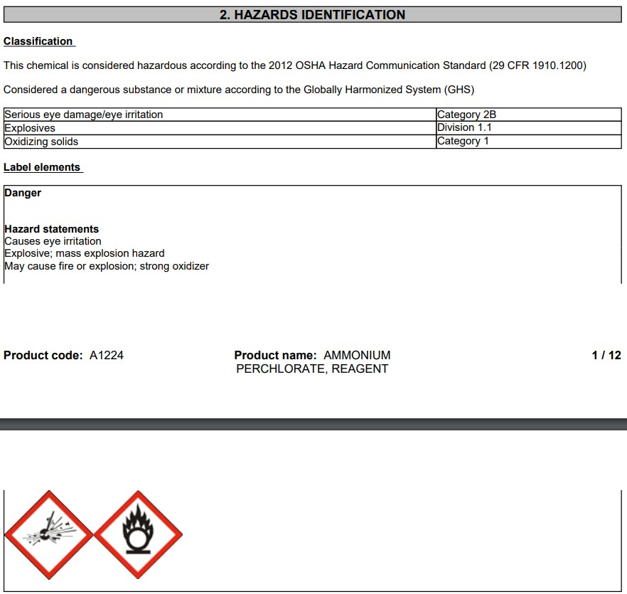

First Aid Information
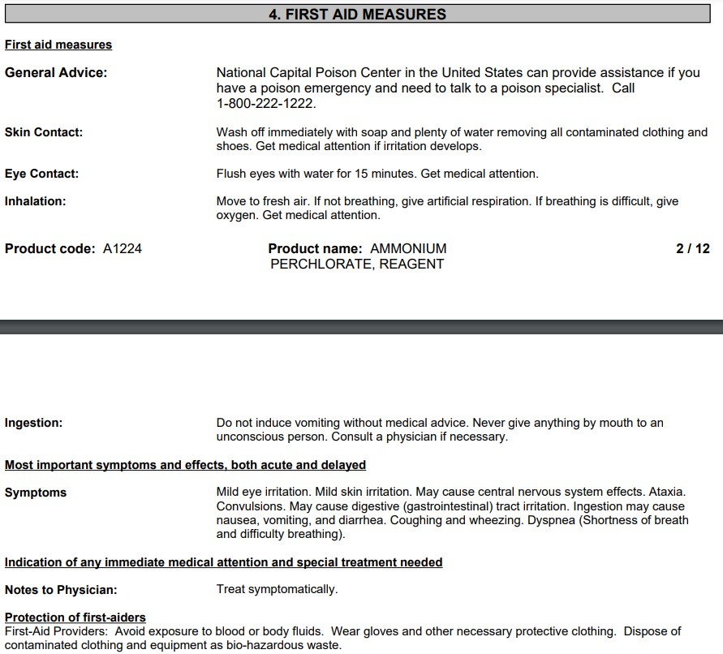

Firefighting Procedures
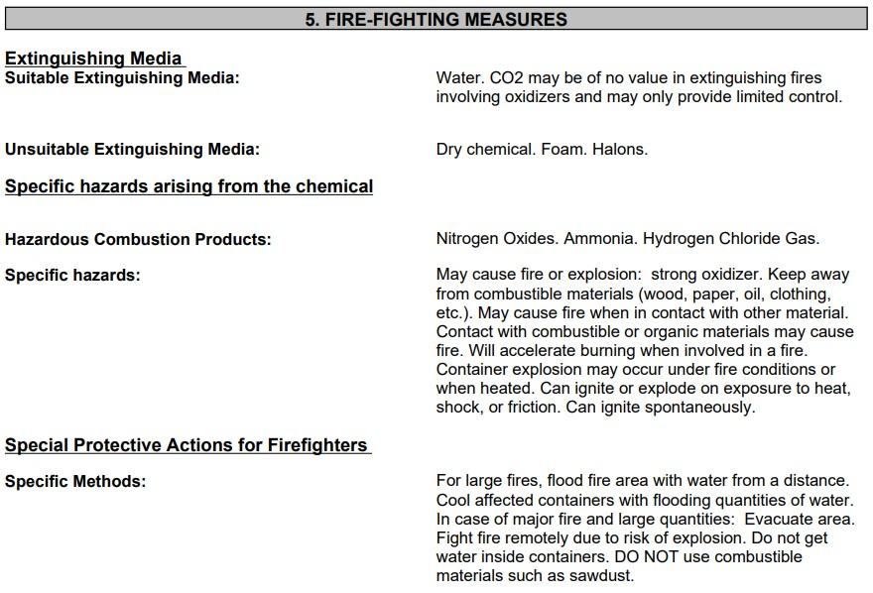

Risk and Safety Phrases / Iconography
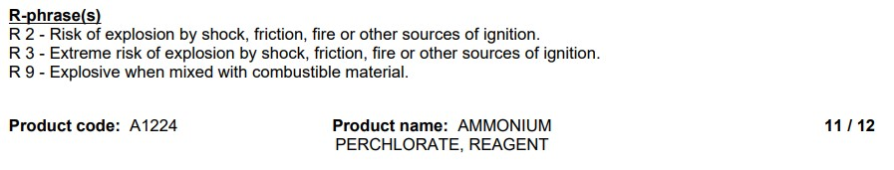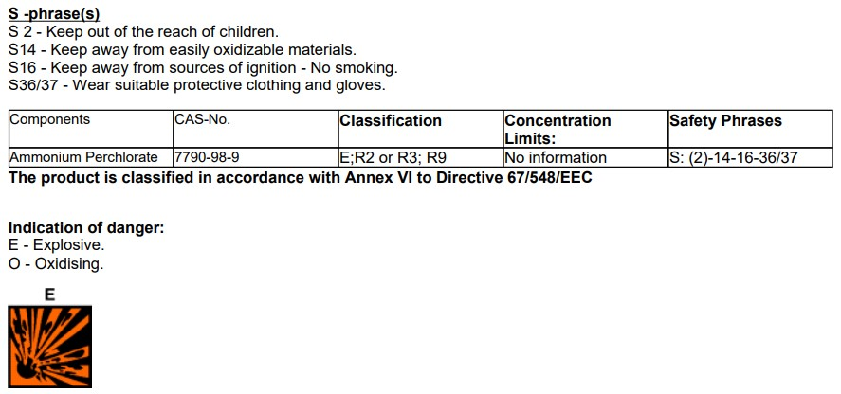

Purchasing
All hazardous materials purchasing must be signed off on by an adult educator after coordination with College of Engineering facilities, ensuring the ability to store the purchased material(s) properly and safely upon delivery. For the purposes of the Zenith Program, solid rocket motors will require sign off by both an adult educator after coordination with College of Engineering facilities, and approval by the student team mentor, whose NAR/TRA Level 2+ certification is required to purchase any L-class motor.

Transportation, Storage, and Handling
Hazardous material must be transported according to DOT standards. Applicable regulations for transportation can be found in the chemical data sheet. Any vehicle transporting hazardous material will display the proper DOT Hazard Diamonds during transport.
Storage guidance for hazardous materials may be found in the chemical data sheet. College of Engineering Facilities will be consulted and provided the chemical data sheet prior to delivery of material to be stored in College of Engineering Hazardous Materials Storage (Section 4.1.2).
Proper Personal Protective Equipment must always be worn while handling hazardous material. The chemical data sheet lists all ways in which the material may cause harm and provides guidance on the proper Personal Protective Equipment for mitigation of each of these risk modes.

Facilities Safety

It is the intention of the Zenith Program team and FAMU-FSU AIAA Executive Board to operate the AIAA shop, and any other facilities used, under the OSHA guidelines for laboratory safety regardless of whether the facility would be considered a traditional laboratory environment in the pursuit of safe operations. Students will be required to attend a briefing on these guidelines and take a quiz demonstrating understanding before beginning work on any portion of the Zenith Program project.

Fabrication Shop
The Sliger Building AIAA Shop is intended as a fabrication space for inert components only. By university regulation, no hazardous materials or pressurized cylinders are to be stored or handled in the project labs. Unpressurized cylinders may be stored in accordance with the laboratory safety regulations discussed below. Electrical work, such as for the avionics systems, will comply with the electrical laboratory safety guidelines outlined below.

Laboratory Safety Regulations
Regulations listed are pulled from the OSHA Laboratory Safety Guidance for sections applicable to Zenith Program work, attached in full as Appendix H.

Chemical Regulations
From OSHA Laboratory Safety Guidance, Hazard Identification:
“Each laboratory must identify which hazardous chemicals will be encountered by its workers. All containers for chemicals must be clearly labeled. An employer must ensure that workers do not use, store, or allow any other person to use or store, any hazardous substance in his or her laboratory if the container does not meet the labeling requirements outlined in the Hazard Communication standard, 29 CFR 1910.1200(f)(4). Labels on chemical containers must not be removed or defaced. Material Safety Data Sheets (MSDSs) for chemicals received by the laboratory must be supplied by the manufacturer, distributor, or importer and must be maintained and readily accessible to laboratory workers. MSDSs are written or printed materials concerning a hazardous chemical. Employers must have an MSDS in the workplace for each hazardous chemical in use.”

Pressure Vessel Regulations
From OSHA Laboratory Safety Guidance, Compressed Gasses:
“…there are hazards from the pressure of the gas and the physical weight of the cylinder. A gas cylinder falling over can break containers and crush feet. The gas cylinder can itself become a missile if the cylinder valve is broken off. Laboratories must include compressed gases in their inventory of chemicals in their Chemical Hygiene Plan…
Store, handle, and use compressed gases in accord with OSHA’s Compressed Gases standard (29 CFR 1910.101) and Pamphlet P-1-1965 from the Compressed Gas Association.
- All cylinders whether empty or full must be stored upright.
- Secure cylinders of compressed gases. Cylinders should never be dropped or allowed to strike each other with force.
- Transport compressed gas cylinders with protective caps in place and do not roll or drag the cylinders.”

Electrical Regulations
From OSHA Laboratory Safety Guidance, Electrical:
“Subpart S is comprehensive and addresses electrical safety requirements for the practical safeguarding of workers in their workplaces. This Subpart includes, but is not limited to, these requirements:
- Electrical equipment must be free from recognized hazards, 29 CFR 1910.303(b)(1);
- Listed or labeled equipment must be used or installed in accord with any instructions included in the listing or labeling, 29 CFR 1910.303(b)(2);
- Sufficient access and working space must be provided and maintained around all electrical equipment operating at ≤ 600 volts to permit ready and safe operation and maintenance of such equipment, 29 CFR 1910.303(g)(1);
- Ensure that all electrical service near sources of water is properly grounded.
- Tag out and remove from service all damaged receptacles and portable electrical equipment, 29 CFR 1910.334(a)(2)(ii);
- Repair all damaged receptacles and portable electrical equipment before placing them back into service, 29 CFR 1910.334(a)(2)(ii);
- Ensure that workers are trained not to plug or unplug energized equipment when their hands are wet, 29 CFR 1910.334(a)(5)(i);
- Select and use appropriate work practices, 29 CFR 1910.333; and
- Follow requirements for Hazardous Classified Locations, 29 CFR 1910.307. This section covers the requirements for electric equipment and wiring in locations that are classified based on the properties of the flammable vapors, liquids or gases, or combustible dusts or fibers that may be present therein and the likelihood that a flammable or combustible concentration or quantity is present.

Launch Operations

Pre-Launch Briefings
A formal pre-launch meeting shall serve as the hazard recognition and accident avoidance briefing for launch and recovery procedures. The meeting shall also serve as a briefing for proper conduct on the launch site including, but not limited to, the rules of the private property and NAR/TRA safety policies. The Project Manager, Safety Officers, and Leads will conduct the meeting prior to the scheduled launch. Attendance will be mandatory for team members to be present at the launch site.

Range Safety Inspection
Before flight of the rocket, permission of the range safety officer must be given. For any reason if the range Safety officer finds an issue with the rocket the team will follow the instruction given by the Range Safety Officer.

Personnel Safety

Safety Philosophy of the Zenith Program
In contrast to the mainstream belief that safety comes first, the Zenith Program team is committed to a different philosophy: “Safety Third!”. While seeming incredibly irresponsible at face value, this ideology is meant to combat the dangers of the “Safety First” mentality and underscore the importance of personal responsibility.
The safety-first mentality generally leads individuals to assume that their working environment has been made as safe as possible, with all risks properly mitigated, and their employer or supervisor singularly focused on their personal safety. This could not be farther from the truth. In most cases, the workplace has not been optimized for safety, quite the opposite. The safety-first mentality leads to complacency on the part of management and employees; assuming that all risk has been mitigated causes a sharp drop-off in vigilance by all involved and can lead to higher incidence rates of minor and major accidents.
The safety-third ideology is intended to combat this complacency. By constantly reminding oneself “safety third!”, one is reminded of a harsh reality: nobody is watching out for you! This mentality is meant to create a thought process in the mind of employees that management is primarily concerned with turning profit, and not making sure they are safe while doing it. This puts the impetus on the employee to guarantee their own personal safety by practicing extreme vigilance for hazard identification, and close adherence to policies and procedures in place for risk mitigation, such as the use of Personal Protective Equipment. A safety-first employee may neglect safety goggles in a low-risk activity with the slim possibility of eye injury, while a safety-third employee will always wear their eye protection knowing their judgement and actions are what keep them safe.
The safety third ideology and its’ advantages are eloquently described by Mike Rowe in an episode of his hit TV show “Dirty Jobs”. Mr. Rowe outlines the philosophy above with a touch of humor during a personal anecdote aboard a Bering Sea crab-fishing boat, found at:
[ https://www.youtube.com/watch?v=Km8XxRCuCho ]

Hazard Recognition and Accident Avoidance
From OSHA Laboratory Safety Guidance, Hazard Identification:

“Laboratory workers must be provided with information and training relevant to the hazards of the chemicals present in their laboratory. The training must be provided at the time of initial assignment to a laboratory and prior to assignments involving new exposure situations. The employer must inform workers about the following:
The content of the OSHA Laboratory standard and its appendices (the full text must be made available)

The location and availability of the Chemical Hygiene Plan

Permissible exposure limits (PELs) for OSHA regulated substances, or recommended exposure levels for other hazardous chemicals where there is no applicable standard

Signs and symptoms associated with exposure to hazardous chemicals in the laboratory; and

The location and availability of reference materials on the hazards, safe handling, storage, and disposal of hazardous chemicals in the laboratory, including, but not limited to, MSDSs.

Training must include the following:

Methods and observations used to detect the presence or release of a hazardous chemical. These may include employer monitoring, continuous monitoring devices, and familiarity with the appearance and odor of the chemicals

The physical and health hazards of chemicals in the laboratory work area

The measures that workers can take to protect themselves from these hazards, including protective equipment, appropriate work practices, and emergency procedures

Applicable details of the employer’s written Chemical Hygiene Plan

Retraining, if necessary.”

Personal Protective Equipment
From OSHA Laboratory Safety Guidance:
“Employers must train workers to use the appropriate personal protective equipment (PPE)…This includes:
- face shield or safety goggles
- safety gloves.
- long-sleeved shirts, lab coats, aprons.”

Risk Assessment – Personnel

General Mitigation Strategies
- Use common sense and never attempt to follow any procedures with uncertainty.
- Be sure to always have an informed team member present when executing tasks.
- Abide by all state, federal and local laws as well as all safety regulations at all times.
- Ensure that proper safety equipment is worn at all times.
- Wear appropriate clothing in the lab.
- Always wear safety glasses/goggles.
- Wear gloves when necessary.
- Wear facial protection when necessary.
- Open toe shoes are prohibited in the lab and machine shop.
- Always be aware of surroundings.
- Ensure that there is a knowledgeable team member present at all times.
- Update and review the safety binder as often as possible.
- Contain Safety Data Sheets (SDS) within the confines of the binder.
- Contain pre-activity and pre-launch checklists.
- Ensure each team member understands all information contained in the binder.

In-Depth Risk Assessment
Risk Factor | Possible Outcomes | Mitigation Strategy
Equipment and Tooling | - Cuts, scrapes, burns, and skin irritations  - Damage to equipment | - Be aware of surroundings in the work station  - Ask if unsure  - Wear appropriate safety equipment  - Proceed with caution
Chemical Contact | - Irritation to skin or eyes.  - Inhalation of hazardous fumes  - Fire/explosions  - Equipment damage | - Wear appropriate safety gear and clothing  - Keep workstations clean and well ventilated  - Refer to Chemical Data Sheets
Rocket Motor Handling | - Fire/explosion  - Burns.  - Motor damage | - Only certified personnel should store, handle, and transport motor  - Wear appropriate safety gear and clothing  - Keep motor away from any gunpowder in storage
Launch Vehicle Handling | - Damage to rocket  - Damage to nearby power lines, facilities and cars  - Fires/explosions  - Personal injury  - Death | - Only certified personnel should store, handle, and transport the rocket  - Abide by all federal, state, and local laws as well as the NAR safety codes and FAA  - regulations  - Abide by the regulations set forth by the Range Safety Officer (RSO)  - Use common sense and be aware of surroundings  - Keep emergency contact information in the safety binder and use accordingly
Machine Shop Usage | - Cuts, scrapes, burns, and skin irritations  - Loss of appendages  - Death | - Always ensure there is a knowledgeable team member present in the machine shop.  - Always wear proper safety equipment in the machine shop, especially safety goggles  - Always wear appropriate clothing in the confines of the machine shop (no open  - toed shoes or long sleeves).  - Operate any and all machinery with extreme care.  - Be aware of surroundings at all times.
Other Facility Usage | - Improper rocket storage.  - Failure to abide by the Code of Conduct set forth by the facility/university  - Damage to equipment  - Not respecting hours of operation | - Ensure that only authorized personnel store the rocket, motor, and any explosive materials within the facility.  - Abide by the Code of Conduct to ensure that the use of the facility along with any equipment is not jeopardized  - Handle all equipment with care and ensure to clean all workstations after completion of tasks  - Do not use the facility outside of the hours of operation to ensure future use of the facility
Miscellaneous | - Inclement weather  - Issues with material acquisitions  - Not abiding by the Code of Conduct  - General Injury | - Schedule backup dates for testing.  - Order equipment in advance (at least two weeks prior)  - Abide by the University’s Code of Conduct to avoid losing access to lab space,  - equipment, etc.  - Respect hours of operation  - Respect others at all times  - Review and update safety binder often.

Regulation Compliance
It is of the utmost importance that the Zenith Program team be held to the highest safety standards for the duration of this project. The team must abide by the following rules and regulations to ensure the safety of the team as well as the spectators, competition officials, and any other personnel involved in the development and flight of this high-powered rocket:
- Prior to launch, the team must assess the pre-launch and safety briefings located in the safety binder.
- All spectators must stay at least 200 ft. away from the launch pad during any and all test and competition flights.
- During the development of the rocket, the team should always wear appropriate clothing and proper personal protective equipment to avoid any injuries.
- The team must review the safety data sheets located in the safety binder often and especially before any launch.
- Always ensure that there is a knowledgeable team member present during assembly of the rocket.
- Present the safety binder to the Range Safety Officer (RSO) and await approval for launch.
- In the event that the RSO does not approve the rocket for flight (for any reason), the team acknowledges and accepts that their rocket will be removed from the competition.
In addition to the safety standards previously stated above, the following regulations will also be complied with during the development, testing, and flight of this rocket:
- NAR High Power Safety Code
- FAA regulations, including 14 CFR Subchapter F Part 101 Subpart C
- NFPA 1127
- USLI Safety Regulations (listed below)
The team as a whole agrees to abide by the following regulations from the Student Launch Handbook:
- Range safety inspections of each rocket before it is flown. Each team shall comply with the determination of the safety inspection or may be removed from the program.
- The Range Safety Officer has the final say on all rocket safety issues. Therefore, the Range Safety Officer has the right to deny the launch of any rocket for safety reasons.
- Any team that does not comply with the safety requirements will not be allowed to launch their rocket. Any team member who does not agree to any of the rules above may be refused access to rocket construction or assembly, may not be allowed to attend launches, or may even be removed from the team if necessary.
A copy of this agreement along with each team member’s signature will be available as Appendix A of this proposal.

Preliminary Vehicle Design

Airframe
The proposed flight vehicle will launch to a projected altitude of 4900 feet. The following figure provides a 3D view of the model rocket that was created using OpenRocket.
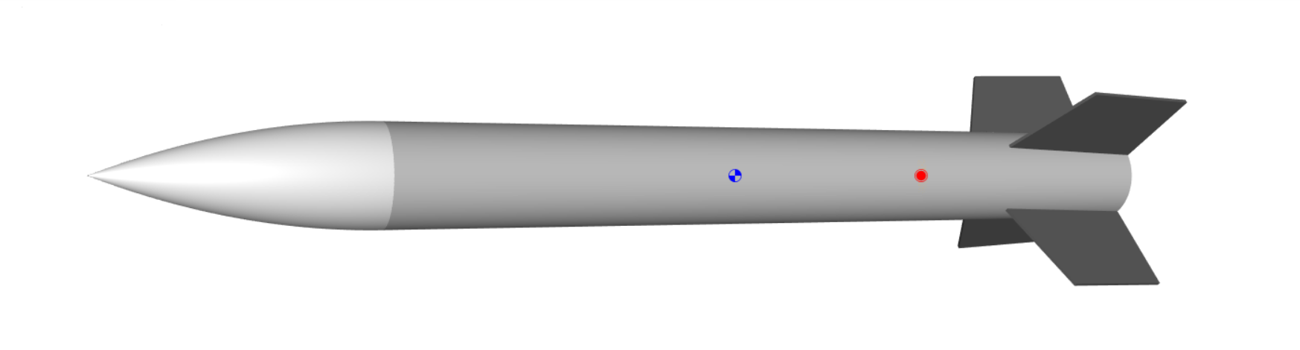

Dimensions

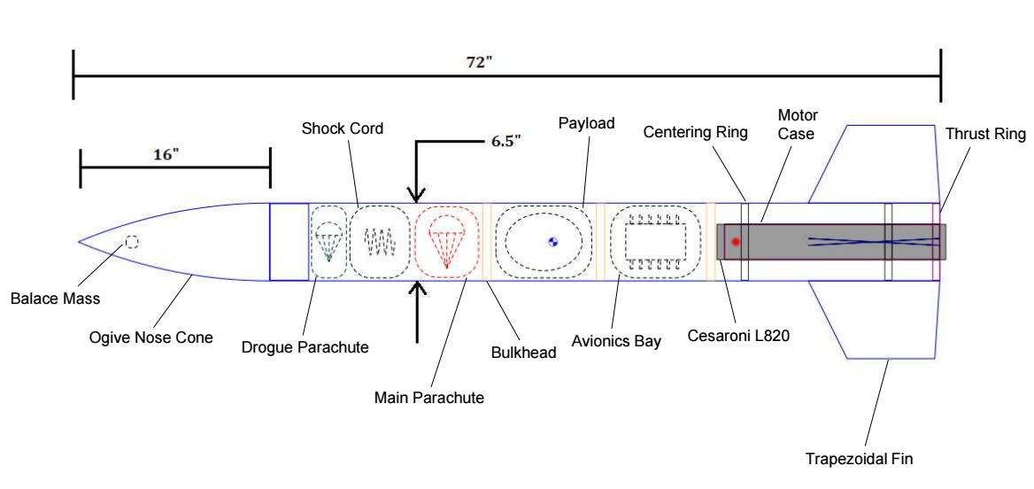
The figure shown above provides a layout of the flight vehicle’s internal components and higher fidelity model of the vehicle’s shape and fins. The overall length of the flight vehicle is 72 inches. The ogive nose cone has a length of 16 inches and the vehicle’s body tube has a diameter of 6.5 inches. The ogive nose cone shoulder acts as a coupler to connect the nose cone and the booster section. The booster section stores a Cesaroni L820 motor, an avionics bay, a payload, and a recovery system. Each main component inside the booster is separated by a bulkhead. The fixed motor mount houses the L820 motor, and the centering rings provide stability for the motor mount. Located at the rear portion of the booster section are four trapezoidal fins. The fins are canted at an angle of 2.5-degrees to cause rotation along its roll axis in order to optimize the rocket’s aerodynamic stability during flight.

Materials and Fabrication
The following table shows commonly used materials for amateur rocketry applications and their corresponding densities. One of the optimization parameters for the flight vehicle is weight reduction, therefore, the lightest materials which provide the needed structural integrity will be chosen. Material weights will also be considered in the component distribution, as this directly impacts vehicle stability.
Material | Density (oz/in^3)
Polypropylene Plastic | 0.517
Blue Tube | 0.751
Braided Nylon | 0.011
Ripstop Nylon | 0.22
Tubular Nylon | 0.312
Aluminum | 1.56
Plywood (Birch) | 0.364
Aluminum | 1.56
PLA | 0.717
Fiberglass | 1.07

The following information briefly describes the proposed component materials and justifications for their use, as well as manufacturing methods for non-Commercial Off the Shelf (COTS) parts
Nose Cone:
- COTS Polypropylene Plastic Ogive nose cone
  - [ More/Less] dense than other materials, such as balsa or birch wood, but significantly more resistant to cracking or fracture than wood components
Body Tube:
- COTS Blue Tube body tube
  - Obtains a relatively high material strength and has a greater heat resistance than other considered materials, such as cardboard or kraft phenolic

Shock Cord:
- COTS Braided Nylon shock cord
  - Optimal shock absorption material and performs well against wear and tear with braided characteristics prevent fraying in the line as tension is applied
Parachute (Main and Drogue):
- COTS Ripstop Nylon Parachute with Tubular Nylon shroud lines
  - Greater strength quality than most paracord materials and possess optimal elastic properties that are crucial to a safe and successful flight vehicle recovery
Engine Mount:
- COTS Kraft Phenolic engine mount
  - Phenolic resins improve material strength and heat resistance in comparison to other paper or plastic products and light weight characteristics improve the vehicle’s stability margin and overall flight performance
Centering Rings and Bulkheads:
- COTS Plywood (birch) centering rings
  - Maintains solid composure and durability due to its grain direction remaining perpendicular to shear loads experienced during flight
Fin Structure:
- In-house 3D Printed Polylactic Acid (PLA) trapezoidal fins with a cant angle of 2.5°
  - Versatile manufacturing method with optimal build time and allows single piece structural components, opposed to a COTS assembly of multiple components with a high risk of assembly failure
  - Thrust structure will have thermal insulating properties to account for fin heat failures

Propulsion

Motor selection
To accommodate the design and weight of the flight vehicle, a handful of motors are still undergoing performance analysis. However, two motors that have performed well with the design parameters of our rocket are the Cesaroni L820 Skidmark Rocket motor and the Cesaroni L3200. While both motors are still being analyzed and tested under a variety of parameter editions, the motor that is currently favored is the Cesaroni L820 Skid mark rocket motor. With a maximum thrust of 984.8 N, the Cesaroni L820 is capable of providing 2945.6 N*s of impulse. The L820 has a loading weight of 3420.0 grams and a burnout weight of 1597.8 grams with a burn time of roughly 4 seconds. The graph below demonstrates the change in thrust during the L820’s burn time.
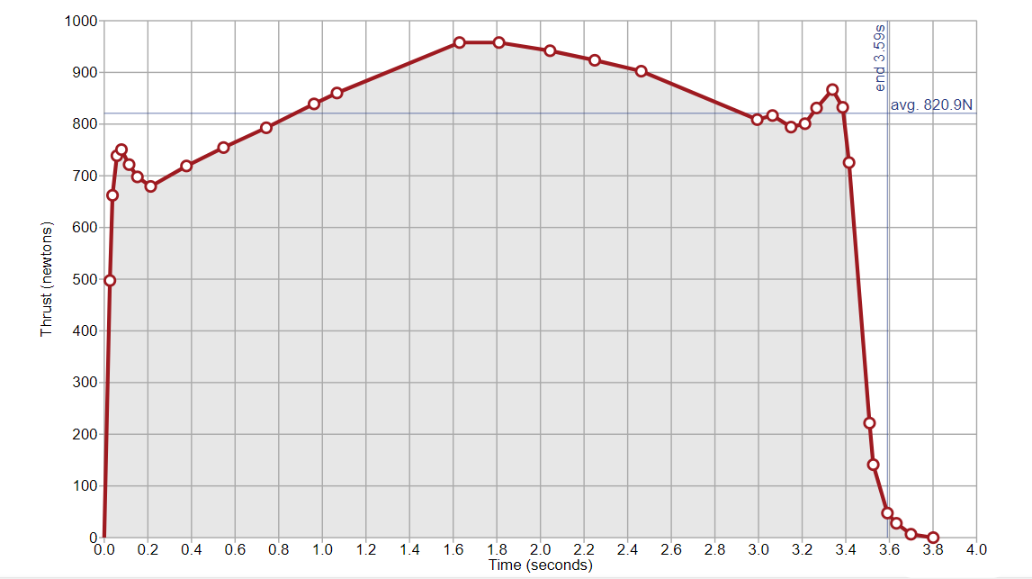

Motor selection is a daily discussion topic between the team to determine which motor will perform best for our vehicle design. One of the main reasons the Cesaroni L820 is currently the top choice is because of its flight performance with our vehicle’s aerodynamic properties and stability margin. Changes in the vehicle’s design characteristics are heavily dependent on maintaining a margin of stability between 3 and 4 calibers to preserve a stable flight path. Currently, the vehicle is designed to uphold a lightweight profile and store only items necessary to the mission. To account for the possibility of modeling errors or weight additions in future design, the L3200 is considered as a fallback plan to maintain stability while achieving desired altitude. Due to their dimensional similarity, replacing the L820 with the L3200 would not cause any drastic design setbacks with the flight vehicle. As the Critical Design Review milestone edges closer, enough data will be collected to appropriately select a final motor choice.

Flight Metrics
Using OpenRocket simulation software, three different flight simulations were tested on the model rocket to account for different launch rail angles. The simulations were modeled at standard conditions (STP, zero wind speed) and under Huntsville, Alabama geographical conditions (34.7° N, 86.7°W longitude). The tables below show the projected outputs of the three launch angle conditions of a 12 ft rod: 5 degrees, 7.5 degrees, and 10 degrees.
Launch Angle: 5 ֯
Motor | L820
Velocity off rod (ft/s) | 64.1
Apogee (ft) | 5001
Velocity at deployment (ft/s) | 101
Optimum delay (seconds) | 13.8
Max. Velocity (ft/s) | 690
Time to apogee (seconds) | 17.5
Flight time (seconds) | 93.4
Ground hit velocity (ft/s) | 17
Descent time (seconds) | 75.9

Launch Angle: 7.5 ֯
Motor | L820
Velocity off rod (ft/s) | 64.1
Apogee (ft) | 4953
Velocity at deployment (ft/s) | 101
Optimum delay (seconds) | 13.9
Max. Velocity (ft/s) | 691
Time to apogee (seconds) | 17.6
Flight time (seconds) | 91.4
Ground hit velocity (ft/s) | 17
Descent time (seconds) | 73.8

Launch Angle: 10 ֯
Motor | L820
Velocity off rod (ft/s) | 64.2
Apogee (ft) | 4886
Velocity at deployment (ft/s) | 101
Optimum delay (seconds) | 13.9
Max. Velocity (ft/s) | 692
Time to apogee (seconds) | 17.7
Flight time (seconds) | 93
Ground hit velocity (ft/s) | 17
Descent time (seconds) | 75.3

Under standard atmospheric conditions, neglecting wind speed, the average apogee of the three flight simulations is 4946.67 feet and the average descent time was 75 seconds. The projected altitude (4900 feet) introduced in section 6.1 is based on consideration of wind speed conditions causing the flight vehicle to undershoot the average apogee under standard conditions. As more detailed parameters are implemented into the design and final motor selections are made, OpenRocket simulation software will be used to analyze the flight performance of the vehicle under average springtime atmospheric conditions in Huntsville, Alabama.

Thrust Structure
Housing the motor will be the Cesaroni Pro-75 motor case. The Pro-75 motor case is a reloadable case manufactured from thin-wall 6061-T6 aluminum tubing with a clear anodized coating for optimal corrosion resistance. This motor case was selected to house the motor due to its lightweight profile and high tensile strength, with the capability of holding over 3000 pounds per square inch of internal pressure. At the head end of the case is a formed rim that acts as a retainer for the motor in response to pressurization throughout the airframe at burn out. Centering the motor case with the flight vehicle will be two centering rings made of plywood. A thrust plate will be screwed to the back side of the aft centering ring to eliminate all shear loads on the centering ring and transfer the thrust load of the motor to the airframe. Machined from aircraft-grade 6061 Aluminum and anodized a bright red, the thrust plates were chosen due to their high material strength and ease of removal by simply removing the flathead screws holding the plate to the aft centering ring.

Recovery System

Avionics
The recovery system will be commanded by a dual-deployment capable flight computer equipped with redundant measuring systems for velocity and/or altitude. At apogee the flight computer will send a command signal to the drogue ejection system to initiate deployment. Shortly after during decent, at a preprogrammed altitude above 500 ft the flight computer will send another signal to the main chute ejection system.

Drogue Chute
The drogue parachute will deploy from the top of the vehicle between apogee and 2 seconds after apogee. The parachute will be the 15” Fruity Chutes: Drogue Chute, a toroidal shaped parachute with a drag coefficient, $C_{d}≈1.5$, shown in the image below. Instead of using a common gun powder charged ejection system, the design will use a small CO2 ejection system for chute deployment, which increases the safety of the recovery system by eliminating the risk of premature ignition. Currently, the CO2 ejection system for the design is the CD3 Adventurer Kit but it may change due to supply issues. The following are specifications of the parachute:
- Material: Ripstop Nylon
- Weight = 0.0948 lb
- Surface Area = 2.2 ft^2
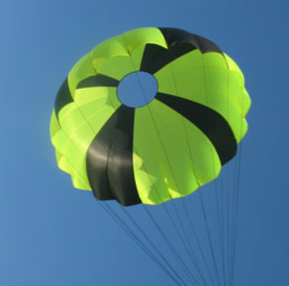

Main Chute
The main parachute will deploy shortly after the drogue chute, at around 600-700 ft above the ground. The 72” Fruity Chutes: Iris Ultra is the parachute of choice, providing a drag coefficient $C_{D}≈2.2$, and is shown in the image below. Similar to the drogue chute, the main chute will use the CD3 Adventurer Kit as the ejection system. The following are specifications of the parachute:
- Material: Ripstop Nylon
- Weight = 0.838 lb
- Surface area = 47.5 ft^2

Payload

Description
The proposed payload is an autonomous four-wheeled rover that will use a robotic arm to perform the task described in section 6.4.3. below. Here is a simplified sketch of the envision, and top (right) views:

Propulsion And Maneuverability
The rover will utilize simple servo DC motors to provide torque to the wheels for propulsion. It will be later decided by the team whether each wheel on the payload uses its own motor, or just the two rear-wheels. The wheels will be large enough to move about the terrain, and the motion of the wheels will be controlled by encoders for adjustment of the motors’ angular position.

Task
The task of the payload is to deploy and use a robotic arm to successfully plant a small American flag to claim the launch site in the name of the FAMU-FSU College of Engineering and for the glory of our great nation. Actuation of the robotic arm is in the concept development stage, with initial ideas being a spring-loaded arm or geared DC motor power arm. The rover will also be equipped with a small digital camera placed at the center of the body on a motorized swivel.

Autonomy
To actuate the motor drivers and robotic arm the rover will be equipped with an Arduino or any other similar microcontroller. There will also be either a light, ultrasonic, image sensors, or a combination of those abroad the vehicle for obstacle detection and terrain anticipation. The microcontroller will be responsible for receiving sensor inputs and behaving based on the receive signals. The controller will also utilize forward and inverse kinematic algorithms for localization and control with the goal of determining the optimal route away from the launch vehicle for performing the landmarking task.

Battery
For powering the rover, the team has yet to decide on whether to use a Lithium Polymer (LiPo), Lithium Ion (Li-Ion) or Nickel-Metal Hydride (NiMH) battery type. All are commonly used in commercial radio-controlled cars and provide similar voltage and capacity. LiPo, Li-Ion, and NiMH have nominal cell voltages of 3.7 V, 3.6 V, and 1.2 V, respectively. Eventually, the final battery will be selected in a later detailed design based on power supply, weight, availability, and cost.

Risk Assessment – Vehicle

Airframe
Failure Mode | Possible Outcomes | Mitigation Strategy
Fins  - Fin shears off of airframe  - Fins deflect under aerodynamic stress | - Loss of controlled flight  - Uncontrolled ground impact  - Risk to onlookers | - FEA simulations of aerodynamic loading  - Sub-scale wind tunnel testing  - Shock test materials and mounting methods
Body  - Loss of structural integrity | - Rocket disintegration mid-flight  - Uncontrolled ground impact  - Risk to onlookers | - FEA simulations of aerodynamic loading  - Sub-scale wind tunnel testing
Nosecone  - Nosecone shear off under loading | - Loss of controlled flight  - Rocket disintegration mid-flight  - Risk to onlookers | - FEA simulations of aerodynamic loading  - Sub-scale wind tunnel testing
Motor / Motor Casing  - Motor burns through casing, compromising vehicle  - Motor Misalignment, breakage of centering rings | - Loss of controlled flight  - Rocket disintegration mid-flight  - Fire, explosion, eruption of onboard pressure vessels  - Risk to onlookers | - Heat transfer simulations prior to engine testing  - Ground testing of engine section at sub- and full-scale  - FEA analysis of centering rings under loading

Payload
Failure Mode | Possible Outcomes | Mitigation Strategy
DC Motor  - Motor reaches stall torque, overloaded  - Motor or electrical system become wet while in flight-ready condition | - Motor jamming  - Short circuit  - Loss of rover propulsion  - Loss of robotic arm actuation | - Design gear ratios to ensure operation below stall torques  - Design water-resistance into payload bay
Robotic Arm  - Structural Failure | - Loss of robotic arm range of motion  - Total arm failure | - Ground testing and validation of rover sequence  - FEA simulations of robotic arm under loading
Micro-Controller (Arduino)  - Moisture intrusion  - Command sequence failure  - Poor sensor data acquisition or transmission | - Short circuit  - Imprecise commands sent to propulsion motor or robotic arm actuators | - Testing and validation of autonomous sequence of rover tasks

Recovery System
Failure Mode | Possible Outcomes | Mitigation Strategy
Ejection system  - Nosecone fails to eject  - Drogue or main chute deployment failure | - Chute deployment prohibited or inhibited  - Uncontrolled descent and ground impact | - CFD and wind tunnel testing on nosecone aerodynamic loads  - Ejection/deployment system testing before launch under determined loading
Avionics  - Altimeter or barometer failure  - Flight computer fails to send eject command | - Loss of telemetry  - No parachute deployment  - Early/late parachute deployment | - Redundant accelerometers and barometers in flight computer  - Redundant flight computers

Technical Assessment
Design/Manufacturing Challenges | Proposed Solutions
3-D printing fins. Printers available are smaller than fin section to be printed | Explore options for printing in sections and joining by plastic welding, or by woodworking joints, etc.
CAD modeling and FEA simulation of sub-scale wind-tunnel model. Stringent requirements for model to be allowed in tunnel. Coordination with FCAAP machine shop required for high-precision model | Speak with FCAAP machinist and tunnel engineer early in design process. Coordinate with graduate students working low-speed tunnel through team members that interned at FCAAP over summer
Precise and smooth fin root fillet to be added on full scale vehicle | Could be as simple as using caulk at fin roots, or as complex as CNC machining entire section from 1 block of aluminum. 3D printed PLA under consideration.
Concerns overheat tolerance of 3D printed PLA for application in fin section. Proximity to hot motor casing is of most concern, followed by exposure to aerodynamic heating | Heat transfer from motor to casing to surrounding airframe components must be simulated and practically tested. Subscale models may be experimented on with small PLA, aluminum, and wooden fin sections

Stem Engagement

Engagement Plan
The team plans on engaging with the local community of up-and-coming STEM majors through various outreach activities with several notable educational institutions. The team plans to reach out to elementary, middle, and high schools in the Tallahassee area to arrange in class visits and afterschool activities.

Local Student Outreach

Augusta Raa Middle School STEAM Club
Raa Middle School is of particular interest to the Zenith Program team for STEM engagement, as it is well known for a student body of mixed socio-economic status. The team feels it is not only important to engage younger students in the STEM pipeline, but to extend this pipeline to traditionally underserved students and communities in order to better incorporate them into well-paying technical fields. The Science, Technology, Engineering, Arts, and Mathematics Club at Raa is comprised of technically inclined students eager for mentorship by those further in their academic and professional careers. The College of Engineering Senior Design program has worked with Raa in the past for STEM outreach, and our faculty advisor has stated their intention to connect with the Raa administration on behalf of the Zenith Program team to begin engagement planning.

Leon High School
Leon High School is a public high school in Tallahassee, Florida, United States. It is the oldest public high school in the state and is a direct feeder to both Florida State and Florida A&M University. Leon High STEM students often visit the College of Engineering during Student Organization Fairs and College Open Houses to tour the campus and meet college students for question and answers regarding their potential future majors and career paths. The Zenith Program team intends to reach out through established connections by AIAA with the Leon High administration made during last year’s National Society of Black Engineers “A Walk for Education” Event, in which AIAA set up a table to interface with visiting Leon students and faculty about students’ futures in aerospace.

SAIL High School Robotics Club
SAIL High has one of the most impressive robotics programs in Tallahassee, admittedly surpassing that of the student organization at the College of Engineering. The Zenith Program team intends to coordinate with the Robotics program sponsor to brief the students on the payload design portion of the Zenith Program and encourage students to develop their own design ideas and hardware solutions for practice in applying their robotics knowledge to a college level problem. The team would also conduct the regular outreach activities outlined below.

Outreach Activities

Water Rocket Altitude Contest
To facilitate interest in rocketry and aerospace, the team intends to provide small water-rocket kits and hold an altitude competition. This activity is likely suited for high school students given the moderate technical complexity. Students could assemble models during a class lecture with instruction on rocket assembly. The instruction can be segmented with safety briefings pertaining to standard practices with large scale rockets and required guidelines for launching small rockets. After the in-class portion of the activity, students can be led outside to launch their rockets in the school field. Safety, logistics, and launch site will be discussed with the school administration and participating instructors prior to the event.

Foam Glider Flight Contest
For a younger age group, the team has decided on an activity of mild technical complexity. Students can assemble foam glider components designed and provided by the student launch team, potentially constructed of laser cut foam board and balsa wood. Students will be encouraged to work in groups to arrange their glider in the configuration they feel will achieve the largest distance when all gliders compete head-to-head. Prior to their work, the Zenith Program team will deliver instruction on the basics of aerodynamics, especially lift and drag. Part one of the proposed activity includes an on-paper assignment where students are instructed to illustrate what they believe will be the best flying airplane design. Subsequently, the students can go outdoors and experiment with different wing configurations and aerodynamic features to gain a better understanding of lift and drag. Upon completion of the flying portion of the activity, students can be gathered and allowed to discuss what they learned, and given a follow-up written activity to assess their initial hypotheses.

Evaluation Criteria
The team will ask all participants to fill out an evaluation form after each activity or event. The form will serve as a tool to help the team gauge how well the participants learned the concepts and enjoyed the activity. The sheet will also ask for recommendations or suggestions on what to change or improve for the activity or event. Changes will be applied to subsequent instances of the same activity based on participant feedback.
Participants will also be provided with a “future engagement” form, in which their technical interests are assessed and classified. Students’ interests will be correlated with existing STEM disciplines, and information about those disciplines and group advising regarding what classes in high school and later college will benefit student success in their STEM path. Understanding younger students’ interests also provides an opportunity for the Zenith Program team to coordinate with College of Engineering Student Organizations to facilitate their outreach operations with the same students in the future, guaranteeing a strong link between these students and the College of Engineering, as well as great resources and support for these students as they pursue STEM education and careers.

Project Plan

Development Schedule / Work Breakdown Structure

The following is a compact presentation of work breakdown structure for viewing tasks to be completed, start/end dates, and duration. The full WBS and Gnatt chart are attached at Appendix G.
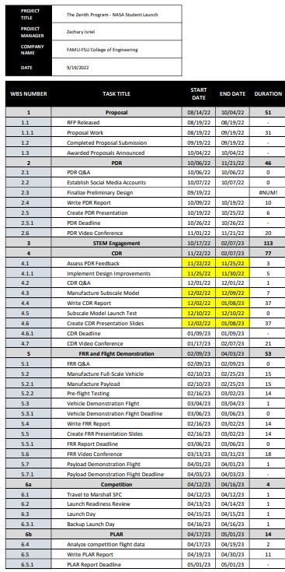

Budget
The full budget sheet is attached as Appendix F. This project budget provides a fair approximation of what exactly the team will need to buy to complete the project. Items quoted are not the exact model or size that will be used but are in the size range required and are comprised of generally accepted materials for each amateur high power rocketry component quoted. These considerations provide a more accurate projected program price for review by the team sponsors and more accurate vehicle weight estimation for use in initial calculations.

The budget sheet produces the following estimates (rounded values):

Full Project Cost | $3,900.00
Full-Scale Vehicle and Payload | $2,800.00
Sub-Scale Vehicle | $250.00
Transportation and Lodging | $600.00
Miscellaneous | $250.00

The following is a compact presentation of the budget for viewing items that will need to be purchased:

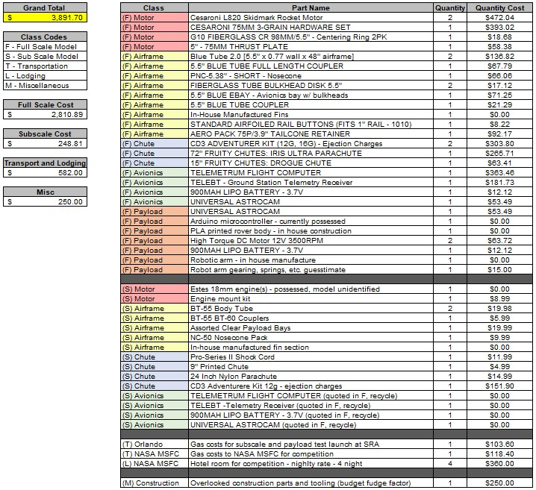

Funding
Funding for this year’s project team is being graciously provided through two sources: the Aero-Propulsion, Mechatronics, and Energy (AME) center has diverted $2,000 of their NASA MUREP Grant funding to Zenith Program in order to facilities Florida A&M student involvement with a complex aerospace project, and to facilitate FAMU student relations with NASA at large, in hopes of creating a firm feeder pipeline of underrepresented minority students to NASA.
The Mechanical Engineering Department has generously offered to cover the difference in project costs in tranches, with disbursement contingent on progression through the Student Launch competition. Once the initial AME Center funding is depleted, Mechanical Engineering will continue funding for parts and material, transportation to the test launch facility, and transportation and lodging for Launch Week should the team progress to that point.

Continuity Plan

Maintaining Partnerships

Industry
The FAMU-FSU College of Engineering is proud to maintain strong industry partnerships with NASA and the Florida Space Grant Consortium. Through the NASA MUREP Grant to FAMU, the college integrates underrepresented minority students into the advancement of aerospace engineering by funding student projects, internships, and research. As part of the MUREP Grant, the College of Engineering was able to fund student participation in the NASA BP-AE summer program, with students working at NASA Kennedy Space Center, NASA Marshall SFC, and at Florida Center for Advanced Aero-Propulsion for a joint project between NASA Broadening Participation of Next Generation Aerospace Engineers (BP-AE) and the Air Force Research Laboratory (AFRL) for the Air Force Munitions Directorate.
Further cooperation between NASA and the College of Engineering is seen at the senior design level, where projects are provided to College of Engineering students yearly by Marshall Spaceflight Center. This relationship exists at the faculty level, between Dr. McConomy and his contact(s) at NASA Marshall and is sure to extend far into the future as students continue doing high-caliber work in support of NASA’s goals in low earth orbit, on the lunar surface, and on to Mars.
The Florida Space Grant Consortium (FSGC) maintains a professional relationship with the College of Engineering in their cooperation in providing grant funding for research, offerings of senior design projects, and funding for student projects in the AIAA technical teams.

Community – Continued STEM Engagement
Continued implementation of the STEM engagement plan in the local community can be ensured through partnership with the American Institute of Aeronautics and Astronautics FAMU-FSU Student Branch. The student branch executive board will be involved with the implementation of the proposed engagement plan and will use this engagement to further their mission of spreading aerospace knowledge and education. Involving AIAA creates redundancy, as the engagement plan and continuity of engagement are now spread across both future Student Launch teams and the AIAA Branch. As previously mentioned, the engagement opportunities will be opened to other student organizations, further increasing the redundancy in this continuity planning. If AIAA does not produce a Student Launch team for a given year, the organization will continue STEM outreach regardless. If AIAA should find itself preoccupied or otherwise unable to conduct outreach, other organizations will continue to engage the community.

Funding Continuity and Expansion
As previously stated, this year’s project team funding is sourced through the AME Center and the College of Engineering Mechanical Engineering (ME) Department. If successful, both contributors intend to continue providing funding and faculty support to multi-year projects in hopes of expanding the College’s presence on the national stage and gaining sponsorship from industry partners and aerospace organizations, primarily out of the Kennedy Space Center.

Future Engagement

Recruitment
As the Zenith Program is a subset of AIAA students, the student branch recruitment plan is held for future student launch activities. From the FAMU-FSU AIAA Leadership Succession and Chapter Recruitment Plan:
“The executive board is committed to an aggressive expansion plan in three parts. The first is inter-organizational engagement. Given the extremely multidisciplinary nature of aerospace engineering, success in current and future projects depends on engaging a student base outside of the mostly mechanical engineering students comprising the chapter at present. In order to facilitate membership and disciplinary expansion, the executive board intends to coordinate with the Institute of Electrical and Electronics Engineers (IEEE), the American Institute of Chemical Engineers (AIChE), and the Materials Research Society (MRS) to find those interested in dual membership in their respective society and AIAA to bring their expertise to research and projects in aeronautics and rocketry conducted by AIAA.
The second part of the recruitment plan is increasing visibility of the chapter. This begins with flyers posted to message boards, visiting classrooms in pre-engineering and entry level (sophomore) engineering to engage eager students early on, and engaging faculty in related disciplines, such as fluid dynamics, to spread the word to upper division students about our chapter, where these higher-level engineering concepts can be applied, not just learned. We are also in contact with the Northwest Florida AIAA, our regionals, regarding a keynote speaker event for which they have offered a list of high-profile speakers, such as Robert Zubrin, President of the Mars Society, and offered to cater. The executive board intends to heavily advertise this event once coordinated, and open it to any student willing to attend, greatly increasing visibility in the College of Engineering. Beyond these recruitment efforts, we intend to market every spectacular success and equally spectacular (but safe) failure on NASA Student Launch technical team, as active design and launches of high-power rockets are sure to attract aerospace engineering inclined students.
The third and most important part of the recruitment plan is continued action. As membership increases the workload can be more easily spread amongst the membership, with specialized teams handling certain tasks. The executive board intends on founding a standing committee for recruitment, whose job it will be to continue the actions outlined above and determine further action that can be taken to attract and retain members. With the general membership free to focus more attention on projects, the opportunity for achieving amazing feats of design, manufacturing, and flight testing vastly increases, as does our chance of intriguing prospective new members.”

Appendices
Attached beginning on following page

Safety Agreement

It is of the utmost importance that the Zenith Program be held to the highest safety standards for the duration of this project. The team must abide by the following rules and regulations to ensure the safety of the team as well as the spectators, competition officials, and any other personnel involved in the development and flight of this high-powered rocket:
- Prior to launch, the team must assess the pre-launch and safety briefings located in the safety binder.
- All spectators must stay at least 200 ft. away from the launch pad during any and all test and competition flights.
- During the development of the rocket, the team should always wear appropriate clothing and proper personal protective equipment to avoid any injuries.
- The team must review the safety data sheets located in the safety binder often and especially before any launch.
- Always ensure that there is a knowledgeable team member present during assembly of the rocket.
- Present the safety binder to the Range Safety Officer (RSO) and await approval for launch.
- In the event that the RSO does not approve the rocket for flight (for any reason), the team acknowledges and accepts that their rocket will be removed from the competition.

In addition to the safety standards previously stated above, the following regulations will also be complied with during the development, testing, and flight of this rocket:
- NAR High Power Safety Code
- FAA regulations, including 14 CFR Subchapter F Part 101 Subpart C
- NFPA 1127
- USLI Safety Regulations (listed below)

The team as a whole agrees to abide by the following regulations from the Student Launch Handbook:
- Range safety inspections of each rocket before it is flown. Each team shall comply with the determination of the safety inspection or may be removed from the program.
- The Range Safety Officer has the final say on all rocket safety issues. Therefore, the Range Safety Officer has the right to deny the launch of any rocket for safety reasons.
- Any team that does not comply with the safety requirements will not be allowed to launch their rocket. Any team member who does not agree to any of the rules above may be refused access to rocket construction or assembly, may not be allowed to attend launches, or may even be removed from the team if necessary.

The signed and dated from below verifies the understanding and acceptance of the above information and safety codes in Appendixes D and E for each individual member.

Signatures Date

___________________________ ____________
Jedreck Acquissa

__________________________ ____________
Peyton Breland

___________________________ ____________
Dylan Gardner

___________________________ ____________
Mark Ioffredo

___________________________ ____________
Zachary Isriel

Chemical Safety Sheet
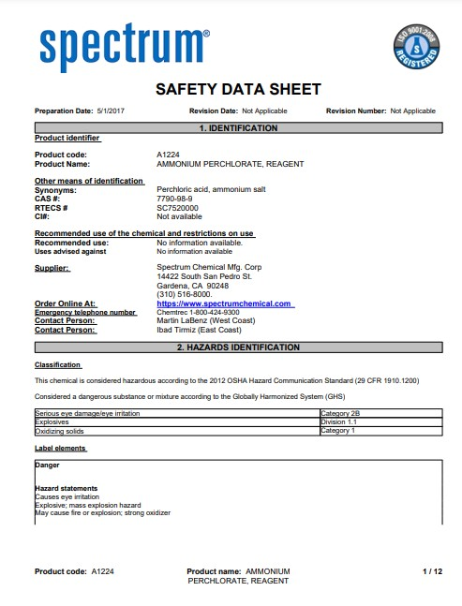
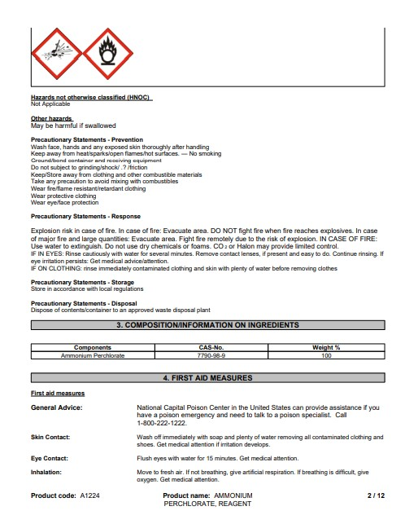
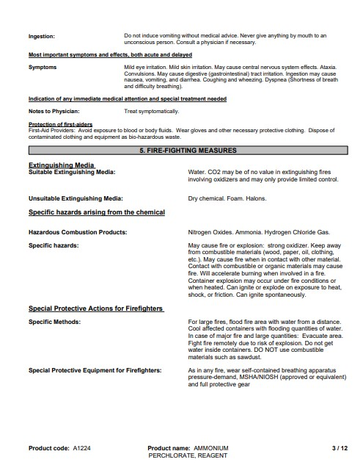
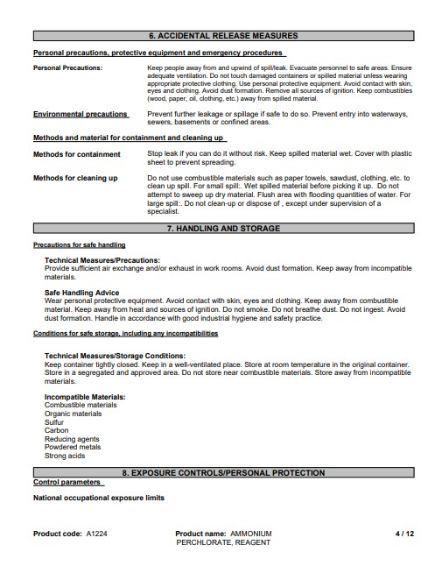
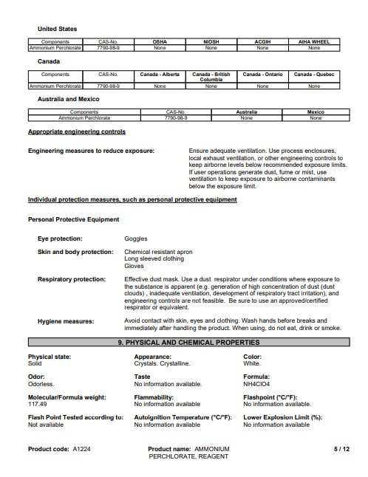
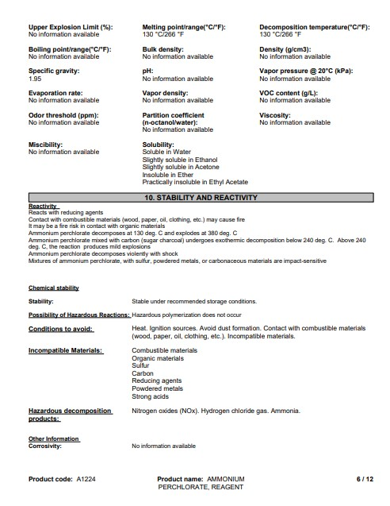
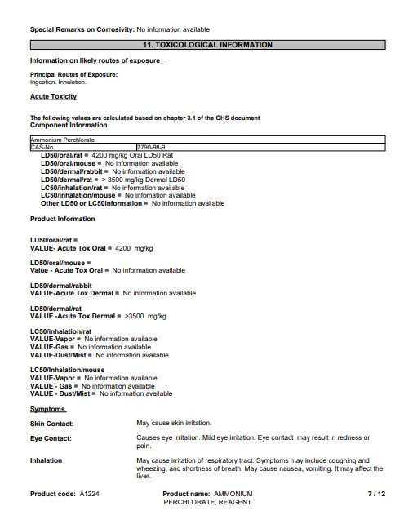
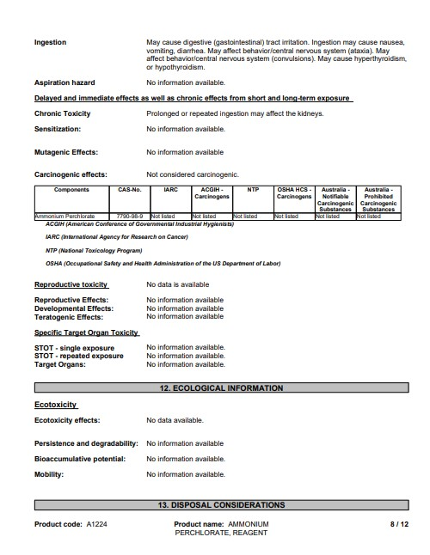
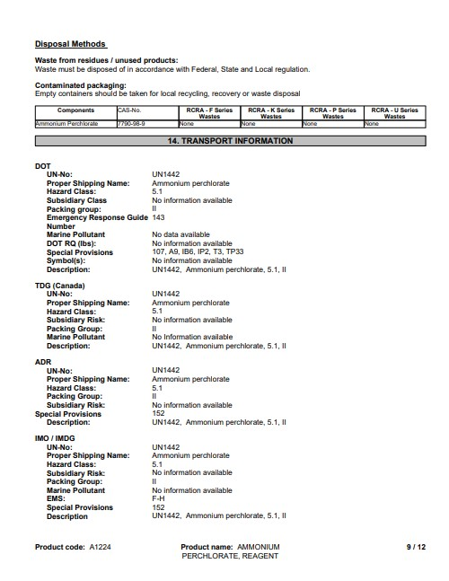
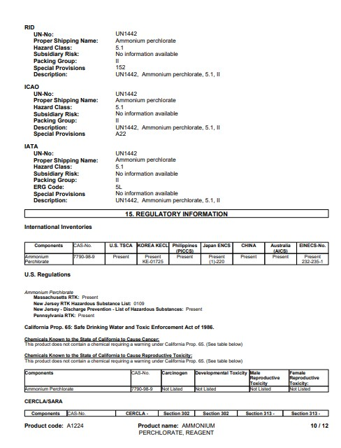
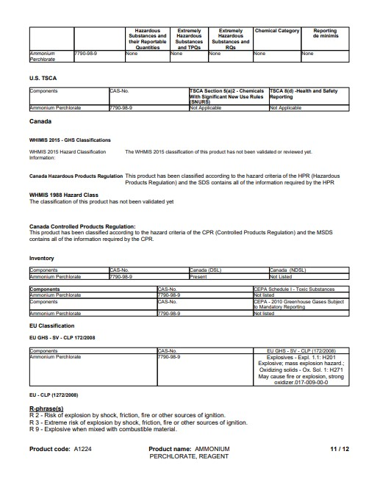
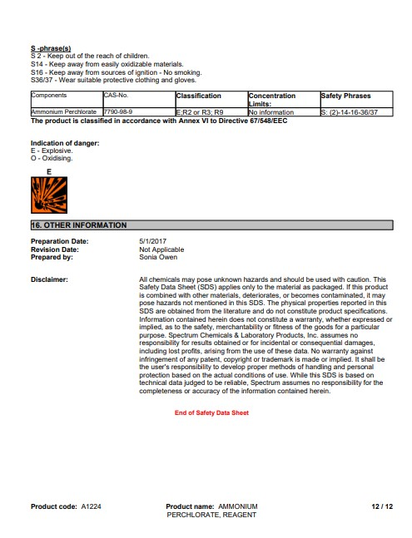

Personnel Safety Briefing
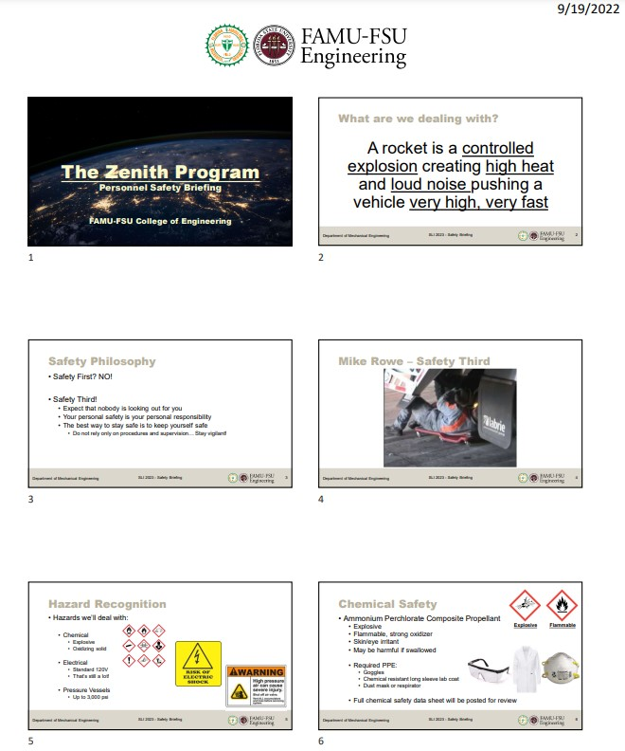
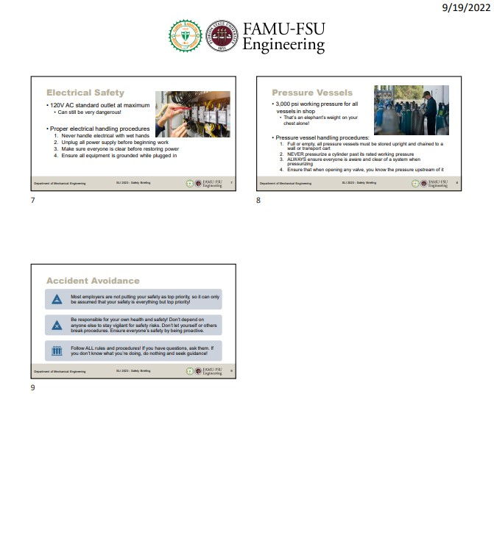

NAR High Power Rocket Safety Code

1. Certification. I will only fly high power rockets or possess high power rocket motors that are within the scope of my user certification and required licensing.
2. Materials. I will use only lightweight materials such as paper, wood, rubber, plastic, fiberglass, or when necessary ductile metal, for the construction of my rocket.
3. Motors. I will use only certified, commercially made rocket motors, and will not tamper with these motors or use them for any purposes except those recommended by the manufacturer. I will not allow smoking, open flames, nor heat sources within 25 feet of these motors.
4. Ignition System. I will launch my rockets with an electrical launch system, and with electrical motor igniters that are installed in the motor only after my rocket is at the launch pad or in a designated prepping area. My launch system will have a safety interlock that is in series with the launch switch that is not installed until my rocket is ready for launch, and will use a launch switch that returns to the “off” position when released. The function of onboard energetics and firing circuits will be inhibited except when my rocket is in the launching position.
5. Misfires. If my rocket does not launch when I press the button of my electrical launch system, I will remove the launcher’s safety interlock or disconnect its battery, and will wait 60 seconds after the last launch attempt before allowing anyone to approach the rocket.
6. Launch Safety. I will use a 5-second countdown before launch. I will ensure that a means is available to warn participants and spectators in the event of a problem. I will ensure that no person is closer to the launch pad than allowed by the accompanying Minimum Distance Table. When arming onboard energetics and firing circuits I will ensure that no person is at the pad except safety personnel and those required for arming and disarming operations. I will check the stability of my rocket before flight and will not fly it if it cannot be determined to be stable. When conducting a simultaneous launch of more than one high power rocket I will observe the additional requirements of NFPA 1127.
7. Launcher. I will launch my rocket from a stable device that provides rigid guidance until the rocket has attained a speed that ensures a stable flight, and that is pointed to within 20 degrees of vertical. If the wind speed exceeds 5 miles per hour I will use a launcher length that permits the rocket to attain a safe velocity before separation from the launcher. I will use a blast deflector to prevent the motor’s exhaust from hitting the ground. I will ensure that dry grass is cleared around each launch pad in accordance with the accompanying Minimum Distance table, and will increase this distance by a factor of 1.5 and clear that area of all combustible material if the rocket motor being launched uses titanium sponge in the propellant.

8. Size. My rocket will not contain any combination of motors that total more than 40,960 N-sec (9208 pound-seconds) of total impulse. My rocket will not weigh more at liftoff than one-third of the certified average thrust of the high power rocket motor(s) intended to be ignited at launch.
9. Flight Safety. I will not launch my rocket at targets, into clouds, near airplanes, nor on trajectories that take it directly over the heads of spectators or beyond the boundaries of the launch site, and will not put any flammable or explosive payload in my rocket. I will not launch my rockets if wind speeds exceed 20 miles per hour. I will comply with Federal Aviation Administration airspace regulations when flying, and will ensure that my rocket will not exceed any applicable altitude limit in effect at that launch site.
10. Launch Site. I will launch my rocket outdoors, in an open area where trees, power lines, occupied buildings, and persons not involved in the launch do not present a hazard, and that is at least as large on its smallest dimension as one-half of the maximum altitude to which rockets are allowed to be flown at that site or 1500 feet, whichever is greater, or 1000 feet for rockets with a combined total impulse of less than 160 N-sec, a total liftoff weight of less than 1500 grams, and a maximum expected altitude of less than 610 meters (2000 feet).
11. Launcher Location. My launcher will be 1500 feet from any occupied building or from any public highway on which traffic flow exceeds 10 vehicles per hour, not including traffic flow related to the launch. It will also be no closer than the appropriate Minimum Personnel Distance from the accompanying table from any boundary of the launch site.
12. Recovery System. I will use a recovery system such as a parachute in my rocket so that all parts of my rocket return safely and undamaged and can be flown again, and I will use only flame-resistant or fireproof recovery system wadding in my rocket.
13. Recovery Safety. I will not attempt to recover my rocket from power lines, tall trees, or other dangerous places, fly it under conditions where it is likely to recover in spectator areas or outside the launch site, nor attempt to catch it as it approaches the ground.

MINIMUM DISTANCE TABLE

Installed Total  Impulse (Newton-  Seconds) | Equivalent High  Power Motor  Type | Minimum  Diameter of  Cleared Area (ft.) | Minimum  Personnel  Distance (ft.) | Minimum Personnel  Distance (Complex  Rocket) (ft.)
0 — 320.00 | H or smaller | 50 | 100 | 200
320.01 — 640.00 | I | 50 | 100 | 200
640.01 — 1,280.00 | J | 50 | 100 | 200
1,280.01 — 2,560.00 | K | 75 | 200 | 300
2,560.01 — 5,120.00 | L | 100 | 300 | 500
5,120.01 —  10,240.00 | M | 125 | 500 | 1000
10,240.01 —  20,480.00 | N | 125 | 1000 | 1500
20,480.01 —  40,960.00 | O | 125 | 1500 | 2000

Note: A Complex rocket is one that is multi-staged or that is propelled by two or more rocket motors
Revision of August 2012

TRA Safety Code for High Power Rocketry

Safety Code for High-Power Rocketry
Tripoli Rocketry Association

This High-Power Rocketry Safety Code is the product of many years of effort on behalf of the hobby by those who care about it and whose prime interest is safety This document sets minimum standards, intended to preserve the hobby in a safe environment. Using this Code as the minimum, it will be your responsibility to regulate your own launches safely for the conditions of each launch site. This Safety Code shall be the standard at all Tripoli Sanctioned Launches.
The Tripoli High-Power Safety Code supplements NFPA 1127 Code for High Power Rocketry with sections that are specific to Tripoli. The foundation of the Tripoli High Power Safety Code is NFPA 1127.
1 General Requirements
1-1 Scope
1-1.1 This code shall set practices for safe operation of High Power rocket launches. It will also address some aspects of safe rocket design, and construction, and limitations of motor power, for use by the certified user for the purposes of education, recreation and sporting use.
1-2 Purpose
1-2.1 The purpose of this code shall be to establish guidelines for reasonably safe operation of rockets at Tripoli Sanctioned Launches.
1-3 Definitions:
For the purposes of this code, the following terms shall be defined as stated in this section. Some of these may be redundant from NFPA 1127.
Insured Flier: A flier that has insurance provided by Tripoli or any rocketry organization that TRA has insurance reciprocity with. At this writing this includes NAR only. Note: some types of TRA membership do not include insurance (e.g. Associate, and Honorary members).
Adult Flier: An Insured Flier that is 18 years old or older.
High Power Rocketry Flier (HPR Flier): An Adult Flier that is certified to fly High Power rockets at their certification level.
Model Rocket Fliers (MR Flier): An Insured Flier who is not certified to fly High Power rockets.
Invited Guests of Fliers (Guests): A person who is not a member of a recognized rocketry organization/not covered by insurance.
Launch Director (LD): A Level 2 or Level 3 flier who has overall administrative responsibility for the launch.
Participants. Persons that are either:
- HPR Fliers.
- Model Rocket Fliers.
- Invited Guests of Fliers.

Range Safety Officer (RSO). A Level 2 or Level 3 flier who has the authority to ensure the safe operation of the range.
Sanctioned Launch. A sanctioned launch is a Tripoli Insured Launch. Any Sanctioned Launch shall meet ALL of the following requirements:
- Responsible person of launch shall be member of Tripoli in good standing.
- Follows the appropriate Tripoli Safety Code.
- All AHJ (e.g. FAA waiver) requirements/regulations met and any required permits secured.
- Landowner permission has been formally obtained.
Shall. Indicates a mandatory requirement.
Should. Indicates a recommendation or that which is advised but not required.
Spectator. A nonparticipant whose primary purpose is to view a rocket launch.
Spectator Area. An area designated where spectators view a rocket launch.
Tripoli Mentoring Program (TMP). Program to permit Tripoli Junior members to participate in supervised high power rocketry activities.
Tripoli (TRA). Tripoli Rocketry Association, Inc.

Requirements for High Power Rocket Operation
- Operating Clearances. A person shall fly a high-power rocket only in compliance with:
        - This code and NFPA 1127;
        - Federal Aviation Administration Regulations, Part 101 (Section 307,72 Statute
749, Title 49 United States Code, Section 1348, “Airspace Control and Facilities,” Federal Aviation Act of 1958);
        - Other applicable federal, state, and local laws, rules, regulations, statutes, and ordinances.
        - Landowner permission.

- Legality
  - The Tripoli Rocketry Association does not claim Rocketry to be legal in every municipality, state or political jurisdiction.
- Insurance
  - Tripoli rocketry activities are only insured when the provisions of this code are followed.
  - No Tripoli member shall misrepresent to any authority or landowner that Tripoli activities are insured .
- Participation,
Participation Note: The information provided below identifies the minimum requirements for individuals that participate/attend Tripoli Sanctioned Launches.
A Launch Director has the authority to impose more stringent rules.

Participation and Access at Tripoli Launches shall be limited to the following:
  - HPR Fliers may access and conduct flights from the High-Power Launch Area and/or Model Rocket Launch Area.
  - Non-Tripoli Members age 18 and over who are students of an accredited educational institution may participate in joint projects with Tripoli members.
    - These individuals are only allowed in the High-Power Launch Area while supervised by an HPR Flier.
    - They are only allowed in the Model Rocket Launch Area while supervised by an Adult Flier.
    - The maximum number of nonmember participants shall not exceed five (5) per supervising flier.
  - Tripoli Junior Members who have successfully completed the TMP may access and conduct flights from the High-Power Launch Area while under the direct supervision of a Tripoli HPR Flier in accordance with the rules of the TMP.
    - The maximum number of TMP participants shall not exceed five (5) per supervising flier.
  - Children younger than 18 years of age may conduct flights from the Model Rocket Launch Area under the direction of an Adult Flier.
  - An invited guest may be permitted in the Model Rocket Launch Area and preparation areas upon approval of the Range Safety Officer. Invited guests are not permitted in the High-Power Launch Area.
  - Spectators are only permitted in the spectator area(s); they are not permitted in the High Power Launch Area or Model Rocket Launch Area.

- Tripoli Launch Operations

  - Insured Fliers shall provide proof of membership and certification status upon request.
  - All flights and static motor tests conducted by a member shall be within the member’s certification level, with the exception of permitted certification attempts.
  - When three or more rockets are to be launched simultaneously, the minimum spectator and participant distance shall be the value set forth in the Safe Distance Table for a complex rocket with the same total installed impulse, but not more than 610 m (2000 ft), or 1.5 times the highest altitude expected to be reached by any of the rockets, whichever is less.
  - No range activity shall be conducted when a thunderstorm has been reported within ten miles, or less, of the launch site or if thunder or lightning is present.
  - No rockets shall be launched when the surface winds exceed 20 MPH (32 KPH)
  - The minimum safe standoff distance from the spectator area for the Model Rocket Launch Area shall be 50 feet (15 meters).
  - All flights planned to exceed 50,000ft AGL shall be submitted to the Class 3 review Committee for approval.
  - Launch Director and Range Safety Officer
    - The LD or RSO may refuse to allow the launch, or static testing, of any rocket or rocket motor that they deem to be unsafe.
    - The LD or RSO may require greater Safe Standoff Distances than specified in this code.
  - Recovery
    - A rocket shall be launched only if it contains a recovery system that is designed to return all parts of the rocket to the ground safely.
    - Rockets that employ passive recovery (e.g. tumble recovery, aero-braking) need not employ an active recovery system.

Minimum spectator and Participant Safe Distance Standoffs

Total Installed Impulse, N-s |  | Motor type | Non-Complex |  | Complex
 |  |  | feet | meters | feet | meters
0.01 to | 160 | High Power  G or smaller | 100 | 30 | 200 | 61
160.01 | 320 | H | 100 | 30 | 200 | 61
320.01 | 640 | I | 100 | 30 | 200 | 61
640.01 | 1280 | J | 100 | 30 | 200 | 61
1,280.01 to | 2,560 | K | 200 | 61 | 300 | 91
2,560.01 to | 5,120 | L | 300 | 92 | 500 | 152
5,120.01 to | 10,240 | M | 500 | 153 | 1,000 | 305
10,240.01 to | 20,480 | N | 1,000 | 305 | 1,500 | 457
20,480.01 to | 40,960 | O | 1,500 | 457 | 2,000 | 610

- Referenced Publications
The following documents or portions thereof are referenced within this code. The edition indicated for each reference is the current edition as of the date of the NFPA issuance of this document.

  - NFPA Publications.
National Fire Protection Association, 1 Batterymarch Park, P.O. Box 9101, Quincy, MA 02269-9101
NFPA 1122, Code for Model Rocketry.
NFPA 1125, Code for the Manufacture of Model Rocket Motors.
NFPA 1127, Code for High Power Rocketry

  - Government Publications.
Superintendent of Documents, U.S. Government Printing Office, Washington DC 20402.
Federal Aviation Administration Regulations, from the Code of Federal Regulations. Federal

Hazardous Substances Act, from the United States Code (re. Airspace Control)

  - TRA Publications.
Tripoli Rocketry Association, Inc., P. O. Box 87, Bellevue NE 68005.
Articles of Incorporation and Bylaws

Tripoli Motor Testing Committee (TMT), Testing Policies

Appendix A - Additional Tripoli Rulings
A-1 NFPA 1127 was adopted by the Tripoli Board of Directors as the Tripoli Safety Code. (Tripoli Report, April 1994, Tripoli Board Minutes, New Orleans, 21 January 1994, Motion
13.)
A-2 All Tripoli members who participate in Association activities shall follow the Tripoli Certification Standards.
A-3 Any Board action(s) with regard to safety, made previous to or after publication of this document, shall be a part of the Tripoli Safety Code.
A-4 Increased descent rates for rocket activities conducted at the Black Rock Desert venue are acceptable if needed to insure a controlled descent to remain inside the FAA approved Dispersion Area.
A-5 A rocket motor shall not be ignited by using:
- A switch that uses mercury.
- “Pressure roller” switches
This edition, and all other editions, of the High-Power Rocketry Safety Code is Copyright ©2017 by the Tripoli Rocketry Association, Inc. All rights reserved.
Reproduction in whole or in part without written permission is prohibited.

Budget Sheet

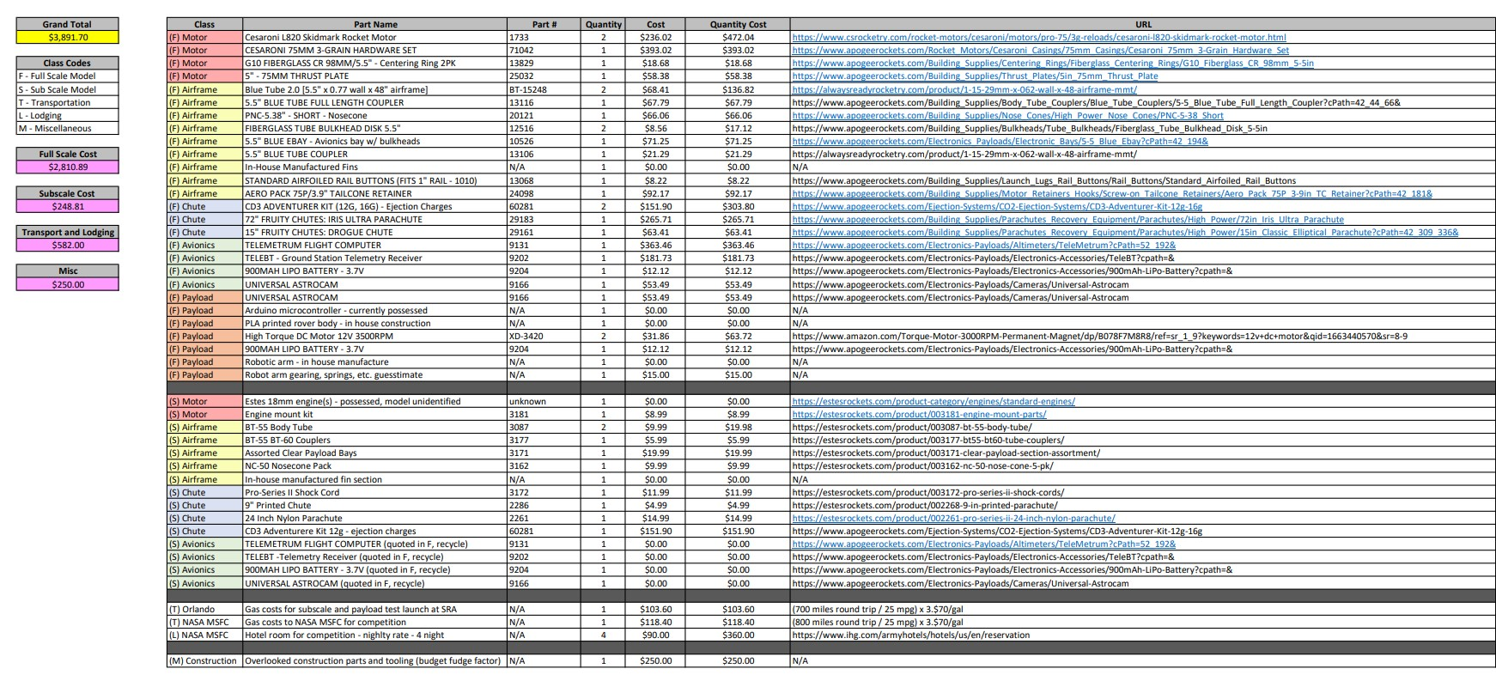

Work Breakdown Structure

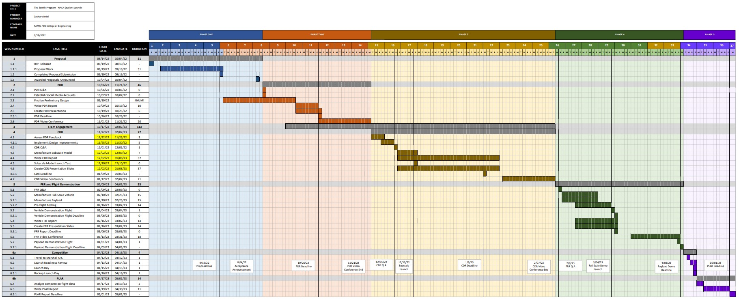

OSHA Laboratory Safety Guidance
Begins on following page.

Laboratory Safety
Guidance
OSHA

3404-11
R
2011

Occupational Safety and Health Act of 1970
“To assure safe and healthful working conditions for working men and women; by authorizing enforcement of the standards developed under the Act; by assisting and encouraging the States in their efforts to assure safe and healthful working conditions; by providing for research, information, education, and training in the field of occupational safety and health.”
This publication provides a general overview of a particular standards-related topic. This publication does not alter or determine compliance responsibilities which are set forth in OSHA standards, and the Occupational Safety and Health Act of 1970. Moreover, because interpretations and enforcement policy may change over time, for additional guidance on OSHA compliance requirements, the reader should consult current administrative interpretations and decisions by the Occupational Safety and Health Review Commission and the courts.
Material contained in this publication is in the public domain and may be reproduced, fully or partially, without permission. Source credit is requested but not required.
This information will be made available to sensory- impaired individuals upon request. Voice phone: (202) 693-1999; teletypewriter (TTY) number: 1-877889-5627.

Laboratory Safety Guidance
Occupational Safety and Health Administration
U.S. Department of Labor
OSHA 3404-11R
2011

This guidance document is not a standard or regulation, and it creates no new legal obligations. It contains recommendations as well as descriptions of mandatory safety and health standards. The recommendations are advisory in nature, informational in content, and are intended to assist employers in providing a safe and healthful workplace. The Occupational Safety and Health Act requires employers to comply with safety and health standards and regulations promulgated by OSHA or by a state with an OSHAapproved state plan. In addition, the Act’s General Duty Clause, Section 5(a)(1), requires employers to provide their employees with a workplace free from recognized hazards likely to cause death or serious physical harm.

Contents
Introduction 4
OSHA Standards 5
Hierarchy of Controls 8
Chemical Hazards 9
Laboratory Standard 9
Hazard Communication Standard 13
Specific Chemical Hazards 13
Air Contaminants Standard 13
Formaldehyde Standard 14
Latex 15
Chemical Fume Hoods 15
Biological Hazards 15
Biological Agents (other than Bloodborne
Pathogens) and Biological Toxins 15
Bloodborne Pathogens 17
Research Animals 19
Biological Safety Cabinets (BSCs) 21
Physical Hazards and Others 21
Ergonomic Hazards 21
Ionizing Radiation 21
Non-ionizing Radiation 22
Noise 23
Safety Hazards 24
Autoclaves and Sterilizers 24
Centrifuges 24
Compressed Gases 24 Cryogens and Dry Ice 25
Electrical 25
Fire 26
Lockout/Tagout 27
Trips, Slips and Falls 28
References 29
Appendices 30
Additional OSHA Information 30
Other Governmental and Non-governmental
Agencies Involved in Laboratory Safety 40
Most Common Zoonotic Diseases
in Animal Workers 45
Complaints, Emergencies
and Further Assistance 46 OSHA Regional Offices 48

Introduction
More than 500,000 workers are employed in laboratories in the U.S. The laboratory environment can be a hazardous place to work. Laboratory workers are exposed to numerous potential hazards including chemical, biological, physical and radioactive hazards, as well as musculoskeletal stresses. Laboratory safety is governed by numerous local, state and federal regulations. Over the years, OSHA has promulgated rules and published guidance to make laboratories increasingly safe for personnel. This document is intended for supervisors, principal investigators and managers who have the primary responsibility for maintaining laboratories under their supervision as safe, healthy places to work and for ensuring that applicable health, safety and environmental regulations are followed. Worker guidance in the form of Fact Sheets and QuickCards™ is also provided for certain hazards that may be encountered in laboratories. There are several primary OSHA standards that apply to laboratories and these are discussed below. There are also other OSHA standards that apply to various aspects of laboratory activities and these are referred to in this document.
The Occupational Exposure to Hazardous Chemicals in Laboratories standard (29 CFR 1910.1450) was created specifically for non-production laboratories. Additional OSHA standards provide rules that protect workers, including those that who in laboratories, from chemical hazards as well as biological, physical and safety hazards. For those hazards that are not covered by a specific OSHA standard, OSHA often provides guidance on protecting workers from these hazards. This document is designed to make employers aware of the OSHA standards as well as OSHA guidance that is available to protect workers from the diverse hazards encountered in laboratories. The extent of detail on specific hazards provided in this document is dependent on the nature of each hazard and its importance in a laboratory setting. In addition to information on OSHA standards and guidance that deal with laboratory hazards, appendices are provided with information on other governmental and non-governmental agencies that deal with various aspects of laboratory safety.
This Laboratory Safety Guidance booklet deals specifically with laboratories within the jurisdiction of Federal OSHA. There are twenty-five states and two U.S. Territories (Puerto Rico and the Virgin Islands) that have their own OSHA-approved occupational safety and health standards, which may be different from federal standards, but must be at least “as effective as” the federal standards. Contact your local or state OSHA office for further information. More information on OSHA-approved state plans is available at: www.osha.gov/dcsp/osp/index.html.

OSHA Standards
Section 5(a)(1) of the Occupational Safety and
Health Act of 1970 (OSH Act), the General Duty Clause, requires that employers “shall furnish to each of his employees employment and a place of employment which are free from recognized hazards that are causing or likely to cause death or serious physical harm to his employees.” Therefore, even if an OSHA standard has not been promulgated that deals with a specific hazard or hazardous operation, protection of workers from all hazards or hazardous operations may be enforceable under section 5(a)(1) of the OSH Act. For example, best practices that are issued by non-regulatory organizations such as the National Institute for Occupational Safety and Health (NIOSH), the Centers for Disease Control and Prevention (CDC), the National Research Council (NRC), and the National Institutes of Health (NIH), can be enforceable under section 5(a)(1).
The principal OSHA standards that apply to all non-production laboratories are listed below. Although this is not a comprehensive list, it includes standards that cover the major hazards that workers are most likely to encounter in their daily tasks. Employers must be fully aware of these standards and must implement all aspects of the standards that apply to specific laboratory work conditions in their facilities.
The Occupational Exposure to Hazardous Chemicals in Laboratories standard (29 CFR 1910.1450), commonly referred to as the Laboratory standard, requires that the employer designate a Chemical Hygiene Officer and have a written Chemical Hygiene Plan (CHP), and actively verify that it remains effective. The CHP must include provisions for worker training, chemical exposure monitoring where appropriate, medical consultation when exposure occurs, criteria for the use of personal protective equipment (Personal Protective Equipment) and engineering controls, special precautions for particularly hazardous substances, and a requirement for a Chemical Hygiene Officer responsible for implementation of the CHP. The CHP must be tailored to reflect the specific chemical hazards present in the laboratory where it is to be used. Laboratory personnel must receive training regarding the Laboratory standard, the CHP, and other laboratory safety practices, including exposure detection, physical and health hazards associated with chemicals, and protective measures.
The Hazard Communication standard (29 CFR 1910.1200), sometimes called the HazCom standard, is a set of requirements first issued in 1983 by OSHA. The standard requires evaluating the potential hazards of chemicals, and communicating information concerning those hazards and appropriate protective measures to employees. The standard includes provisions for: developing and maintaining a written hazard communication program for the workplace, including lists of hazardous chemicals present; labeling of containers of chemicals in the workplace, as well as of containers of chemicals being shipped to other workplaces; preparation and distribution of material safety data sheets (MSDSs) to workers and downstream employers; and development and implementation of worker training programs regarding hazards of chemicals and protective measures. This OSHA standard requires manufacturers and importers of hazardous chemicals to provide material safety data sheets to users of the chemicals describing potential hazards and other information. They must also attach hazard warning labels to containers of the chemicals. Employers must make MSDSs available to workers. They must also train their workers in the hazards caused by the chemicals workers are exposed to and the appropriate protective measures that must be used when handling the chemicals.
The Bloodborne Pathogens standard (29 CFR
1910.1030), including changes mandated by the Needlestick Safety and Prevention Act of 2001, re-quires employers to protect workers from infection with human bloodborne pathogens in the workplace. The standard covers all workers with “reasonably anticipated” exposure to blood or other potentially infectious materials (OPIM). It requires that information and training be provided before the worker begins work that may involve occupational exposure to bloodborne pathogens, annually thereafter, and before a worker is offered hepatitis B vaccination. The Bloodborne Pathogens standard also requires advance information and training for all workers in research laboratories who handle human immunodeficiency virus (HIV) or hepatitis B virus (HBV). The standard was issued as a performance standard, which means that the employer must develop a written exposure control plan (ECP) to provide a safe and healthy work environment, but is allowed some flexibility in accomplishing this goal. Among other things, the ECP requires employers to make an exposure determination, establish procedures for evaluating incidents, and determine a schedule for implementing the standard’s requirements, including engineering and work practice controls. The standard also requires employers to provide and pay for appropriate Personal Protective Equipment for workers with occupational exposures. Although this standard only applies to bloodborne pathogens, the protective measures in this standard (e.g., ECP, engineering and work practice controls, administrative controls, Personal Protective Equipment, housekeeping, training, post-exposure medical follow-up) are the same measures for effectively controlling exposure to other biological agents.
The Personal Protective Equipment (Personal Protective Equipment) standard (29 CFR 1910.132) requires that employers provide and pay for Personal Protective Equipment and ensure that it is used wherever “hazards of processes or environment, chemical hazards, radiological hazards, or mechanical irritants are encountered in a manner capable of causing injury or impairment in the function of any part of the body through absorption, inhalation or physical contact.” [29 CFR 1910.132(a) and 1910.132(h)]. In order to determine whether and what Personal Protective Equipment is needed, the employer must “assess the workplace to determine if hazards are present, or are likely to be present, which necessitate the use of [Personal Protective Equipment],” 29 CFR 1910.132(d)(1). Based on that assessment, the employer must select appropriate Personal Protective Equipment (e.g., protection for eyes, face, head, extremities; protective clothing; respiratory protection; shields and barriers) that will protect the affected worker from the hazard, 29 CFR 1910.132 (d)(1)(i), communicate selection decisions to each affected worker, 29 CFR 1910.132 (d)(1)(ii), and select Personal Protective Equipment that properly fits each affected employee, 29 CFR 1910.132(d)(1)(iii). Employers must provide training for workers who are required to use Personal Protective Equipment that addresses when and what Personal Protective Equipment is necessary, how to wear and care for Personal Protective Equipment properly, and the limitations of Personal Protective Equipment, 29 CFR 1910.132(f).
The Eye and Face Protection standard (29 CFR 1910.133) requires employers to ensure that each affected worker uses appropriate eye or face protection when exposed to eye or face hazards from flying particles, molten metal, liquid chemicals, acids or caustic liquids, chemical gases or vapors, or potentially injurious light radiation, 29 CFR 1910.133(a).
The Respiratory Protection standard (29 CFR 1910.134) requires that a respirator be provided to each worker when such equipment is necessary to protect the health of such individual. The employer must provide respirators that are appropriate and suitable for the purpose intended, as described in 29 CFR 1910.134(d)(1). The employer is responsible for establishing and maintaining a respiratory protection program, as required by 29 CFR 1910.134(c), that includes, but is not limited to, the following: selection of respirators for use in the workplace; medical evaluations of workers required to use respirators; fit testing for tight-fitting respirators; proper use of respirators during routine and emergency situations; procedures and schedules for cleaning, disinfecting, storing, inspecting, repairing and discarding of respirators; procedures to ensure adequate air quality, quantity, and flow of breathing air for atmosphere-supplying respirators; training of workers in respiratory hazards that they may be exposed to during routine and emergency situations; training of workers in the proper donning and doffing of respirators, and any limitations on their use and maintenance; and regular evaluation of the effectiveness of the program.
The Hand Protection standard (29 CFR 1910.138), requires employers to select and ensure that workers use appropriate hand protection when their hands are exposed to hazards such as those from skin absorption of harmful substances; severe cuts or lacerations; severe abrasions; punctures; chemical burns; thermal burns; and harmful temperature extremes, 29 CFR 1910.138(a). Further, employers must base the selection of the appropriate hand protection on an evaluation of the performance characteristics of the hand protection relative to the task(s) to be performed, conditions present, duration of use, and the hazards and potential hazards identified, 29 CFR 1910.138(b).
The Control of Hazardous Energy standard (29 CFR 1910.147), often called the “Lockout/Tagout” standard, establishes basic requirements for locking and/or tagging out equipment while installation, maintenance, testing, repair, or construction operations are in progress. The primary purpose of the standard is to protect workers from the unexpected energization or startup of machines or equipment, or release of stored energy. The procedures apply to the shutdown of all potential energy sources associated with machines or equipment, including pressures, flows of fluids and gases, electrical power, and radiation.
In addition to the standards listed above, other
OSHA standards that pertain to electrical safety
(29 CFR 1910 Subpart S-Electrical); fire safety (Portable Fire Extinguishers standard, 29 CFR
1910.157); and slips, trips and falls (29 CFR 1910
Subpart D – Walking-Working Surfaces, Subpart
E -Means of Egress, and Subpart J - General
Environmental Controls) are discussed at pages 25-28. These standards pertain to general industry, as well as laboratories. When laboratory workers are using large analyzers and other equipment, their potential exposure to electrical hazards associated with this equipment must be assessed by employers and appropriate precautions taken. Similarly, worker exposure to wet floors or spills and clutter can lead to slips/trips/falls and other possible injuries and employers must assure that these hazards are minimized. While large laboratory fires are rare, there is the potential for small bench-top fires, especially in laboratories using flammable solvents. It is the responsibility of employers to implement appropriate protective measures to assure the safety of workers.

Hierarchy of Controls
Occupational safety and health professionals use a framework called the “hierarchy of controls” to select ways of dealing with workplace hazards. The hierarchy of controls prioritizes intervention strategies based on the premise that the best way to control a hazard is to systematically remove it from the workplace, rather than relying on workers to reduce their exposure. The types of measures that may be used to protect laboratory workers, prioritized from the most effective to least effective, are:
- engineering controls;
- administrative controls;
- work practices; and
- personal protective equipment (Personal Protective Equipment).
Most employers use a combination of control methods. Employers must evaluate their particular workplace to develop a plan for protecting their workers that may combine both immediate actions as well as longer term solutions. A description of each type of control for non-production laboratories follows.
Engineering controls are those that involve making changes to the work environment to reduce work-related hazards. These types of controls are preferred over all others because they make permanent changes that reduce exposure to hazards and do not rely on worker behavior. By reducing a hazard in the workplace, engineering controls can be the most cost-effective solutions for employers to implement.
Examples include:
- Chemical Fume Hoods; and
- Biological Safety Cabinets (BSCs).
Administrative controls are those that modify workers’ work schedules and tasks in ways that minimize their exposure to workplace hazards.
Examples include:
- Developing a Chemical Hygiene Plan; and
- Developing Standard Operating Procedures for chemical handling.
Work practices are procedures for safe and proper work that are used to reduce the duration, frequency or intensity of exposure to a hazard. When defining safe work practice controls, it is a good idea for the employer to ask workers for their suggestions, since they have firsthand experience with the tasks as actually performed. These controls need to be understood and followed by managers, supervisors and workers.
Examples include:
- No mouth pipetting; and
- Chemical substitution where feasible (e.g., selecting a less hazardous chemical for a specific procedure).
Personal Protective Equipment (Personal Protective Equipment) is protective gear needed to keep workers safe while performing their jobs. Examples of Personal Protective Equipment include respirators (for example, N95), face shields, goggles and disposable gloves. While engineering and administrative controls and proper work practices are considered to be more effective in minimizing exposure to many workplace hazards, the use of Personal Protective Equipment is also very important in laboratory settings.
It is important that Personal Protective Equipment be:
- Selected based upon the hazard to the worker;
- Properly fitted and in some cases periodically refitted (e.g., respirators);
- Conscientiously and properly worn;
- Regularly maintained and replaced in accord with the manufacturer’s specifications;
- Properly removed and disposed of to avoid contamination of self, others or the environment; and
- If reusable, properly removed, cleaned, disinfected and stored.
The following sections of this document are organized based upon classes of hazards, i.e., chemical, biological, physical, safety and other hazards. The organization of these sections and/or subsections may differ somewhat. For instance, OSHA’s Laboratory standard is described in greater detail than any other standard in this document. This is because this is the only standard that is specific to laboratories (i.e., non-production laboratories). In all other sections, only those specific aspects of various standards that are considered most relevant to non-production laboratories are discussed. In sections of this document where there are no specific OSHA standards that apply, guidance in the form of Fact Sheets or QuickCards™ may be provided.

Chemical Hazards
Hazardous chemicals present physical and/or health threats to workers in clinical, industrial, and academic laboratories. Laboratory chemicals include cancer-causing agents (carcinogens), toxins (e.g., those affecting the liver, kidney, and nervous system), irritants, corrosives, sensitizers, as well as agents that act on the blood system or damage the lungs, skin, eyes, or mucous membranes. OSHA rules regulate exposures to approximately 400 substances.
Laboratory Standard

(29 CFR 1910.1450)
In 1990, OSHA issued the Occupational Exposure to Hazardous Chemicals in Laboratories standard (29 CFR 1910.1450). Commonly known as the Laboratory standard, it was developed to address workplaces where relatively small quantities of hazardous chemicals are used on a non-production basis. However, not all laboratories are covered by the Laboratory standard. For example, most quality control laboratories are not covered under the standard. These laboratories are usually adjuncts of production operations which typically perform repetitive procedures for the purpose of assuring reliability of a product or a process. On the other hand, laboratories that conduct research and development and related analytical work are subject to the requirements of the Laboratory standard, regardless of whether or not they are used only to support manufacturing.
The purpose of the Laboratory standard is to ensure that workers in non-production laboratories are informed about the hazards of chemicals in their workplace and are protected from chemical exposures exceeding allowable levels [i.e., OSHA permissible exposure limits (PELs)] as specified in Table Z of the Air Contaminants standard (29 CFR 1910.1000) and as specified in other substance-specific health standards. The Laboratory standard achieves this protection by establishing safe work practices in laboratories to implement a Chemical Hygiene Plan (CHP).

Scope and Application
The Laboratory standard applies to all individuals engaged in laboratory use of hazardous chemicals. Work with hazardous chemicals outside of laboratories is covered by the Hazard Communication standard (29 CFR 1910.1200). Laboratory uses of chemicals which provide no potential for exposure (e.g., chemically impregnated test media or prepared kits for pregnancy testing) are not covered by the Laboratory standard.
Formaldehyde is one of the most commonly used hazardous chemicals in laboratories. The OSHA Formaldehyde standard (29 CFR 1910.1048) specifically deals with protecting workers from the hazards associated with exposure to this chemical. It should be noted that the scope of the Formaldehyde standard is not affected in most cases by the Laboratory standard. The Laboratory standard specifically does not apply to formaldehyde use in histology, pathology and human or animal anatomy laboratories; however, if formaldehyde is used in other types of laboratories which are covered by the Laboratory standard, the employer must comply with 29 CFR 1910.1450.

Program Description
The Laboratory standard consists of five major elements:
- Hazard identification;
- Chemical Hygiene Plan;
- Information and training;
- Exposure monitoring; and
- Medical consultation and examinations.
Each laboratory covered by the Laboratory standard must appoint a Chemical Hygiene Officer (CHO) to develop and implement a Chemical Hygiene Plan. The CHO is responsible for duties such as monitoring processes, procuring chemicals, helping project directors upgrade facilities, and advising administrators on improved chemical hygiene policies and practices. A worker designated as the CHO must be qualified, by training or experience, to provide technical guidance in developing and implementing the provisions of the CHP.

Hazard Identification
Each laboratory must identify which hazardous chemicals will be encountered by its workers. All containers for chemicals must be clearly labeled. An employer must ensure that workers do not use, store, or allow any other person to use or store, any hazardous substance in his or her laboratory if the container does not meet the labeling requirements outlined in the Hazard Communication standard,
29 CFR 1910.1200(f)(4). Labels on chemical con- tainers must not be removed or defaced.
Material Safety Data Sheets (MSDSs) for chemicals received by the laboratory must be supplied by the manufacturer, distributor, or importer and must be maintained and readily accessible to laboratory workers. MSDSs are written or printed materials concerning a hazardous chemical. Employers must have an MSDS in the workplace for each hazardous chemical in use.
MSDS sheets must contain:
- Name of the chemical;
- Manufacturer’s information;
- Hazardous ingredients/identity information;
- Physical/chemical characteristics;
- Fire and explosion hazard data;
- Reactivity data;
- Health hazard data;
- Precautions for safe handling and use; and
- Control measures.
The United States is participating in the Global
Harmonization System of Classifying and Labeling Chemicals (GHS) process and is planning to adopt the GHS in its Hazard Communication standard. The GHS process is designed to improve comprehensibility, and thus the effectiveness of the Hazard Communication standard (HCS), and help to further reduce illnesses and injuries. GHS is a system that defines and classifies the hazards of chemical products, and communicates health and safety information on labels and material safety data sheets (called Safety Data Sheets, or SDSs, in the GHS). The most significant changes to the Hazard Communication standard will include changing terminology: “hazard determination” to “hazard classification” (along with related terms) and “material safety data sheet” to “safety data sheet.” The goal is that the same set of rules for classifying hazards, and the same format and content for labels and safety data sheets (SDS) will be adopted and used around the world. An international team of hazard communication experts developed GHS.
The biggest visible impact of the GHS is the appearance of and information required for labels and SDSs. Labels will require signal words, pictograms, precautionary statements and appropriate hazard statements. The GHS system covers all hazardous chemicals and may be adopted to cover chemicals in the workplace, transport, consumer products,
and pesticides. SDSs will follow a new 16-section format, containing requirements similar to those identified in the American National Standards Institute (ANSI) Z400 and International Organization for Standardization (ISafety Officer) 11014 standards. Information on GHS classification, labels and SDSs is available at: http://www.unece.org/ trans/danger/ publi/ghs/ghs_welcome_e.html.

Chemical Hygiene Plan (CHP)
The purpose of the CHP is to provide guidelines for prudent practices and procedures for the use of chemicals in the laboratory. The Laboratory standard requires that the CHP set forth procedures, equipment, Personal Protective Equipment and work practices capable of protecting workers from the health hazards presented by chemicals used in the laboratory.
The following information must be included in each CHP:
Standard Operating Procedures (Safety OfficerPs): Prudent laboratory practices which must be followed when working with chemicals in a laboratory. These include general and laboratory-specific procedures for work with hazardous chemicals.

Criteria for Exposure Control Measures: Criteria used by the employer to determine and implement control measures to reduce worker exposure to hazardous chemicals including engineering controls, the use of Personal Protective Equipment and hygiene practices.
Adequacy and Proper Functioning of Fume Hoods and other Protective Equipment: Specific measures that must be taken to ensure proper and adequate performance of protective equipment, such as fume hoods.
Information and Training: The employer must provide information and training required to ensure that workers are apprised of the hazards of chemicals in their work areas and related information.
Requirement of Prior Approval of Laboratory Procedures: The circumstances under which certain laboratory procedures or activities require approval from the employer or employer’s designee before work is initiated.
Medical Consultations and Examinations: Provisions for medical consultation and examination when exposure to a hazardous chemical has or may have taken place.
Chemical Hygiene Officer Designation: Identification of the laboratory CHO and outline of his or her role and responsibilities; and, where appropriate, establishment of a Chemical Hygiene Committee.
Particularly Hazardous Substances: Outlines additional worker protections for work with particularly hazardous substances. These include select carcinogens, reproductive toxins, and substances which have a high degree of acute toxicity.

Information and Training
Laboratory workers must be provided with information and training relevant to the hazards of the chemicals present in their laboratory. The training must be provided at the time of initial assignment to a laboratory and prior to assignments involving new exposure situations.
The employer must inform workers about the following:
- The content of the OSHA Laboratory standard and its appendices (the full text must be made available);
- The location and availability of the Chemical Hygiene Plan;
- Permissible exposure limits (PELs) for OSHAregulated substances, or recommended exposure levels for other hazardous chemicals where there is no applicable standard;
- Signs and symptoms associated with exposure to hazardous chemicals in the laboratory; and
- The location and availability of reference materials on the hazards, safe handling, storage and disposal of hazardous chemicals in the laboratory, including, but not limited to, MSDSs.
Training must include the following:
- Methods and observations used to detect the presence or release of a hazardous chemical. These may include employer monitoring, continuous monitoring devices, and familiarity with the appearance and odor of the chemicals;
- The physical and health hazards of chemicals in the laboratory work area;
- The measures that workers can take to protect themselves from these hazards, including protective equipment, appropriate work practices, and emergency procedures;
- Applicable details of the employer’s written Chemical Hygiene Plan;
- Retraining, if necessary.

Exposure Determination
OSHA has established permissible exposure limits (PELs), as specified in 29 CFR 1910, subpart Z, for hundreds of chemical substances. A PEL is the chemical-specific concentration in inhaled air that is intended to represent what the average, healthy worker may be exposed to daily for a lifetime of work without significant adverse health effects. The employer must ensure that workers’ exposures to OSHA-regulated substances do not exceed the PEL. However, most of the OSHA PELs were adopted soon after the Agency was first created in 1970 and were based upon scientific studies available at that time. Since science has continued to move forward, in some cases, there may be health data that suggests a hazard to workers below the levels permitted by the OSHA PELs. Other agencies and organizations have developed and updated recommended occupational exposure limits (OELs) for chemicals regulated by OSHA, as well as other chemicals not currently regulated by OSHA. Employers should consult other OELs, in addition to the OSHA PEL, to make a fully informed decision about the potential health risks to workers associated with chemical exposures. The American Conference of Governmental Industrial Hygienists (ACGIH), the American Industrial Hygiene Association (AIHA), the National Institute for Occupational Safety and Health (NIOSH), as well as some chemical manufacturers have established OELs to assess safe exposure limits for various chemicals.
Employers must conduct exposure monitoring, through air sampling, if there is reason to believe that workers may be exposed to chemicals above the action level or, in the absence of an action level, the PEL. Periodic exposure monitoring should be conducted in accord with the provisions of the relevant standard. The employer should notify workers of the results of any monitoring within 15 working days of receiving the results. Some OSHA chemical standards have specific provisions regarding exposure monitoring and worker notification. Employers should consult relevant standards to see if these provisions apply to their workplace.

Medical Consultations and Examinations
Employers must do the following:
- Provide all exposed workers with an opportunity to receive medical attention by a licensed physician, including any follow-up examinations which the examining physician determines to be necessary.
- Provide an opportunity for a medical consultation by a licensed physician whenever a spill, leak, explosion or other occurrence results in the likelihood that a laboratory worker experienced a hazardous exposure in order to determine whether a medical examination is needed.
- Provide an opportunity for a medical examination by a licensed physician whenever a worker develops signs or symptoms associated with a hazardous chemical to which he or she may have been exposed in the laboratory.
- Establish medical surveillance for a worker as required by the particular standard when exposure monitoring reveals exposure levels routinely exceeding the OSHA action level or, in the absence of an action level, the PEL for an OSHA regulated substance.
- Provide the examining physician with the identity of the hazardous chemical(s) to which the individual may have been exposed, and the conditions under which the exposure may have occurred, including quantitative data, where available, and a description of the signs and symptoms of exposure the worker may be experiencing.
- Provide all medical examinations and consultations without cost to the worker, without loss of pay, and at a reasonable time and place.
The examining physician must complete a written opinion that includes the following information: • Recommendations for further medical follow-up.
- The results of the medical examination and any associated tests.
- Any medical condition revealed in the course of the examination that may place the individual at increased risk as a result of exposure to a hazardous chemical in the workplace.
- A statement that the worker has been informed of the results of the consultation or medical examination and any medical condition that may require further examination or treatment. However, the written opinion must not reveal specific findings of diagnoses unrelated to occupational exposure.
A copy of the examining physician’s written opinion must be provided to the exposed worker.

Recordkeeping
Employers must also maintain an accurate record of exposure monitoring activities and exposure mea-surements as well as medical consultations and examinations, including medical tests and written opinions. Employers generally must maintain worker exposure records for 30 years and medical records for the duration of the worker’s employment plus 30 years, unless one of the exemptions listed in 29 CFR 1910.1020(d)(1)(i)(A)-(C) applies. Such records must be maintained, transferred, and made available, in accord with 29 CFR 1910.1020, to an individual’s physician or made available to the worker or his/her designated representative upon request.
Roles and Responsibilities in

Implementing the Laboratory Standard
The following are the National Research Council’s recommendations concerning the responsibilities of various individuals for chemical hygiene in laboratories.
Chief Executive Officer
- Bears ultimate responsibility for chemical hygiene within the facility.
- Provides continuing support for institutional chemical hygiene.
Chemical Hygiene Officer
- Develops and implements appropriate chemical hygiene policies and practices.
- Monitors procurement, use, and disposal of chemicals used in the lab.
- Ensures that appropriate audits are maintained.
- Helps project directors develop precautions and adequate facilities.
- Knows the current legal requirements concerning regulated substances.
- Seeks ways to improve the chemical hygiene program.
Laboratory Supervisors
- Have overall responsibility for chemical hygiene in the laboratory.
- Ensure that laboratory workers know and follow the chemical hygiene rules.
- Ensure that protective equipment is available and in working order.
- Ensure that appropriate training has been provided.
- Provide regular, formal chemical hygiene and housekeeping inspections, including routine inspections of emergency equipment.
- Know the current legal requirements concerning regulated substances.
- Determine the required levels of Personal Protective Equipment and equipment.
- Ensure that facilities and training for use of any material being ordered are adequate.
Laboratory Workers
- Plan and conduct each operation in accord with the facility’s chemical hygiene procedures, including use of Personal Protective Equipment and engineering controls, as appropriate.
- Develop good personal chemical hygiene habits.
- Report all accidents and potential chemical exposures immediately.
For more detailed information, OSHA has developed a Safety and Health Topics Page on Laboratories available at: www.osha.gov/SLTC/ laboratories/index.html. See the Appendix for other OSHA documents relevant to this topic.
Two OSHA Fact Sheets have been developed to supplement this section. One is entitled Laboratory Safety – OSHA Laboratory Standard, and the other is entitled Laboratory Safety – Chemical Hygiene Plan; both are available online at www.osha.gov.

Hazard Communication Standard
(29 CFR 1910.1200)
This standard is designed to protect against chemical source illnesses and injuries by ensuring that employers and workers are provided with sufficient information to recognize, evaluate and control chemical hazards and take appropriate protective measures.
The steps that employers must take to comply with the requirements of this standard must include, but are not limited to:
- Development and maintenance of a written hazard communication program for the workplace, including lists of hazardous chemicals present;
- Ensuring that containers of chemicals in the workplace, as well as containers of chemicals being shipped to other workplaces, are properly labeled;
- Ensuring that material safety data sheets (MSDSs) for chemicals that workers may be exposed to are made available to workers; and
- Development and implementation of worker training programs regarding hazards of chemicals they may be exposed to and the appropriate protective measures that must be used when handling these chemicals.
This OSHA standard also requires manufacturers and importers of hazardous chemicals to provide MSDSs to users of the chemicals describing potential hazards and other information. They must also attach hazard warning labels to containers of the chemicals. Distributors of hazardous chemicals must also provide MSDSs to employers and other distributors.
An OSHA QuickFacts entitled Laboratory Safety – Labeling and Transfer of Chemicals has been developed to supplement this section and is available online at www.osha.gov.

Specific Chemical Hazards

Air Contaminants standard (29 CFR 1910.1000)
The Air Contaminants standard provides rules for protecting workers from airborne exposure to over 400 chemicals. Several of these chemicals are commonly used in laboratories and include: toluene, xylene, and acrylamide. Toluene and xylene are solvents used to fix tissue specimens and rinse stains. They are primarily found in histology, hematology, microbiology and cytology laboratories.
Toluene
Exposure routes | Symptoms | Target Organs
Inhalation;  Ingestion; Skin and/or eye contact;  Skin absorption. | Irritation of eyes, nose; Weakness, exhaustion, confusion, euphoria, headache; Dilated pu-  pils, tearing; Anxiety; Muscle fatigue; Insomnia; Tingling, pricking, or numbness  of skin;  Dermatitis; Liver, kidney damage. | Eyes;  Skin; Respiratory system; Central nervous system;  Liver;  Kidneys.
Xylene
Exposure routes | Symptoms | Target Organs
Inhalation;  Ingestion; Skin and/or eye contact;  Skin absorption. | Irritation of eyes, skin, nose, throat; Dizziness, excitement, drowsiness, incoherence, staggering gait; Corneal vacuolization (cell debris); Anorexia, nausea, vomiting, abdominal pain;  Dermatitis. | Eyes;  Skin; Respiratory system; Central nervous system;  GI tract;  Blood;  Liver;  Kidneys.
Acrylamide is usually found in research laboratories and is used to make polyacrylamide gels for separations of macromolecules (e.g., DNA, proteins).
Acrylamide
Exposure routes | Symptoms | Target Organs
Inhalation;  Ingestion; Skin and/or eye contact;  Skin absorption. | Irritation of eyes, skin; Ataxia (staggering gait), numb limbs,  tingling,  pricking, or  numbness of  skin; Muscle weakness; Absence of deep tendon  reflex;  Hand sweating; Tearing,  Drowsiness;  Reproductive effects; Potential occupational carcinogen. | Eyes;  Skin; Central nervous system; Peripheral nervous system; Reproductive system (in animals: tumors of the lungs, testes, thyroid and adrenal glands).
Employers must do the following to prevent worker exposure:
Implement a written program for chemicals that workers are exposed to and that meet the requirements of the Hazard Communication standard. This program must contain provisions for worker training, warning labels and access to Material Safety Data Sheets (MSDSs).

Formaldehyde standard (29 CFR 1910.1048)
Formaldehyde is used as a fixative and is commonly found in most laboratories. The employer must ensure that no worker is exposed to an airborne concentration of formaldehyde which exceeds 0.75 parts formaldehyde per million parts of air (0.75 ppm) as an 8-hour time weighted average (TWA), 29 CFR 1910.1048(c)(1).
The Hazard Communication standard requires employers to maintain an MSDS, which manufacturers or distributors of formaldehyde are required to provide. The MSDS must be kept in an area that is accessible to workers that may be exposed to formaldehyde.
Formaldehyde
Exposure routes | Symptoms | Target Organs
Inhalation;  Ingestion; Skin and/or eye contact. | Irritation of eyes, skin, nose, throat, respiratory system;  Tearing;  Coughing;  Wheezing;  Dermatitis; Potential occupational nasal carcinogen. | Eyes;  Skin; Respiratory system.
Employers must provide the following to workers to prevent exposure:
- Appropriate Personal Protective Equipment, 29 CFR 1910.132, 29 CFR 1910.133, and 29 CFR 1910.1048(h).
- Acceptable eyewash facilities within the immediate work area for emergency use, if there is any possibility that a worker’s eyes may be splashed with solutions containing 0.1 percent or greater formaldehyde, 29 CFR 1910.1048(i)(3).

Latex
One of the most common chemicals that laboratory workers are exposed to is latex, a plant protein. The most common cause of latex allergy is direct contact with latex, a natural plant derivative used in making certain disposable gloves and other products. Some healthcare workers have been determined to be latex sensitive, with reactions ranging from localized dermatitis (skin irritation) to immediate, possibly life-threatening reactions. Under OSHA’s Personal Protective Equipment standard, 29 CFR 1910.132, the employer must ensure that appropriate personal protective equipment (Personal Protective Equipment) is accessible at the worksite or issued to workers. Latex-free gloves, glove liners, powder-free gloves, or other similar alternatives are obtainable and must be readily accessible to those workers who are allergic to latex gloves or other latex-containing Personal Protective Equipment, 29 CFR 1910.1030(c)(3)(iii).
Latex allergy should be suspected in workers who develop certain symptoms after latex exposure, including:
- nasal, eye, or sinus irritation
- hives or rash
- difficulty breathing
- coughing
- wheezing
- nausea
- vomiting • diarrhea
An exposed worker who exhibits these symptoms should be evaluated by a physician or other licensed healthcare professional because further exposure could cause a serious allergic reaction.
Once a worker becomes allergic to latex, special precautions are needed to prevent exposures. Certain medications may reduce the allergic symptoms, but complete latex avoidance is the most effective approach.
Appropriate work practices should be used to reduce the chance of reactions to latex. If a worker must wear latex gloves, oil-based hand creams or lotions (which can cause glove deterioration) should not be used unless they have been shown to reduce latex-related problems and maintain glove barrier protection. After removing latex gloves, workers should wash their hands with a mild soap and dry them thoroughly.
An OSHA QuickFacts entitled Laboratory Safety – Latex Allergy has been developed to supplement this section and is available online at www.osha.gov.

Specific Engineering Control -

Chemical Fume Hoods
The fume hood is often the primary control device for protecting laboratory workers when working with flammable and/or toxic chemicals. OSHA’s Occupational Exposure to Hazardous Chemicals in Laboratories standard, 29 CFR 1910.1450, requires that fume hoods be maintained and function properly when used, 29 CFR 1910.1450(e)(3)(iii).
An OSHA QuickFacts entitled Laboratory Safety – Chemical Fume Hoods has been developed to supplement this section and is available online at www.osha.gov.

Biological Hazards
Biological Agents (other than Bloodborne

Pathogens) and Biological Toxins
Many laboratory workers encounter daily exposure to biological hazards. These hazards are present in various sources throughout the laboratory such as blood and body fluids, culture specimens, body tissue and cadavers, and laboratory animals, as well as other workers.
A number of OSHA’s Safety and Health Topics Pages mentioned below have information on select agents and toxins. These are federally regulated biological agents (e.g., viruses, bacteria, fungi, and prions) and toxins that have the potential to pose a severe threat to public health and safety, to animal or plant health, or to animal or plant products. The agents and toxins that affect animal and plant health are also referred to as high-consequence livestock pathogens and toxins, non-overlap agents and toxins, and listed plant pathogens. Select agents and toxins are defined by lists that appear in sections 73.3 of Title 42 of the Code of Federal Regulations (HHS/CDC Select Agent Regulations), sections 121.3 and 121.4 of Title 9 of the Code of Federal Regulations (USDA/APHIS/VS Select Agent
Regulations), and section 331.3 of Title 7 of the
Code of Federal Regulations (plants - USDA/APHIS/
PPQ Select Agent Regulations) and Part 121, Title
9, Code of Federal Regulations (animals – USDA/ APHIS). Select agents and toxins that are regulated by both HHS/CDC and USDA/APHIS are referred to as “overlap” select agents and toxins (see 42 CFR section 73.4 and 9 CFR 121.4). Employers may use the list below as a starting point for technical and regulatory information about some of the most virulent and prevalent biological agents and toxins. The OSHA Safety and Health Topics Page entitled Biological Agents can be accessed at: www.osha. gov/SLTC/biologicalagents/index.html.
Anthrax. Anthrax is an acute infectious disease caused by a spore-forming bacterium called Bacillus anthracis. It is generally acquired following contact with anthrax-infected animals or anthrax-contaminated animal products. Bacillus anthracis is an HHS and USDA select agent.

Avian Flu. Avian influenza is caused by Influenza A viruses. These viruses normally reside in the intestinal tracts of water fowl and shore birds, where they cause little, if any, disease. However, when they are passed on to domestic birds, such as chickens, they can cause deadly contagious disease, highly pathogenic avian influenza (HPAI). HPAI viruses are considered USDA/APHIS select agents.

Botulism. Cases of botulism are usually associated with consumption of preserved foods. However, botulinum toxins are currently among the most common compounds explored by terrorists for use as biological weapons. Botulinum neurotoxins, the causative agents of botulism, are HHS/CDC select agents.

Foodborne Disease. Foodborne illnesses are caused by viruses, bacteria, parasites, toxins, metals, and prions (microscopic protein particles). Symptoms range from mild gastroenteritis to life-threatening neurologic, hepatic and renal syndromes.

Hantavirus. Hantaviruses are transmitted to humans from the dried droppings, urine, or saliva of mice and rats. Animal laboratory workers and persons working in infested buildings are at increased risk to this disease.

Legionnaires’ Disease. Legionnaires’ disease is a bacterial disease commonly associated with water-based aerosols. It is often the result of poorly maintained air conditioning cooling towers and potable water systems.

Molds and Fungi. Molds and fungi produce and release millions of spores small enough to be air-, water-, or insect-borne which may have negative effects on human health including, allergic reactions, asthma, and other respiratory problems.

Plague. The World Health Organization reports 1,000 to 3,000 cases of plague every year. A bioterrorist release of plague could result in a rapid spread of the pneumonic form of the disease, which could have devastating consequences. Yersinia pestis, the causative agent of plague, is an HHS/CDC select agent.

Ricin. Ricin is one of the most toxic and easily produced plant toxins. It has been used in the past as a bioterrorist weapon and remains a serious threat.
Ricin is an HHS/CDC select toxin.

Severe Acute Respiratory Syndrome (SARS). SARS is an emerging, sometimes fatal, respiratory illness. According to the Centers for Disease Control and Prevention (CDC), the most recent human cases of SARS were reported in China in April 2004 and there is currently no known transmission anywhere in the world.

Smallpox. Smallpox is a highly contagious disease unique to humans. It is estimated that no more than 20 percent of the population has any immunity from previous vaccination. Variola major virus, the causative agent for smallpox, is an HHS/CDC select agent.

Tularemia. Tularemia is also known as “rabbit fever” or “deer fly fever” and is extremely infectious. Relatively few bacteria are required to cause the disease, which is why it is an attractive weapon for use in bioterrorism. Francisella tularensis, the causative agent for tularemia, is an HHS/CDC select agent.

Viral Hemorrhagic Fevers (VHFs). Hemorrhagic fever viruses are among the agents identified by the Centers for Disease Control and Prevention (CDC) as the most likely to be used as biological weapons. Many VHFs can cause severe, life-threatening disease with high fatality rates. Many VHFs are HHS/ CDC select agents; for example, Marburg virus, Ebola viruses, and the Crimean-Congo hemorrhagic fever virus.
An additional OSHA Safety and Health Topics page on Pandemic Influenza has been added in response to the 2009 H1N1 influenza pandemic. It can be accessed at: www.osha.gov/dsg/topics/ pandemicflu/index.html.

Pandemic Influenza. A pandemic is a global disease outbreak. An influenza pandemic occurs when a new influenza virus emerges for which there is little or no immunity in the human population; begins to cause serious illness; and then spreads easily person-to-person worldwide.
The list above does not include all of the biologi-cal agents and toxins that may be hazardous to laboratory workers. New agents will be added over time. For agents that may pose a hazard to laboratory workers but are not listed above, consult the CDC web page at: www.cdc.gov. See Appendix for more information on BSL levels.

Material Safety Data Sheets (MSDSs) on Infectious Agents
Although MSDSs for chemical products have been available to workers for many years in the U.S. and other countries, Canada is the only country that has developed MSDSs for infectious agents. These MSDSs were produced by the Canadian Public Health Agency for personnel working in the life sciences as quick safety reference material relating to infectious microorganisms.
These MSDSs on Infectious Agents are organized to contain health hazard information such as infectious dose, viability (including decontamination), medical information, laboratory hazard, recommended precautions, handling information and spill procedures. These MSDSs are available at: www.phac-aspc.gc.ca/msds-ftss.

Bloodborne Pathogens
The OSHA Bloodborne Pathogens (BBP) standard (29 CFR 1910.1030) is designed to protect workers from the health hazards of exposure to bloodborne pathogens. Employers are subject to the BBP standard if they have workers whose jobs put them at reasonable risk of coming into contact with blood or other potentially infectious materials (OPIM). Employers subject to this standard must develop a written Exposure Control Plan, provide training to exposed workers, and comply with other requirements of the standard, including use of Standard Precautions when dealing with blood and OPIM.
In 2001, in response to the Needlestick Safety and
Prevention Act, OSHA revised the Bloodborne Pathogens standard. The revised standard clarifies the need for employers to select safer needle devices and to involve workers in identifying and choosing these devices. The updated standard also requires employers to maintain a log of injuries from contaminated sharps.
OSHA estimates that 5.6 million workers in the healthcare industry and related occupations are at risk of occupational exposure to bloodborne pathogens, including HIV, HBV, HCV, and others. All occupational exposure to blood or OPIM places workers at risk for infection with bloodborne pathogens. OSHA defines blood to mean human blood, human blood components, and products made from human blood. OPIM means: (1) The following human body fluids: semen, vaginal secretions, cerebrospinal fluid, synovial fluid, pleural fluid, pericardial fluid, peritoneal fluid, amniotic fluid, saliva in dental procedures, any body fluid that is visibly contaminated with blood, and all body fluids in situations where it is difficult or impossible to differentiate between body fluids; (2) Any unfixed tissue or organ (other than intact skin) from a human (living or dead); and (3) HIV- or HBV-containing cell or tissue cultures, organ cultures, and HIV- or HBVcontaining culture medium or other solutions; and blood, organs, or other tissues from experimental animals infected with HIV or HBV.

The Centers for Disease Control and Prevention (CDC) notes that although more than 200 different diseases can be transmitted from exposure to blood, the most serious infections are hepatitis B virus (HBV), hepatitis C virus (HCV), and human immunodeficiency virus (HIV). Fortunately, the risk of acquiring any of these infections is low. HBV is the most infectious virus of the three viruses listed above. For an unvaccinated healthcare worker, the risk of developing an infection from a single needlestick or a cut exposed to HBV-infected blood ranges from 6-30%. The risk for infection from HCV- and HIVinfected blood under the same circumstances is 1.8 and 0.3 percent, respectively. This means that after a needlestick/cut exposure to HCV-contaminated blood, 98.2% of individuals do not become infected, while after a similar exposure to HIV-con-taminated blood, 99.7% of individuals do not become infected. (http://www.cdc.gov/OralHealth/infectioncontrol/faq/ bloodborne_exposures.htm).
Many factors influence the risk of becoming infected after a needlestick or cut exposure to HBV-, HCV- or HIV-contaminated blood. These factors include the health status of the individual, the volume of the blood exchanged, the concentration of the virus in the blood, the extent of the cut or the depth of penetration of the needlestick, etc.

Employers must ensure that workers are trained and prohibited from engaging in the following activities:
- Mouth pipetting/suctioning of blood or OPIM, 29 CFR 1910.1030(d)(2)(xii);
- Eating, drinking, smoking, applying cosmetics or lip balm, or handling contact lenses in work areas where there is a reasonable likelihood of occupational exposure to blood or OPIM, 29 CFR
1910.1030(d)(2)(ix); and
- Storage of food or drink in refrigerators, freezers, shelves, cabinets or on countertops or benchtops where blood or OPIM are present, 29 CFR 1910.1030(d)(2)(x).
Employers must ensure that the following are provided:
- Appropriate Personal Protective Equipment for workers if blood or OPIM exposure is anticipated, 29 CFR 1910.1030(d)(3); n The type and amount of Personal Protective Equipment depends on the anticipated exposure.
- Gloves must be worn when hand contact with blood, mucous membranes, OPIM, or non-intact skin is anticipated, or when handling contaminated items or surfaces, 29 CFR 1910.1030(d)(3)(ix).
- Surgical caps or hoods and/or shoe covers or boots must be worn in instances when gross contamination can reasonably be anticipated such as during autopsies or orthopedic surgery, 29 CFR 1910.1030(d)
(3)(xii).
- Effective engineering and work practice controls to help remove or isolate exposures to blood and bloodborne pathogens, 29 CFR 1910.1030(d) (2)(i), CPL 02-02-069 (CPL 2-2.69); and
- Hepatitis B vaccination (if not declined by a worker) under the supervision of a physician or other licensed healthcare professional to all workers who have occupational exposure to blood or OPIM, 29 CFR 1910.1030(f)(1)(ii)(A)-(C).

Labels
When any blood, OPIM or infected animals are present in the work area, a hazard warning sign (see graphic) incorporating the universal biohazard symbol, 29 CFR 1910.1030(g)(1)(ii)(A), must be posted on all access doors, 29 CFR 1910.1030(e)
(2)(ii)(D).

Engineering Controls and HIV/HBV Laboratories
Work Practices for All Employers must ensure that: ! WARNING
- All activities involving OPIM are conducted in Biological
Safety Cabinets (BSCs) or BIOHAZARD
other physical-containment devices; work with OPIM must not be conducted on the open bench, 29 CFR 1910.1030(e)(2)(ii)(E);
- Certified BSCs or other appropriate combinations of personal protection or physical containment devices, such as special protective clothing, respirators, centrifuge safety cups, sealed centrifuge rotors, and containment caging for animals, be used for all activities with OPIM that pose a threat of exposure to droplets, splashes, spills, or aerosols, 29 CFR 1910.1030(e)(2)(iii)(A);
- Each laboratory contains a facility for hand washing and an eyewash facility which is readily available within the work area, 29 CFR
1910.1030(e)(3)(i); and
- Each work area contains a sink for washing hands and a readily available eyewash facility. The sink must be foot, elbow, or automatically operated and must be located near the exit door of the work area, 29 CFR 1910.1030(e)(4)(iii).
Additional BBP Standard Requirements

Apply to HIV and HBV Research Laboratories
Requirements include:
- Waste materials:
  - All regulated waste must either be incinerated or decontaminated by a method such as autoclaving known to effectively destroy bloodborne pathogens, 29 CFR 1910.1030(e)(2)(i);
and
n Contaminated materials that are to be decontaminated at a site away from the work area must be placed in a durable, leakproof, labeled or color-coded container that is closed before being removed from the work area, 29 CFR 1910.1030(e)(2)(ii)(B).
- Access:
  - Laboratory doors must be kept closed when
work involving HIV or HBV is in progress,
29 CFR 1910.1030(e)(2)(ii)(A); n Access to the production facilities’ work area must be limited to authorized persons. Written policies and procedures must be established whereby only persons who have been advised of the potential biohazard,
who meet any specific entry requirements, and who comply with all entry and exit procedures must be allowed to enter the work areas and animal rooms, 29 CFR
1910.1030(e)(2)(ii)(C); n Access doors to the production facilities’ work area or containment module must be self-closing, 29 CFR 1910.1030(e)(4)(iv);
n Work areas must be separated from areas that are open to unrestricted traffic flow within the building. Passage through two sets of doors must be the basic requirement for entry into the work area from access corridors or other contiguous areas. Physical separation of the high-containment work area from access corridors or other areas or activities may also be provided by a double-doored clothes-change room (showers may be included), airlock, or other access facility that requires passing through two sets of doors before entering the work area, 29
CFR 1910.1030(e)(4)(i); and n The surfaces of doors, walls, floors and ceilings in the work area must be water-resistant so that they can be easily cleaned. Penetrations in these surfaces must be sealed or capable of being sealed to facilitate decon-tamination, 29 CFR 1910.1030(e)(4)(ii).
(These requirements do not apply to clinical or diagnostic laboratories engaged solely in the analysis of blood, tissue, or organs, 29 CFR 1910.1030(e)(1).)

Research Animals
All procedures on animals should be performed by properly trained personnel. By using safe work practices and appropriate Personal Protective Equipment, 29 CFR 1910.132(a), workers can minimize the likelihood that they will be bitten, scratched, and/or exposed to animal body fluids and tissues.

Possible Injuries/Illnesses
The most common work-related health complaints reported by individuals working with small animals are the following: 1. Sprains;
- Strains;
- Bites; and
- Allergies.
Of these injuries, allergies (i.e., exaggerated reactions by the body’s immune system) to proteins in small animals’ urine, saliva, and dander are the greatest potential health risk. An allergic response may evolve into life-long asthma. Because mice and rats are the animals most frequently used in research studies, there are more reports of allergies to rodents than other laboratory animals. Most workers who develop allergies to laboratory animals will do so within the first twelve months of working with them. Sometimes reactions only occur in workers after they have been handling animals for several years. Initially, the symptoms are present within minutes of the worker’s exposure to the animals. Approximately half of allergic workers will have their initial symptoms subside and then recur three or four hours following the exposure.
Employers should adopt the following best practices to reduce allergic responses of workers:
- Eliminate or minimize exposure to the proteins found in animal urine, saliva and dander.
- Limit the chances that workers will inhale or have skin contact with animal proteins by using well-designed air handling and waste management systems.
- Have workers use appropriate Personal Protective Equipment (e.g., gloves, gowns, hair covers, respirators) to further minimize their risk of exposure.

Zoonotic Diseases
There are a host of possible infectious agents that can be transferred from animals to humans. These are referred to as zoonotic diseases. The common routes of exposure to infectious agents are inhalation, inoculation, ingestion and contamination of skin and mucous membranes. Inhalation hazards may arise during work practices that can generate aerosols. These include the following: centrifugation, mixing (e.g., blending, vortexing, and sonication), pouring/decanting and spilling/splashing of culture fluids. Inoculation hazards include needlesticks and lacerations from sharp objects. Ingestion hazards include the following: splashes to the mouth, placing contaminated articles/fingers in mouth, consumption of food in the laboratory, and mouth pipetting. Contamination of skin and mucous membranes can occur via splashes or contact with contaminated fomites (e.g., towels, bedclothes, cups, money). Some of the zoonotic diseases that can be acquired from animals are listed below.

Zoonotic Diseases – Wild and Domesticated Animals
Wild rodents and other wild animals may inflict an injury such as a bite or scratch. Workers need to receive training on the correct way to capture and handle any wild animals. While they may carry or shed organisms that may be potentially infectious to humans, the primary health risk to individuals working with captured animals is the development of an allergy. The development of disease in the human host often requires a preexisting state that compromises the immune system. Workers who have an immune compromising medical condition or who are taking medications that impair the immune system (steroids, immunosuppressive drugs, or chemotherapy) are at higher risk for contracting a rodent disease.
Wild rodents may act as carriers for viruses such as Hantavirus and lymphocytic choriomeningitis virus (LCMV) depending on where they were captured. Additionally, each rodent species may harbor their own range of bacterial diseases, such as tularemia and plague. These animals may also have biting insect vectors which can act as a potential carrier of disease (mouse to human transmission).
Examples of zoonotic diseases that can be transmitted from wild and domesticated animals to humans are listed in the table at page 45 in the Appendix.

Zoonotic Diseases – Non-human Primates (e.g., monkeys)
It should not be surprising that, given our many similarities, humans and non-human primates are susceptible to similar infectious agents. Because of our differences, the consequences of infection with the same agent often vary considerably. Infection may cause few if any symptoms in one group and may be lethal to the other. Exposures to body fluids from non-human primates should be treated immediately.
In 2003, a report entitled, Occupational Safety and
Health in the Care and Use of Non-Human Primates (see References) was published. This report covers topics relevant to facilities in which non-human primates are housed or where non-human primate blood or tissues are handled. The report describes the hazards associated with work involving non-human primates and discusses the components of a successful occupational health and safety program, including hazard identification, risk assessment and management, institutional management of workers after a suspected occupational exposure, applicable safety regulations, and personnel training.
Employers should ensure that workers are trained to adhere to the following good practices to prevent exposure to zoonotic diseases when working with research animals:
- Avoid use of sharps whenever possible. Take extreme care when using a needle and syringe to inject research animals or when using sharps during necropsy procedures. Never remove, recap, bend, break, or clip used needles from disposable syringes. Use safety engineered needles when practical.
- Take extra precautions when handling hoofed animals. Due to the physical hazards of weight and strength of the animal, large hoofed mammals pose additional concerns for workers. Hoofed mammals may resist handling and may require multiple workers to administer medication or perform other functions.
- Keep hands away from mouth, nose and eyes.
- Wear appropriate Personal Protective Equipment (i.e., gloves, gowns, face protection) in all areas within the animal facility.
  - A safety specialist may recommend additional precautions, based upon a risk assessment of the work performed.
- Wear tear-resistant gloves to prevent exposure by animal bites. Micro-tears in the gloves may compromise the protection they offer.
- Remove gloves and wash hands after handling animals or tissues derived from them and before leaving areas where animals are kept.
- Use mechanical pipetting devices (no mouth pipetting).
- Never eat, drink, smoke, handle contact lenses, apply cosmetics, or take or apply medicine in areas where research animals are kept.
- Perform procedures carefully to reduce the possibility of creating splashes or aerosols.
- Contain operations that generate hazardous aerosols in BSCs or other ventilated enclosures, such as animal bedding dump stations.
- Wear eye protection.
- Wear head/hair covering to protect against sprays or splashes of potentially infectious fluids.
- Keep doors closed to rooms where research animals are kept.
- Clean all spills immediately.
- Report all incidents and equipment malfunctions to the supervisor.
- Promptly decontaminate work surfaces when procedures are completed and after surfaces are soiled by spills of animal material or waste.
- Properly dispose of animal waste and bedding.
- Workers should report all work-related injuries and illnesses to their supervisor immediately.
- Following a bite by an animal or other injury in which the wound may be contaminated, first aid should be initiated at the work site.
  - Contaminated skin and wounds should be washed thoroughly with soap and water for 15 minutes.
n Contaminated eyes and mucous membranes should be irrigated for 15 minutes using normal saline or water.
- Consult an occupational health physician concerning wound care standard operating procedures (Safety OfficerPs) for particular animal bites/ scratches.
An OSHA QuickCardTM entitled Laboratory Safety – Working with Small Animals has been developed to supplement this section and is available online at www.osha.gov.
Specific Engineering Control –

Biological Safety Cabinets (BSCs)
Properly maintained BSCs, when used in conjunction with good microbiological techniques, provide an effective containment system for safe manipulation of moderate and high-risk infectious agents [Biosafety Level 2 (BSL 2) and 3 (BSL 3) agents]. BSCs protect laboratory workers and the immediate environment from infectious aerosols generated within the cabinet.

Biosafety Cabinet Certifications
BSCs must be certified when installed, whenever they are moved and at least annually, 29 CFR 1030(e)(2)(iii)(B).
An OSHA Fact Sheet entitled Laboratory Safety – Biosafety Cabinets (BSCs) has been developed to supplement this section and is available online at www.osha.gov.

Physical Hazards and Others
Besides exposure to chemicals and biological agents, laboratory workers can also be exposed to a number of physical hazards. Some of the common physical hazards that they may encounter include the following: ergonomic, ionizing radiation, non-ionizing radiation and noise hazards. These hazards are described below in individual sections.

Ergonomic Hazards
Laboratory workers are at risk for repetitive motion injuries during routine laboratory procedures such as pipetting, working at microscopes, operating microtomes, using cell counters and keyboarding at computer workstations. Repetitive motion injuries develop over time and occur when muscles and joints are stressed, tendons are inflamed, nerves are pinched and the flow of blood is restricted. Standing and working in awkward positions in front of laboratory hoods/biological safety cabinets can also present ergonomic problems.
By becoming familiar with how to control laboratory ergonomics-related risk factors, employers can reduce chances for occupational injuries while improving worker comfort, productivity, and job satisfaction. In addition to the general ergonomic guidance, laboratory employers are reminded of some simple adjustments that can be made at the workplace. While there is currently no specific OSHA standard relating to ergonomics in the laboratory workplace, it is recommended that employers provide the information to laboratory workers contained in the new OSHA fact sheet highlighted below.
An OSHA Fact Sheet entitled Laboratory Safety – Ergonomics for the Prevention of Musculoskeletal Disorders in Laboratories has been developed to supplement this section and is available online at osha.gov.

Ionizing Radiation
OSHA’s Ionizing Radiation standard, 29 CFR 1910. 1096, sets forth the limitations on exposure to radiation from atomic particles. Ionizing radiation sources are found in a wide range of occupational settings, including laboratories. These radiation sources can pose a considerable health risk to affected workers if not properly controlled.
Any laboratory possessing or using radioactive isotopes must be licensed by the Nuclear Regulatory Commission (NRC) and/or by a state agency that has been approved by the NRC, 10 CFR 31.11 and 10 CFR 35.12.
The fundamental objectives of radiation protection measures are: (1) to limit entry of radionuclides into the human body (via ingestion, inhalation, absorption, or through open wounds) to quantities as low as reasonably achievable (ALARA) and always within the established limits; and (2) to limit exposure to external radiation to levels that are within established dose limits and as far below these limits as is reasonably achievable.
All areas in which radioactive materials are used or stored symbol for radiation hazards and ! WARNING must conspicuously display the
access should be restricted to authorized personnel.

RADIATION
The OSHA Ionizing Radiation standard requires precautionary measures and personnel monitoring for workers who are likely to be exposed to radiation hazards. Personnel monitoring devices (film badges, thermoluminescent dosimeters (TLD), pocket dosimeters, etc.) must be supplied and used if required to measure an individual’s radiation exposure from gamma, neutron, energetic beta, and X-ray sources. The standard monitoring device is a clip-on badge or ring badge bearing the individual assignee’s name, date of the monitoring period and a unique identification number. The badges are provided, processed and reported through a commercial service company that meets current requirements of the National Institute of Standards and Technology’s National Voluntary Laboratory Accreditation Program (NIST NVLAP).
It is important for employers to understand and follow all applicable regulations for the use of isotopes. In institutional settings, it is the responsibility of each institution to ensure compliance with local, state, and federal laws and regulations; to obtain licenses for official use of radioactive substances; and to designate a radiation safety officer (RSO) to oversee and ensure compliance with state and/ or NRC requirements. Information on radioactive materials licenses may be obtained from the Department of Public Health from individual states or from the NRC.
The following OSHA Safety and Health Topics Page provides links to technical and regulatory information on the control of occupational hazards from ionizing radiation: www.osha.gov/SLTC/radiationionizing/index.html.

Non-ionizing Radiation
Non-ionizing radiation is described as a series of energy waves composed of oscillating electric and magnetic fields traveling at the speed of light. Nonionizing radiation includes the spectrum of ultraviolet (UV), visible light, infrared (IR), microwave (MW), radio frequency (RF), and extremely low frequency (ELF). Lasers commonly operate in the UV, visible, and IR frequencies. Non-ionizing radiation is found in a wide range of occupational settings and can pose a considerable health risk to potentially exposed workers if not properly controlled.
The following OSHA Safety and Health Topics Pages provide links to technical and regulatory information on the control of occupational hazards from non-ionizing radiation and are available at: www.osha.gov/SLTC/radiation_nonionizing/index.html.

Extremely Low Frequency Radiation (ELF)
Extremely Low Frequency (ELF) radiation at 60 HZ is produced by power lines, electrical wiring, and electrical equipment. Common sources of intense exposure include ELF induction furnaces and high-voltage power lines.

Radiofrequency and Microwave Radiation Microwave radiation (MW) is absorbed near the skin, while radiofrequency (RF) radiation may be absorbed throughout the body. At high enough intensities both will damage tissue through heating. Sources of RF and MW radiation include radio emitters and cell phones.

Infrared Radiation (IR)
The skin and eyes absorb infrared radiation (IR) as heat. Workers normally notice excessive exposure through heat sensation and pain. Sources of IR radiation include heat lamps and IR lasers.

Visible Light Radiation
The different visible frequencies of the electromagnetic (EM) spectrum are "seen" by our eyes as different colors. Good lighting is conducive to increased production, and may help prevent incidents related to poor lighting conditions. Excessive visible radiation can damage the eyes and skin.

Ultraviolet Radiation (UV)
Ultraviolet radiation (UV) has a high photon energy range and is particularly hazardous because there are usually no immediate symptoms of excessive exposure. Sources of UV radiation in the laboratory include black lights and UV lasers.

Laser Hazards
Lasers typically emit optical (UV, visible light, IR) radiations and are primarily an eye and skin hazard. Common lasers include CO2 IR laser; helium - neon, neodymium YAG, and ruby visible lasers, and the Nitrogen UV laser.
LASER is an acronym which stands for Light
Amplification by Stimulated Emission of Radiation.
The laser produces an intense, highly directional beam of light. The most common cause of laser-induced tissue damage is thermal in nature, where the tissue proteins are denatured due to the temperature rise following absorption of laser energy.
The human body is vulnerable to the output of certain lasers, and under certain circumstances, exposure can result in damage to the eye and skin. Research relating to injury thresholds of the eye and skin has been carried out in order to understand the biological hazards of laser radiation. It is now widely accepted that the human eye is almost always more vulnerable to injury than human skin.

Noise
OSHA’s Occupational Noise Exposure standard, 29 CFR 1910.95, requires employers to develop and implement a hearing conservation program that includes the use of Personal Protective Equipment (e.g., hearing protectors), if workers are exposed to a time-weighted average (TWA) of ≥ 85 dBA over an 8-hour work shift. In addition, when workers are exposed to noise levels ≥ 85 dBA, the employer must develop a monitoring program to assess noise levels. The monitoring program must include the following components:
- All continuous, intermittent, and impulsive sound levels from 80-130 dBA must be included in noise measurements, 29 CFR 1910.95(d)(2)(i);
- Instruments used to measure worker noise exposure must be calibrated to ensure measurement accuracy, 29 CFR 1910.95(d)(2)(ii); and
- Monitoring must be repeated whenever a change in production, process, equipment, or controls increases noise exposures, 29 CFR 1910.95(d)(3).
Laboratory workers are exposed to noise from a variety of sources. Operation of large analyzers (e.g., chemistry analyzer), fume hoods, biological safety cabinets, incubators, centrifuges (especially ultracentrifuges), cell washers, sonicators, and stirrer motors, all contribute to the noise level in laboratories. Further sources of noise in laboratories include fans and compressors for cryostats, refrigerators, refrigerated centrifuges, and freezers. As an example, a high-speed refrigerated centrifuge alone can generate noise levels as high as 65 dBA. To provide some further context, a whisper registers approximately 30 dBA; normal conversation about 50 to 60 dBA; a ringing phone 80 dBA and a power mower 90 dBA. If noise levels exceed 80 dBA, people must speak very loudly to be heard, while at noise levels of 85 to 90 dBA, people have to shout.
In order to determine if the noise levels in the laboratory are above the threshold level that damages hearing, the employer must conduct a noise exposure assessment using an approved sound level monitoring device, such as a dosimeter, and measuring an 8-hour TWA exposure. If the noise levels are found to exceed the threshold level, the employer must provide hearing protection at no cost to the workers and train them in the proper use of the protectors. The potential dangers of miscommunicating instructions or laboratory results are obvious, and efforts should be made to improve the design of clinical laboratories and to evaluate new instrumentation with regard to the impact of these factors on worker noise exposure. The employer should evaluate the possibility of relocating equipment to another area or using engineering controls to reduce the noise level below an 8-hour TWA of 85 dBA in order to comply with OSHA’s Occupational Noise Exposure standard.
While most laboratories’ noise levels do not equal or exceed the 8-hour TWA of 85 dBA, certain accrediting agencies are implementing special emphasis programs on noise reduction in the laboratory. Because noise is becoming more of a concern in the clinical setting, the College of American Pathologists has added evaluation of noise in the laboratory under their general checklist for accreditation (GEN.70824).

Health Effects
Exposure to continuous noise may lead to the following stress-related symptoms:
- Depression;
- Irritability;
- Decreased concentration in the workplace;
- Reduced efficiency and decreased productivity;
- Noise-induced hearing loss; • Tinnitus (i.e., ringing in the ears); and
- Increased errors in laboratory work.

There are several steps that employers can take to minimize the noise in the laboratory, including:
- Moving noise-producing equipment (e.g., freezers, refrigerators, incubators and centrifuges) from the laboratory to an equipment room;
- Locating compressors for controlled-temperature rooms remotely; and
- Providing acoustical treatment on ceilings and walls.
An OSHA Fact Sheet entitled Laboratory Safety – Noise has been developed to supplement this section and is available online at www.osha.gov.

Safety Hazards
Employers must assess tasks to identify potential worksite hazards and provide and ensure that workers use appropriate personal protective equipment (Personal Protective Equipment) as stated in the Personal Protective Equipment standard, 29 CFR 1910.132.
Employers must require workers to use appropriate hand protection when hands are exposed to hazards such as sharp instruments and potential thermal burns. Examples of Personal Protective Equipment which may be selected include using oven mitts when handling hot items, and steel mesh or cut-resistant gloves when handling or sorting sharp instruments as stated in the Hand Protection standard, 29 CFR 1910.138.

Autoclaves and Sterilizers
Workers should be trained to recognize the potential for exposure to burns or cuts that can occur from handling or sorting hot sterilized items or sharp instruments when removing them from autoclaves/ sterilizers or from steam lines that service the autoclaves.
In order to prevent injuries from occurring, employers must train workers to follow good work practices such as those outlined in the QuickCard™ highlighted below.
An OSHA QuickFacts entitled Laboratory Safety – Autoclaves/Sterilizers has been developed to supplement this section and is available online at www.osha.gov.

Centrifuges
Centrifuges, due to the high speed at which they operate, have great potential for injuring users if not operated properly. Unbalanced centrifuge rotors can result in injury, even death. Sample container breakage can generate aerosols that may be harmful if inhaled.
The majority of all centrifuge accidents are the result of user error. In order to prevent injuries or exposure to dangerous substances, employers should train workers to follow good work practices such as those outlined in the QuickCard™ highlighted below.
Employers should instruct workers when centrifuging infectious materials that they should wait 10 minutes after the centrifuge rotor has stopped before opening the lid. Workers should also be trained to use appropriate decontamination and cleanup procedures for the materials being centrifuged if a spill occurs and to report all accidents to their supervisor immediately.
An OSHA QuickFacts entitled Laboratory Safety – Centrifuges has been developed to supplement this section and is available online at www.osha.gov.

Compressed Gases
According to OSHA’s Laboratory standard, a “compressed gas” (1) is a gas or mixture of gases in a container having an absolute pressure exceeding 40 pounds per square inch (psi) at 70°F (21.1°C); or (2) is a gas or mixture of gases having an absolute pressure exceeding 104 psi at 130°F (54.4°C) regardless of the pressure at 70°F (21.1°C); or (3) is a liquid having a vapor pressure exceeding 40 psi at 100°F (37.8°C) as determined by ASTM (American Society for Testing and Materials) D-323-72, [29 CFR 1910. 1450(c)(1)-(3)].
Within laboratories, compressed gases are usually supplied either through fixed piped gas systems or individual cylinders of gases. Compressed gases can be toxic, flammable, oxidizing, corrosive, or inert. Leakage of any of these gases can be hazardous. Leaking inert gases (e.g., nitrogen) can quickly displace air in a large area creating an oxygen-deficient atmosphere; toxic gases (e.g., can create poison atmospheres; and flammable (oxygen) or reactive gases can result in fire and exploding cylinders. In addition, there are hazards from the pressure of the gas and the physical weight of the cylinder. A gas cylinder falling over can break containers and crush feet. The gas cylinder can itself become a missile if the cylinder valve is broken off. Laboratories must include compressed gases in their inventory of chemicals in their Chemical Hygiene Plan.
Compressed gases contained in cylinders vary in chemical properties, ranging from inert and harmless to toxic and explosive. The high pressure of the gases constitutes a serious hazard in the event that gas cylinders sustain physical damage and/or are exposed to high temperatures.
Store, handle, and use compressed gases in accord with OSHA’s Compressed Gases standard (29 CFR 1910.101) and Pamphlet P-1-1965 from the Compressed Gas Association.
- All cylinders whether empty or full must be stored upright.
- Secure cylinders of compressed gases. Cylinders should never be dropped or allowed to strike each other with force.
- Transport compressed gas cylinders with protective caps in place and do not roll or drag the cylinders.

Cryogens and Dry Ice
Cryogens, substances used to produce very low temperatures [below -153°C (-243°F)], such as liquid nitrogen (LN2) which has a boiling point of -196°C (-321°F), are commonly used in laboratories. Although not a cryogen, solid carbon dioxide or dry ice which converts directly to carbon dioxide gas at -78°C (-109°F) is also often used in laboratories. Shipments packed with dry ice, samples preserved with liquid nitrogen, and in some cases, techniques that use cryogenic liquids, such as cryogenic grinding of samples, present potential hazards in the laboratory.

Overview of Cryogenic Safety Hazards
The safety hazards associated with the use of cryogenic liquids are categorized as follows:
- Cold contact burns
Liquid or low-temperature gas from any cryogenic substance will produce effects on the skin similar to a burn.
- Asphyxiation
Degrees of asphyxia will occur when the oxygen content of the working environment is less than 20.9% by volume. This decrease in oxygen content can be caused by a failure/leak of a cryogenic vessel or transfer line and subsequent vaporization of the cryogen. Effects from oxygen deficiency become noticeable at levels below approximately 18% and sudden death may occur at approximately 6% oxygen content by volume.
- Explosion - Pressure
Heat flux into the cryogen from the environment will vaporize the liquid and potentially cause pressure buildup in cryogenic containment vessels and transfer lines. Adequate pressure relief should be provided to all parts of a system to permit this routine outgassing and prevent explosion.
- Explosion - Chemical
Cryogenic fluids with a boiling point below that of liquid oxygen are able to condense oxygen from the atmosphere. Repeated replenishment of the system can thereby cause oxygen to accumulate as an unwanted contaminant. Similar oxygen enrichment may occur where condensed air accumulates on the exterior of cryogenic piping. Violent reactions, e.g., rapid combustion or explosion, may occur if the materials which make contact with the oxygen are combustible.

Employer Responsibility
It is the responsibility of the employer, specifically the supervisor in charge of an apparatus, to ensure that the cryogenic safety hazards are minimized. This will entail (1) a safety analysis and review for all cryogenic facilities, (2) cryogenic safety and operational training for relevant workers, (3) appropriate maintenance of cryogenic systems in their original working order, i.e., the condition in which the system was approved for use, and (4) upkeep of inspection schedules and records.

Employers must train workers to use the appropriate personal protective equipment (Personal Protective Equipment)
Whenever handling or transfer of cryogenic fluids might result in exposure to the cold liquid, boil-off gas, or surface, protective clothing must be worn. This includes:
- face shield or safety goggles;
- safety gloves; and
- long-sleeved shirts, lab coats, aprons.
Eye protection is required at all times when working with cryogenic fluids. When pouring a cryogen, working with a wide-mouth Dewar flask or around the exhaust of cold boil-off gas, use of a full face shield is recommended.

Hand protection is required to guard against the hazard of touching cold surfaces. It is recommended that Cryogen Safety Gloves be used by the worker.
An OSHA QuickFacts entitled Laboratory Safety – Cryogens and Dry Ice has been developed to supplement this section and is available online at www.osha.gov.

Electrical
In the laboratory, there is the potential for workers to be exposed to electrical hazards including electric shock, electrocutions, fires and explosions. Damaged electrical cords can lead to possible shocks or electrocutions. A flexible electrical cord may be damaged by door or window edges, by staples and fastenings, by equipment rolling over it, or simply by aging.
The potential for possible electrocution or electric shock or contact with electrical hazards can result from a number of factors, including the following:
- Faulty electrical equipment/instrumentation or wiring;
- Damaged receptacles and connectors; and
- Unsafe work practices.
Employers are responsible for complying with OSHA’s standard 1910 Subpart

S-Electrical
Subpart S is comprehensive and addresses electrical safety requirements for the practical safeguarding of workers in their workplaces. This Subpart includes, but is not limited to, these requirements:
- Electrical equipment must be free from recognized hazards, 29 CFR 1910.303(b)(1);
- Listed or labeled equipment must be used or installed in accord with any instructions included in the listing or labeling, 29 CFR 1910.303(b)(2);
- Sufficient access and working space must be provided and maintained around all electrical equipment operating at ≤ 600 volts to permit ready and safe operation and maintenance of such equipment, 29 CFR 1910.303(g)(1);
- Ensure that all electrical service near sources of water is properly grounded.
- Tag out and remove from service all damaged receptacles and portable electrical equipment,
  - CFR 1910.334(a)(2)(ii);
- Repair all damaged receptacles and portable electrical equipment before placing them back into service, 29 CFR 1910.334(a)(2)(ii);
- Ensure that workers are trained not to plug or unplug energized equipment when their hands are wet, 29 CFR 1910.334(a)(5)(i);
- Select and use appropriate work practices,
  - CFR 1910.333; and
- Follow requirements for Hazardous Classified Locations, 29 CFR 1910.307. This section covers the requirements for electric equipment and wiring in locations that are classified based on the properties of the flammable vapors, liquids or gases, or combustible dusts or fibers that may be present therein and the likelihood that a flammable or combustible concentration or quantity is present.
Notes:
- Only “Qualified Persons,” as defined by OSHA in 29 CFR 1910.399, are to work on electrical circuits/systems.
- Workers must be trained to know the locations of circuit breaker panels that serve their lab area.

An OSHA QuickFacts entitled Laboratory Safety – Electrical Hazards has been developed to supplement this section and is available online at www.osha.gov.

Fire
Fire is the most common serious hazard that one faces in a typical laboratory. While proper procedures and training can minimize the chances of an accidental fire, laboratory workers should still be prepared to deal with a fire emergency should it occur. In dealing with a laboratory fire, all containers of infectious materials should be placed into autoclaves, incubators, refrigerators, or freezers for containment.
Small bench-top fires in laboratory spaces are not uncommon. Large laboratory fires are rare. However, the risk of severe injury or death is significant because fuel load and hazard levels in labs are typically very high. Laboratories, especially those using solvents in any quantity, have the potential for flash fires, explosion, rapid spread of fire, and high toxicity of products of combustion (heat, smoke, and flame).

Employers should ensure that workers are trained to do the following in order to prevent fires
- Plan work. Have a written emergency plan for your space and/or operation.
- Minimize materials. Have present in the immediate work area and use only the minimum quantities necessary for work in progress. Not only does this minimize fire risk, it reduces costs and waste.
- Observe proper housekeeping. Keep work areas uncluttered, and clean frequently. Put unneeded materials back in storage promptly. Keep aisles, doors, and access to emergency equipment unobstructed at all times.
- Observe restrictions on equipment (i.e., keeping solvents only in an explosion-proof refrigerator).
- Keep barriers in place (shields, hood doors, lab doors).
- Wear proper clothing and personal protective equipment.
- Avoid working alone.
- Store solvents properly in approved flammable liquid storage cabinets.
- Shut door behind you when evacuating.
- Limit open flames use to under fume hoods and only when constantly attended.
- Keep combustibles away from open flames.
- Do not heat solvents using hot plates.
- Remember the “RACE” rule in case of a fire.
n R= Rescue/remove all occupants n A= Activate the alarm system n C= Confine the fire by closing doors n E= Evacuate/Extinguish

Employers should ensure that workers are trained in the following emergency procedures
- Know what to do. You tend to do under stress what you have practiced or pre-planned. Therefore, planning, practice and drills are essential.
- Know where things are: The nearest fire extinguisher, fire alarm box, exit(s), telephone, emergency shower/eyewash, and first-aid kit, etc.
- Be aware that emergencies are rarely “clean” and will often involve more than one type of problem. For example, an explosion may generate medical, fire, and contamination emergencies simultaneously.
- Train workers and exercise the emergency plan. • Learn to use the emergency equipment provided.
Employers must be knowledgeable about OSHA’s
Portable Fire Extinguishers standard, 29 CFR 1910.157, and train workers to be aware of the different fire extinguisher types and how to use them. OSHA’s Portable Fire Extinguishers standard, 29 CFR 1910.157, applies to the placement, use, maintenance, and testing of portable fire extinguishers provided for the use of workers. This standard requires that a fire extinguisher be placed within 75 feet for Class A fire risk (ordinary combustibles; usually fuels that burn and leave “ash”) and within 50 feet for high-risk Class B fire risk (flammable liquids and gases; in the laboratory many organic solvents and compressed gases are fire hazards).
The two most common types of extinguishers in the chemistry laboratory are pressurized dry chemical (Type BC or ABC) and carbon dioxide. In addition, you may also have a specialized Class D dry powder extinguisher for use on flammable metal fires. Water-filled extinguishers are not acceptable for laboratory use.

Employers should train workers to remember the “PASS” rule for fire extinguishers
PASS summarizes the operation of a fire extinguisher. P – Pull the pin
A – Aim extinguisher nozzle at the base of the fire S – Squeeze the trigger while holding the extinguisher upright
S – Sweep the extinguisher from side to side; cover the fire with the spray

Employers should train workers on appropriate procedures in the event of a clothing fire
- If the floor is not on fire, STOP, DROP and ROLL to extinguish the flames or use a fire blanket or a safety shower if not contraindicated (i.e., there are no chemicals or electricity involved).
- If a coworker’s clothing catches fire and he/she runs down the hallway in panic, tackle him/her and smother the flames as quickly as possible, using appropriate means that are available (e.g., fire blanket, fire extinguisher).

Lockout/Tagout
Workers performing service or maintenance on equipment may be exposed to injuries from the unexpected energization, startup of the equipment, or release or stored energy in the equipment. OSHA’s Control of Hazardous Energy standard,
29 CFR 1910.147, commonly referred to as the “Lockout/Tagout” standard, requires the adoption and implementation of practices and procedures to shut down equipment, isolate it from its energy source(s), and prevent the release of potentially hazardous energy while maintenance and servicing activities are being performed. It contains minimum performance requirements, and definitive criteria for establishing an effective program for the control of hazardous energy. However, employers have the flexibility to develop Lockout/Tagout programs that are suitable for their respective facilities.
This standard establishes basic requirements involved in locking and/or tagging equipment while installation, maintenance, testing, repair or construction operations are in progress. The primary purpose is to prevent hazardous exposure to personnel and possible equipment damage. The procedures apply to the shutdown of all potential energy sources associated with the equipment. These could include pressures, flows of fluids and gases, electrical power, and radiation. This standard covers the servicing and maintenance of machines and equipment in which the “unexpected” energization or startup of the machines or equipment, or release of stored energy could cause injury to workers.
Under the standard, the term “unexpected” also covers situations in which the servicing and/or maintenance is performed during ongoing normal production operations if:
- A worker is required to remove or bypass machine guards or other safety devices, 29 CFR
1910.147(a)2)(ii)(A) or
- A worker is required to place any part of his or her body into a point of operation or into an area on a machine or piece of equipment where work is performed, or into the danger zone associated with the machine’s operation, 29 CFR 1910.147(a)
(2)(ii)(B).
The Lockout/Tagout standard establishes minimum performance requirements for the control of such hazardous energy.
Maintenance activities can be performed with or without energy present. A probable, underlying cause of many accidents resulting in injury during maintenance is that work is performed without the knowledge that the system, whether energized or not, can produce hazardous energy. Unexpected and unrestricted release of hazardous energy can occur if: (1) all energy sources are not identified; (2) provisions are not made for safe work practices with energy present; or (3) deactivated energy sources are reactivated, mistakenly, intentionally, or accidentally, without the maintenance worker’s knowledge.
Problems involving control of hazardous energy require procedural solutions. Employers must adopt such procedural solutions for controlling hazards to ensure worker safety during maintenance. However, such procedures are effective only if strictly enforced. Employers must, therefore, be committed to strict implementation of such procedures.

Trips, Slips and Falls
Worker exposure to wet floors or spills and clutter can lead to slips/trips/falls and other possible injuries. In order to keep workers safe, employers are referred to OSHA standard 29 CFR 1910 Subpart D – Walking-Working Surfaces, Subpart E - Means of Egress, and Subpart J - General environmental controls which states the following:
- Keep floors clean and dry, 29 CFR 1910.22(a)(2). In addition to being a slip hazard, continually wet surfaces promote the growth of mold, fungi, and bacteria that can cause infections.
- Provide warning (caution) signs for wet floor areas, 29 CFR 1910.145(c)(2).
- Where wet processes are used, maintain drainage and provide false floors, platforms, mats, or other dry standing places where practicable, or provide appropriate waterproof footgear, 29 CFR 1910.141(a)(3)(ii).
- The Walking/Working Surfaces standard requires that all employers keep all places of employment clean and orderly and in a sanitary condition, 29 CFR 1910.22(a)(1).
- Keep aisles and passageways clear and in good repair, with no obstruction across or in aisles that could create a hazard, 29 CFR 1910.22(b)(1). Provide floor plugs for equipment, so that power cords need not run across pathways.
- Keep exits free from obstruction. Access to exits must remain clear of obstructions at all times, 29 CFR 1910.37(a)(3).
- Ensure that spills are reported and cleaned up immediately.
- Eliminate cluttered or obstructed work areas.
- Use prudent housekeeping procedures such as using caution signs, cleaning only one side of a passageway at a time, and provide good lighting for all halls and stairwells to help reduce accidents, especially during the night hours.
- Instruct workers to use the handrail on stairs, to avoid undue speed, and to maintain an unobstructed view of the stairs ahead of them even if that means requesting help to manage a bulky load.
- Eliminate uneven floor surfaces.
- Promote safe work practices, even in cramped working spaces.
- Avoid awkward positions, and use equipment that makes lifting easier.

References
American Chemical Society, Safety in Academic Chemistry Laboratories. 1990. 5th Edition.
Burnett L, Lunn G, Coico R. Biosafety: Guidelines for working with pathogenic and infectious microorganisms. Current Protocols in Microbiology. 2009. 13:1A.1.1.-1A.1.14.
Centers for Disease Control and Prevention
(CDC), National Institutes of Health (NIH). Primary Containment for Biohazards: Selection, Installation, and Use of Biological Safety Cabinets. 2007. 3rd Edition.
Centers for Disease Control and Prevention (CDC), National Institutes of Health (NIH). Biosafety Manual. 2007. 5th Edition. Washington, DC: U.S. Government Printing Office.
Centers for Disease Control and Prevention (CDC),
Safety Survival Skills II. Laboratory Safety. A
Primer on Safe Laboratory Practice and Emergency Response for CDC Workers. 2004. Available at: www.cdc.gov/od/ohs/safety/S2.pdf (Accessed January 7, 2009).
Clinical Laboratory Standards Institute (formerly NCCLS) document GP17-A2. Clinical Laboratory Safety. 2nd Edition. 2004.
Clinical Laboratory Standards Institute (formerly NCCLS) document GP18-A2. Laboratory Design. 2nd Edition. 2007.
Clinical Laboratory Standards Institute (formerly NCCLS) document M29-A3. Protection of Laboratory Workers from Occupationally Acquired Infections. 3rd Edition. 2005.
Committee on Occupational Health and Safety in the Care and Use of Non-human Primates, National Research Council. 2003. Occupational Health and Safety in the Care and Use of Non-human Primates. 2003. The National Academy Press, Washington, D.C.
Darragh AR, Harrison H, Kenny S. Effect of ergonomics intervention on workstations of microscope workers. American Journal of Occupational Therapy. 2008. 62:61-69.
Davis D. Laboratory Safety: A Self Assessment Workbook, ASCP Press, 1st Edition, 2008.
Furr AK. CRC Handbook of Laboratory Safety, 5th Edition, Chemical Rubber Company Press, 2000.
Gile TJ. Ergonomics in the laboratory. Lab Med. 2001. 32:263-267.
Illinois State University. Chemical Hygiene Plan for Chemistry Laboratories: Information and Training, 1995.
Kimman TG, Smit E, Klein MR. Evidence-based biosafety: A review of the principles and effectiveness of microbiological containment. Clinical Microbiology Reviews. 2008. 21:403-425.
National Institute of Occupational Safety and
Health, Registry of Toxic Effects of Chemical Substances, (published annually) U.S. Department of Health and Human Services, Occupational Health Guidelines for Chemical Hazards, NIOSH/OSHA.
National Research Council, Prudent Practices in the Laboratory: Handling and Management of Chemical Hazards, National Academy Press, 2011.
Rose S. Clinical Laboratory Safety. J.B. Lippincott. Philadelphia, PA, 1984.
Singh K. Laboratory-acquired infections. Clinical Infectious Diseases. 2009. 49:142-147.
University of Illinois at Urbana-Champaign. UIUC Model Chemical Hygiene Plan, 1999.
University of Nebraska – Lincoln. UNL Environmental Health and Safety. Safe Operating Procedures, 2005-2008.
Vecchio D, Sasco AJ, Cann CI. 2003. Occupational risk in health care and research. American Journal of Industrial Medicine. 43:369-397.

Appendices

Additional OSHA Information

Chemical Hazards
Laboratory workers may be exposed to a variety of hazardous chemicals on the job. The following OSHA resources provide information on how to prevent or reduce exposure to some of the more common chemicals.

OSHA Standards
The Air Contaminants standard (1910.1000) provides rules for protecting workers from exposure to over 400 chemicals.
- Complete standard n 29 CFR 1910.1000 http://www.osha.gov/pls/oshaweb/owadisp.show_document?p_ table=STANDARDS&p_id=9991
- Hospital eTool n Laboratories – Common safety and health topics
- Toluene, Xylene, or Acrylamide Exposure
http://www.osha.gov/SLTC/etools/hospital/lab/lab.html#Toulene,Xylene,orAcrylamideExposure
The Ethylene Oxide standard (29 CFR 1910.1047) requires employers to provide workers with protection from occupational exposure to ethylene oxide (EtO).
- Complete standard n 29 CFR 1910.1047 http://www.osha.gov/pls/oshaweb/owadisp.show_document?p_ table=STANDARDS&p_id=10070
- Fact Sheet n Ethylene Oxide http://www.osha.gov/OshDoc/data_General_Facts/ethylene-oxide-factsheet.pdf
- Booklet n Ethylene Oxide (EtO): Understanding OSHA’s Exposure Monitoring Requirements.
OSHA Publication 3325 (2007). http://www.osha.gov/Publications/OSHA_ethylene_oxide.pdf n Small Business Guide for Ethylene Oxide. OSHA Publication 3359 (2009). http://www.osha.gov/Publications/ethylene-oxide-final.html
- Safety and Health Topics Page n Ethylene Oxide http://www.osha.gov/SLTC/ethyleneoxide/index.html
The Formaldehyde standard (29 CFR 1910.1048) requires employers to provide workers with protection from occupational exposure to formaldehyde.
- Complete standard n 29 CFR 1910.1048 http://www.osha.gov/pls/oshaweb/owadisp.show_document?p_table=STANDARDS&p_id=10075
- Fact Sheet n Formaldehyde http://www.osha.gov/OshDoc/data_General_Facts/formaldehyde-factsheet.pdf
- Hospital eTool n Laboratories – Common safety and health topics
- Formaldehyde Exposure http://www.osha.gov/SLTC/etools/hospital/lab/lab.html#FormaldehydeExposure
- Safety and Health Topics Page n Formaldehyde http://www.osha.gov/SLTC/formaldehyde/index.html
The Hazard Communication standard (29 CFR 1910.1200) is designed to protect against chemical source illnesses and injuries by ensuring that employers and employees are provided with sufficient information to recognize, evaluate and control chemical hazards and take appropriate protective measures. In addition to the information provided at page 13 of this document, the following documents are available in either electronic or hard copy formats or both.
- Complete standard n 29 CFR 1910.1200 http://www.osha.gov/pls/oshaweb/owadisp.show_document?p_table=STANDARDS&p_id=10099
- Brochures n Chemical Hazard Communication. OSHA Publication 3084 (1998). http://www.osha.gov/Publications/osha3084.pdf
  - Hazard Communication Guidance for Combustible Dusts. OSHA Publication 3371 (2009). http://www.osha.gov/Publications/osha3371.pdf
n Hazard Communication Guidelines for Compliance. OSHA publication 3111 (2000). http://www.osha.gov/Publications/osha3111.pdf
- Sample program n Model Plans and Programs for the OSHA Bloodborne Pathogens and Hazard Communications Standards. OSHA Publication 3186 (2003).
http://www.osha.gov/Publications/osha3186.pdf
- QuickFacts n Laboratory Safety – Labeling and Transfer of Chemicals. OSHA Publication 3410 (2011). http://www.osha.gov/Publications/laboratory/OSHAquickfacts-lab-safety-labeling-chemical-transfer.pdf
- Safety and Health Topics Pages n Hazard Communication: Foundation of Workplace Chemical Safety Programs http://www.osha.gov/dsg/hazcom/MSDSenforcementInitiative.html
  - Hazard Communication – HAZCOM Program http://www.osha.gov/dsg/hazcom/solutions.html
n Hazardous Drugs http://www.osha.gov/SLTC/hazardousdrugs/index.html
The Occupational Exposure to Hazardous Chemicals in Laboratories standard (29 CFR 1910.1450), commonly referred to as the Laboratory standard, requires that the employer designate a Chemical Hygiene Officer and have a written Chemical Hygiene Plan (CHP), and actively verify that it remains effective. In addition to the information provided at page 9 of this document, the following documents are available in either electronic or hard copy formats or both.
- Complete standard n 29 CFR 1910.1450 http://www.osha.gov/pls/oshaweb/owadisp.show_document?p_table=STANDARDS&p_id=10106
- Fact Sheet n Laboratory Safety – OSHA Laboratory Standard
http://www.osha.gov/Publications/laboratory/OSHAfactsheet-laboratory-safety-osha-lab-standard.pdf n Laboratory Safety – Chemical Hygiene Plan
http://www.osha.gov/Publications/laboratory/OSHAfactsheet-laboratory-safety-chemical-hygieneplan.pdf
- Hospital eTool http://www.osha.gov/SLTC/etools/hospital/lab/lab.html n Laboratories – Common safety and health topics:
- Bloodborne Pathogens (BBPs) http://www.osha.gov/SLTC/etools/hospital/lab/lab.html#BloodbornePathogens
- Tuberculosis (TB) https://www.osha.gov/SLTC/etools/hospital/lab/lab.html#Tuberculosis
- OSHA Laboratory Standard http://www.osha.gov/SLTC/etools/hospital/lab/lab.html#OSHA_Laboratory_Standard
- Formaldehyde Exposure http://www.osha.gov/SLTC/etools/hospital/lab/lab.html#FormaldehydeExposure
- Toluene, Xylene, or Acrylamide Exposure http://www.osha.gov/SLTC/etools/hospital/lab/lab.html#Toulene,Xylene,orAcrylamideExposure
- Needle Stick and Sharps Injuries http://www.osha.gov/SLTC/etools/hospital/lab/lab.html#NeedlestickInjuries
- Work Practices and Behaviors http://www.osha.gov/SLTC/etools/hospital/lab/lab.html#WorkPractices
- Engineering Controls http://www.osha.gov/SLTC/etools/hospital/lab/lab.html#EngineeringControls
- Morgue http://www.osha.gov/SLTC/etools/hospital/lab/lab.html#Morgue
- Latex Allergy http://www.osha.gov/SLTC/etools/hospital/lab/lab.html#LatexAllergy
- Slips/Trips/Falls http://www.osha.gov/SLTC/etools/hospital/lab/lab.html#Slips/Trips/Falls
- Ergonomics http://www.osha.gov/SLTC/etools/hospital/lab/lab.html#Ergonomics

Additional OSHA Information on Chemical Hazards

Beryllium
- Hazard Information Bulletin n Preventing Adverse Effects from Exposure to Beryllium in Dental Laboratories. (2002). http://www.osha.gov/dts/hib/hib_data/hib20020419.html
- Safety and Health Topics Page n Beryllium http://www.osha.gov/SLTC/beryllium/index.html

Glutaraldehyde
- Booklet n Best Practices for the Safe Use of Glutaraldehyde in Health Care. OSHA Publication 3258-08N, (2006). http://www.osha.gov/Publications/glutaraldehyde.pdf
- Hospital eTool n Glutaraldehyde http://www.osha.gov/SLTC/etools/hospital/hazards/glutaraldehyde/glut.html

Latex
- Safety and Health Information Bulletin n Potential for Sensitization and Possible Allergic Reaction to Natural Rubber Latex Gloves and other Natural Rubber Products. (2008). http://www.osha.gov/dts/shib/shib012808.html
- Letters of Interpretation n Bloodborne Pathogens and the issue of latex allergy and latex hypersensitivity. (1995 - 10/23/1995). http://www.osha.gov/pls/oshaweb/owadisp.show_document?p_table=INTERPRETATIONS&p_id=21987
n Concern of potential adverse affects from latex by consumers and health care patients with Hevea Natural Rubber Latex Allergy. (2004 - 01/29/2004).
http://www.osha.gov/pls/oshaweb/owadisp.show_document?p_table=INTERPRETATIONS&p_id=24742
n Labeling of Latex. (1996 - 01/11/1996).
http://www.osha.gov/pls/oshaweb/owadisp.show_document?p_table=INTERPRETATIONS&p_id=22040
- Hospital eTool n Latex Allergy http://www.osha.gov/SLTC/etools/hospital/hazards/latex/latex.html
- Safety and Health Topics Page n Latex Allergy http://www.osha.gov/SLTC/latexallergy/index.html
- QuickFacts n Laboratory Safety - Latex Allergy. OSHA Publication 3411 (2011). http://www.osha.gov/Publications/laboratory/OSHAquickfacts-lab-safety-latex-allergy.pdf Mercury is commonly found in thermometers, manometers, barometers, gauges, valves, switches, batteries, and high-intensity discharge (HID) lamps. It is also used in amalgams for dentistry, preservatives, heat transfer technology, pigments, catalysts, and lubricating oils.
- Safety and Health Topics Page n Mercury http://www.osha.gov/SLTC/mercury/index.html

Biological Hazards
The Bloodborne Pathogens standard (29 CFR 1910.1030), including changes mandated by the Needlestick Safety and Prevention Act of 2001, requires employers to protect workers from infection from human bloodborne pathogens in the workplace. The standard covers all workers with “reasonably anticipated” exposure to blood or other potentially infectious materials (OPIM).
- Complete standard n 29 CFR 1910.1030 http://www.osha.gov/pls/oshaweb/owadisp.show_document?p_table=STANDARDS&p_id=10051
- Standard interpretations n OSHA’s standard interpretations for 29 CFR 1910.1030 http://www.osha.gov/pls/oshaweb/owasrch.search_form?p_doc_type=INTERPRETATIONS&p_toc_ level=3&p_keyvalue=1910.1030&p_status=CURRENT
- Brochure/Sample program n Model Plans and Programs for the OSHA Bloodborne Pathogens and Hazard Communications Standards. OSHA Publication 3186 (2003). http://www.osha.gov/Publications/osha3186.html
- Fact Sheets (Accessible through the Safety and Health Topics Page entitled, Bloodborne Pathogens and Needlestick Prevention) NOTE: The links provided below are for the old Fact Sheets. All of these have been updated and approved for publication (2010) - please upload the new Fact Sheets n OSHA’s Bloodborne Pathogens Standard http://www.osha.gov/OshDoc/data_BloodborneFacts/bbfact01.pdf
  - Protecting Yourself When Handling Contaminated Sharps http://www.osha.gov/OshDoc/data_BloodborneFacts/bbfact02.pdf
n Personal Protective Equipment Reduces Exposure to Bloodborne Pathogens http://www.osha.gov/OshDoc/data_BloodborneFacts/bbfact03.pdf
n Exposure Incidents http://www.osha.gov/OshDoc/data_BloodborneFacts/bbfact04.pdf
n Hepatitis B Vaccination Protection http://www.osha.gov/OshDoc/data_BloodborneFacts/bbfact05.pdf
- Safety and Health Topics Page n Bloodborne Pathogens and Needlestick Prevention http://www.osha.gov/SLTC/bloodbornepathogens/index.html
- Safety and Health Information Bulletins n Use of Blunt-Tip Suture Needles to Decrease Percutaneous Injuries to Surgical Personnel. (2007).
http://www.cdc.gov/niosh/docs/2008-101/
  - Disposal of Contaminated Needles and Blood Tube Holders Used for Phlebotomy. (2003).
http://www.osha.gov/dts/shib/shib101503.html
n Potential for Occupational Exposure to Bloodborne Pathogens from Cleaning Needles Used in Allergy Testing Procedures. (1995).
http://www.osha.gov/dts/hib/hib_data/hib19950921.html
n Sharps Disposal Containers with Needle Removal Features. (1993).
http://www.osha.gov/dts/hib/hib_data/hib19930312.html
- Hospital eTool n Bloodborne Pathogens http://www.osha.gov/SLTC/etools/hospital/hazards/bbp/bbp.html

Additional OSHA Information on Biological Agents

Tuberculosis
- Hospital eTool n Sample Tuberculosis Exposure Control Plan http://www.osha.gov/SLTC/etools/hospital/hazards/tb/sampleexposurecontrolplan.html
  - Tuberculosis http://www.osha.gov/SLTC/etools/hospital/hazards/tb/tb.html
- Safety and Health Topics Page
  - Tuberculosis
http://www.osha.gov/SLTC/tuberculosis/index.html

Physical Hazards and Others
Ionizing Radiation standard (29 CFR 1910.1096). Ionizing radiation sources may be found in a wide range of occupational settings, including, but not limited to, healthcare facilities, research institutions, nuclear reactors and their support facilities, nuclear weapons production facilities, and other various manufacturing settings. These radiation sources pose considerable health risks to affected workers if not properly controlled. This standard requires employers to conduct a survey of the types of radiation used in the facility, including x-rays, to designate restricted areas to limit worker exposure and to require those working in designated areas to wear personal radiation monitors. In addition, radiation areas and equipment must be labeled and equipped with caution signs.
- Complete standard n 29 CFR 1910.1096 http://www.osha.gov/pls/oshaweb/owadisp.show_document?p_table=STANDARDS&p_id=10098
- Safety and Health Topics Page n Ionizing Radiation http://www.osha.gov/SLTC/radiationionizing/index.html
- Hospital eTool n Radiation Exposure http://www.osha.gov/SLTC/etools/hospital/clinical/radiology/radiology.html#Radiation
Occupational Noise Exposure standard (29 CFR 1910.95). This standard requires employers to have a hearing conservation program in place if workers are exposed to a time-weighted average of 85 decibels (dB) over an 8-hour work shift.
- Complete standard n 29 CFR 1910.95 http://www.osha.gov/pls/oshaweb/owadisp.show_document?p_table=STANDARDS&p_id=10625
- Safety and Health Topics Page n Noise and Hearing Conservation http://www.osha.gov/SLTC/noisehearingconservation/index.html
- Fact Sheet n Laboratory Safety – Noise
http://www.osha.gov/Publications/laboratory/OSHAfactsheet-laboratory-safety-noise.pdf

Additional OSHA Information on Physical Hazards

Centrifuges
• QuickFacts n Laboratory Safety – Centrifuges. OSHA Publication 3406 (2011).
http://www.osha.gov/Publications/laboratory/OSHAquickfacts-lab-safety-centrifuges.pdf

Cryogens & Dry Ice
• QuickFacts n Laboratory Safety – Cryogens & Dry Ice. OSHA Publication 3408 (2011). http://www.osha.gov/Publications/laboratory/OSHAquickfacts-lab-safety-cryogens-dryice.pdf

Laser hazards
- Safety and Health Information Bulletin n Hazard of Laser Surgery Smoke (1988).
http://www.osha.gov/dts/hib/hib_data/hib19880411.html
- Hospital eTool n Laser Hazards http://www.osha.gov/SLTC/etools/hospital/surgical/lasers.html
- Safety and Health Topics Pages n Laser Hazards http://www.osha.gov/SLTC/laserhazards/index.html
n Laser/Electrosurgery Plume http://www.osha.gov/SLTC/laserelectrosurgeryplume/index.html

Safety Hazards
The Control of Hazardous Energy standard (29 CFR 1910.147), often called the “Lockout/Tagout” standard, establishes basic requirements for locking and/or tagging out equipment while installation, maintenance, testing, repair, or construction operations are in progress. The primary purpose of the standard is to protect workers from the unexpected energization or start-up of machines or equipment, or release of stored energy.
- Complete standard n 29 CFR 1910.147 http://www.osha.gov/pls/oshaweb/owadisp.show_document?p_table=STANDARDS&p_id=9804
- Booklet n Control of Hazardous Energy Lockout/Tagout. OSHA Publication 3120 (2002). http://www.osha.gov/Publications/osha3120.pdf
- Safety and Health Topics Page n Control of Hazardous Energy (Lockout/Tagout) http://www.osha.gov/SLTC/controlhazardousenergy/index.html
Electrical Hazards standards (29 CFR 1910 Subpart S). Wiring deficiencies are one of the hazards most frequently cited by OSHA. OSHA’s electrical standards include design requirements for electrical systems and safety-related work practices. If flammable gases are used, special wiring and equipment installation may be required.
- Complete standard n 29 CFR 1910 Subpart S http://www.osha.gov/pls/oshaweb/owadisp.show_document?p_table=STANDARDS&p_id=10135
- Booklet n Controlling Electrical Hazards. OSHA Publication 3075 (2002). http://www.osha.gov/Publications/osha3075.pdf
- Safety and Health Topics Page n Electrical http://www.osha.gov/SLTC/electrical/index.html
- Hospital eTool n Electrical Hazards http://www.osha.gov/SLTC/etools/hospital/hazards/electrical/electrical.html
- QuickFacts n Laboratory Safety – Electrical Hazards. OSHA Publication 3409 (2011). http://www.osha.gov/Publications/laboratory/OSHAquickfacts-lab-safety-electrical-hazards.pdf
Fire Prevention Plans standard (29 CFR 1910.39). OSHA recommends that all employers have a Fire Prevention Plan. A plan is mandatory when required by an OSHA standard. Additional fire hazard information is available via OSHA publications and web pages.
- Complete standard n 29 CFR 1910.39 http://www.osha.gov/pls/oshaweb/owadisp.show_document?p_table=STANDARDS&p_id=12887
- Booklet n Fire Service Features of Buildings and Fire Protection Systems. OSHA Publication 3256 (2006).
http://www.osha.gov/Publications/osha3256.pdf
- Expert Advisor n Fire Safety Advisor http://www.osha.gov/dts/osta/oshasoft/softfirex.html
- Fact Sheet n Fire Safety in the Workplace http://www.osha.gov/OshDoc/data_General_Facts/FireSafetyN.pdf
- Safety and Health Topics Page n Fire Safety http://www.osha.gov/SLTC/firesafety/index.html
- eTool n Evacuation Plans and Procedures http://www.osha.gov/SLTC/etools/evacuation/index.html

Additional OSHA Information on Safety Hazards

Compressed gas
- Safety and Health Topics Page n Compressed Gas and Equipment http://www.osha.gov/SLTC/compressedgasequipment/index.html Ergonomics
- Fact Sheet n Laboratory Safety – Ergonomics for the Prevention of Musculoskeletal Disorders http://www.osha.gov/Publications/laboratory/OSHAfactsheet-laboratory-safety-ergonomics.pdf

Engineering Controls

Autoclaves/Sterilizers
- QuickFacts n Laboratory Safety – Autoclaves/Sterilizers. OSHA Publication 3405 (2011).
http://www.osha.gov/Publications/laboratory/OSHAquickfacts-lab-safety-autoclaves-sterilizers.pdf Biosafety Cabinets (BSCs)
- Fact Sheet n Laboratory Safety – Biosafety Cabinets (BSCs).
http://www.osha.gov/Publications/laboratory/OSHAfactsheet-laboratory-safety-biosafety-cabinets.pdf Chemical Fume Hoods
- QuickFacts n Laboratory Safety – Chemical Fume Hoods. OSHA Publication 3407 (2011). http://www.osha.gov/Publications/laboratory/OSHAquickfacts-lab-safety-chemical-fume-hoods.pdf

Personal Protective Equipment
The Personal Protective Equipment (Personal Protective Equipment) standard (29 CFR 1910.132) requires that employers provide Personal Protective Equipment and ensure that it is used wherever “hazards of processes or environment, chemical hazards, radiological hazards, or mechanical irritants [are] encountered in a manner capable of causing injury or impairment in the function of any part of the body through absorption, inhalation or physical contact,” 29 CFR 1910.132(a).
- Complete standards n 29 CFR 1910 Subpart I http://www.osha.gov/pls/oshaweb/owadisp.show_document?p_table=STANDARDS&p_id=10118
- Fact Sheet n Personal Protective Equipment http://www.osha.gov/OshDoc/data_General_Facts/ppe-factsheet.pdf
- Brochures/Booklets n Personal Protective Equipment. OSHA Publication 3151 (2003).
http://www.osha.gov/Publications/osha3151.html
- Safety and Health Topics Page n Personal Protective Equipment http://www.osha.gov/SLTC/personalprotectiveequipment/index.html
The Eye and Face Protection standard (29 CFR 1910.133) requires that employers ensure that each affected employee uses appropriate eye or face protection when exposed to eye or face hazards from flying particles, molten metal, liquid chemicals, acids or caustic liquids, chemical gases or vapors, or potentially injurious light radiation, 29 CFR 1910.133(a).
- Complete standard n 29 CFR 1910.133 http://www.osha.gov/pls/oshaweb/owadisp.show_document?p_table=STANDARDS&p_id=9778
- eTool
  - Eye and Face Protection http://www.osha.gov/SLTC/etools/eyeandface/index.html
- Safety and Health Topics Page n Eye and Face Protection http://www.osha.gov/SLTC/eyefaceprotection/index.html
The Respiratory Protection standard (29 CFR 1910.134) requires that a respirator be provided to each worker when such equipment is necessary to protect their health. The employer must provide respirators that are appropriate based on the hazards to which the worker is exposed and factors that affect respirator performance and reliability, as described in 29 CFR 1910.134(d)(1).
- Complete standard n 29 CFR 1910.134 http://www.osha.gov/pls/oshaweb/owadisp.show_document?p_table=STANDARDS&p_id=12716&p_ text_version=FALSE
- Guidance Documents
  - Respiratory Protection. OSHA Publication 3079 (2002). n Small Entity Compliance Guide for OSHA’s Respiratory Protection Standard. OSHA Publication 9071 (1999).
http://www.osha.gov/Publications/secgrev-current.pdf
n Assigned Protection Factors for the Revised Respiratory Protection Standard. OSHA Publication 3352 (2009). http://www.osha.gov/SLTC/etools/respiratory/index.html
- Fact Sheet n Respiratory Infection Control: Respirators Versus Surgical Masks
- eTool
  - Respiratory Protection http://www.osha.gov/SLTC/etools/respiratory/index.html
- Safety and Health Topics Page n Respiratory Protection http://www.osha.gov/SLTC/respiratoryprotection/index.html
The Hand Protection standard (29 CFR 1910.138), requires that employers select and require workers to use appropriate hand protection when their hands are exposed to hazards such as those from skin absorption of harmful substances; severe cuts or lacerations; severe abrasions; punctures; chemical burns; thermal burns; and harmful temperature extremes, 29 CFR 1910.138(a). Further, employers must base the selection of the appropriate hand protection on an evaluation of the performance characteristics of the hand protection relative to the task(s) to be performed, conditions present, duration of use, and the hazards and potential hazards identified, 29 CFR 1910.138(b).
- Complete standard n 29 CFR 1910.138 http://www.osha.gov/pls/oshaweb/owadisp.show_document?p_table=STANDARDS&p_id=9788

Miscellaneous Information
Emergency Action Plan standard (29 CFR 1910.38). OSHA recommends that all employers have an
Emergency Action Plan. A plan is mandatory when required by an OSHA standard. An Emergency Action
Plan describes the actions workers should take to ensure their safety in a fire or other emergency situation.
- Complete standard n 29 CFR 1910.38 http://www.osha.gov/pls/oshaweb/owadisp.show_document?p_table=STANDARDS&p_id=9726
- Brochures/Booklets n Principal Emergency Response and Preparedness – Requirements and Guidance. OSHA Publication
3122 (2004) http://www.osha.gov/Publications/osha3122.pdf n How to Plan for Workplace Emergencies and Evacuations. OSHA Publication 3088 (2001). http://www.osha.gov/Publications/osha3088.pdf
- QuickFacts n Laboratory Safety – Working with Small Animals. OSHA Publication 3412 (2011). http://www.osha.gov/Publications/laboratory/OSHAquickfacts-lab-safety-working-with-small-animals.pdf
- eTool n Evacuation Plans and Procedures http://www.osha.gov/SLTC/etools/evacuation/index.html
- eTool n Emergency Preparedness and Response http://www.osha.gov/SLTC/emergencypreparedness/index.html
Exit Routes standards (29 CFR 1910.34 – 29 CFR 1910.37). All employers must comply with OSHA’s requirements for exit routes in the workplace.
- Complete standards n 29 CFR 1910.34 http://www.osha.gov/pls/oshaweb/owadisp.show_document?p_table=STANDARDS&p_id=12886
  - 29 CFR 1910.35 http://www.osha.gov/pls/oshaweb/owadisp.show_document?p_table=STANDARDS&p_id=9723
n 29 CFR 1910.36 http://www.osha.gov/pls/oshaweb/owadisp.show_document?p_table=STANDARDS&p_id=9724
n 29 CFR 1910.37 http://www.osha.gov/pls/oshaweb/owadisp.show_document?p_table=STANDARDS&p_id=9725
- Fact Sheet n Emergency Exit Routes. http://www.osha.gov/OshDoc/data_General_Facts/emergency-exit-routes-factsheet.pdf
- QuickCard™ n Emergency Exit Routes. OSHA Publication 3183 (2003).
Medical and First Aid standard (29 CFR 1910.151). OSHA requires employers to provide medical and first-aid personnel and supplies commensurate with the hazards of the workplace. The details of a workplace medical and first-aid program are dependent on the circumstances of each workplace and employer.
- Complete standard n 29 CFR 1910.151 http://www.osha.gov/pls/oshaweb/owadisp.show_document?p_table=STANDARDS&p_id=9806
- Brochures/Booklets n Best Practices Guide: Fundamentals of a Workplace First-Aid Program. OSHA Publication 3317 (2006) http://www.osha.gov/Publications/OSHA3317first-aid.pdf
- Safety and Health Topics Page n Medical and First Aid http://www.osha.gov/SLTC/medicalfirstaid/index.html
Recordkeeping standard (29 CFR 1904). OSHA requires most employers to keep records of workplace injuries and illnesses. The employer should first determine if it is exempt from the routine recordkeeping requirements. An employer is not required to keep OSHA injury and illness records (unless asked to do so in writing by OSHA or the Bureau of Labor Statistics) if:
- It had 10 or fewer workers during all of the last calendar year (29 CFR 1904.1); or
- It is engaged in certain low-hazard industries (29 CFR Part 1904, Subpart B, Appendix A). The following types of healthcare facilities are exempt from OSHA’s injury and illness recordkeeping requirements, regardless of size: n Offices and Clinics of Medical Doctors (SIC 801) n Offices and Clinics of Dentists (SIC 802) n Offices of Osteopathic Physicians (SIC 803)
  - Offices of Other Health Care Practitioners (SIC 804) n Medical and Dental Laboratories (SIC 807)
n Health and Allied Services, Not Elsewhere Classified (SIC 809)
If an employer does not fall within one of these exemptions, it must comply with OSHA’s recordkeeping requirements. Download OSHA’s recordkeeping forms or order them from the OSHA Publications Office at www.osha.gov.
For additional information on the Recordkeeping standard, see the following OSHA documents.
- Complete standards n Recording and reporting occupational injuries and illness. 29 CFR 1904 http://www.osha.gov/pls/oshaweb/owasrch.search_form?p_doc_type=STANDARDS&p_toc_ level=1&p_keyvalue=1904
  - Recording criteria for needlestick and sharps injuries. 29 CFR 1904.8 http://www.osha.gov/pls/oshaweb/owadisp.show_document?p_table=STANDARDS&p_id=9639
- Standard Interpretations n Recordkeeping Handbook - The Regulation and Related Interpretations for Recording and Reporting Occupational Injuries and Illnesses. OSHA Publication 3245 (2005). http://www.osha.gov/recordkeeping/handbook/index.html
- Fact Sheets n Highlights of OSHA’s Recordkeeping Rule http://www.osha.gov/OshDoc/data_RecordkeepingFacts/RKfactsheet1.pdf
  - OSHA Recordkeeping Help http://www.osha.gov/OshDoc/data_RecordkeepingFacts/RKfactsheet2.pdf
- Brochures
  - Access to Medical and Exposure Records. OSHA Publication 3110 (2001). http://www.osha.gov/Publications/osha3110.pdf
n RECORDKEEPING - It’s new, it’s improved, and it’s easier.... OSHA Publication 3169 (2001). http://www.osha.gov/Publications/osha3169.pdf
n Recordkeeping Handbook. OSHA Publication 3245 (2005). http://www.osha.gov/Publications/osha3245.pdf
- OSHA Web Page
  - Injury and Illness: Recordkeeping http://www.osha.gov/recordkeeping/index.html
Access to Worker Exposure and Medical Records standard (29 CFR 1910.1020).
This standard requires all employers, regardless of size or industry, to report the work-related death of any worker or hospitalizations of three or more workers. It also requires employers to provide workers, their designated representatives, and OSHA with access to worker exposure and medical records. Employers generally should maintain worker exposure records for 30 years and medical records for the duration of the worker’s employment plus 30 years, unless one of the exemptions listed in 29 CFR 1910.1020(d)(1)(i) (A)-(C) applies.
All employers covered by OSHA recordkeeping requirements must post the OSHA Poster (or state plan equivalent) in a prominent location in the workplace. The OSHA Poster can be downloaded or ordered in either English or Spanish.
The following OSHA document provides more detailed information on this standard.
• Booklet n Access to Medical and Exposure Records. OSHA Publication 3110 (2001). http://www.osha.gov/Publications/osha3110.pdf

NOTE: If your workplace is in a state operating an OSHA-approved state program, state plan record- keeping and reporting regulations, although substantially identical to federal ones, may have different exemptions or more stringent or supplemental requirements, such as for reporting of fatalities and catastrophes. Contact your state program directly for additional information.

Other Governmental and Non- governmental Agencies Involved in Laboratory Safety

U.S. Environmental Protection Agency (EPA)
Microbial Products of Biotechnology:

Final Rule (62 FR 17910)
The regulation under which the TSCA Biotechnology
Program functions is titled "Microbial Products of
Biotechnology; Final Regulation Under the Toxic
Substances Control Act" (TSCA), published in the Federal Register on April 11, 1997. This rule was developed under TSCA Section 5, which authorizes the Agency to, among other things, review new chemicals before they are introduced into commerce. Under a 1986 intergovernmental policy statement, intergeneric microorganisms (microorganisms created to contain genetic material from organisms in more than one taxonomic genus) are considered new chemicals under TSCA Section 5. The Biotechnology rule sets forth the manner in which the Agency will review and regulate the use of intergeneric microorganisms in commerce, or commercial research.
Documents relevant to this rule can be found at the following web site: http://www.epa.gov/oppt/biotech/ pubs/biorule.htm.

U.S. Nuclear Regulatory Commission (NRC)
10 CFR 31.11 – General license for use of byproduct material for certain in vitro clinical or laboratory testing. Link at: http://www.nrc.gov/reading-rm/doccollections/cfr/part031/part031-0011.html.

U.S. Department of Transportation (DOT)
An infectious substance is regulated as a hazardous material under the DOT’s Hazardous Materials Regulations (HMR; 49 CFR Parts 171-180). The HMR apply to any material DOT determines is capable of posing an unreasonable risk to health, safety, and property when transported in commerce. An infectious substance must conform to all applicable HMR requirements when offered for transportation or transported by air, highway, rail, or water.
DOT’s Pipeline and Hazardous Materials Safety
Administration (PHMSA) published a final rule on June 1, 2006, revising the requirements in the HMR applicable to the transportation of infectious substances. The new requirements became effective October 1, 2006. Changes under the new rule apply to parts 171, 172, 173, and 175 of the HMR and include the following:
- New classification system
- New and revised definitions
- Revised marking requirements
- Revised packaging requirements
- New shipping paper requirements
- New security plan requirements
- New carriage by aircraft requirements
A guide to these changes is available at: http://www.phmsa.dot.gov/staticfiles/PHMSA/ DownloadableFiles/Files/Transporting_Infectious_ Substances_brochure.pdf.

U.S. Department of Health and Human Services (HHS)

Centers for Disease Control and Prevention (CDC)
Biosafety Levels
Laboratory supervisors are responsible for ensuring that appropriate safety and health precautions are in place in the laboratory. Therefore, for each biosafety level, there are specific supervisory qualifications as assurance that laboratory workers are provided with effective supervision. Various types of specialized controls and equipment are used to provide primary barriers between the microorganism and the laboratory worker. These range from disposable gloves and other Personal Protective Equipment to complex biosafety cabinets or other containment devices.
The laboratory director is specifically and primarily responsible for the safe operation of the laboratory. His/her knowledge and judgment are critical in assessing risks and appropriately applying these recommendations. The recommended biosafety level represents those conditions under which the agent can ordinarily be safely handled. Special characteristics of the agents used, the training and experience of personnel, and the nature or function of the laboratory may further influence the director in applying these recommendations.
The U.S. Department of Health and Human Services’
(DHHS) Centers for Disease Control and Prevention (CDC) defines four levels of biosafety, which are outlined below. Selection of an appropriate biosafety level for work with a particular agent or animal study (see Animal Facilities) depends upon a number of factors. Some of the most important are the virulence, pathogenicity, biological stability, route of spread, and communicability of the agent; the nature or function of the laboratory; the procedures and manipulations involving the agent; the endemicity (restricted to a locality/region) of the agent; and the availability of effective vaccines or therapeutic measures.

CDC Summary of Recommended Biosafety Levels for Infectious Agents
Biosafety Level | Agent Characteristics | Practices | Safety Equipment | Facilities  (secondary barriers)
BSL-1 | Not known to consistently cause disease in healthy adults | Standard microbiological Practices | None | Open bench top sink
BSL-2 | Associated with human disease, hazard from percutaneous injury, ingestion, mucous membrane exposure | Standard microbiological Practices  Limited access Biohazard warning signs Sharps precautions Biosafety manual defining any needed waste decontamination or medical surveillance policies. | Class I or II biosafety cabinets (BSCs) or other containment devices used for all agents that cause splashes or aerosols of infectious materials Laboratory coats and gloves Face protection as needed | Open bench top sink  Autoclave
BSL-3 | Indigenous or exotic agents with potential for aerosol transmission; disease may  have serious or lethal consequences | All BSL-2 practices  Controlled access  Decontamination of all waste  Decontamination of laboratory clothing before laundering Baseline serum | Class I or II BSCs or other physical containment devices used for all open manipulations of agents  Protective lab clothing and gloves Respiratory protection as needed | Open bench top sink Autoclave Physical separation from access corridors Self-closing, doubledoor access Exhaust air not recirculated  Negative airflow in laboratory
BSL-4 | Dangerous/exotic agents which pose  high risk of life-threatening disease; aerosol-transmitted lab infections; or related agents with unknown risk of transmission | All BSL-3 practices Clothing change before entering Shower on exit All material decontaminated on exit from  facility | All procedures conducted in Class III BSCs, or Class I or II BSCs in combination with full-body, air-supplied, positive pressure personnel suit. | BSL-3 plus:  Separate building or isolated zone Dedicated supply and exhaust, vacuum, and decontamination systems Other requirements outlined in the text

NOTE: The following information has been adapted from Biosafety in Microbiological and Biomedical Laboratories, 5th Ed. (BMBL, 5th Ed.), which is published jointly by the U.S. Centers for Disease Control and Prevention (CDC) and the National Institutes of Health (NIH), and is available online at www.cdc. gov/od/ohs/biosfty/bmbl5/bmbl5toc.htm. Laboratory workers and supervisors are strongly urged to review this publication directly before engaging in any experimentation.
Biosafety Level 1 (BSL-1) BSL-1 is appropriate for working with microorganisms that are not known to cause disease in healthy humans. BSL-l practices, safety equipment, and facility design and construction are appropriate for undergraduate and secondary educational training and teaching laboratories, and for other laboratories in which work is done with defined and characterized strains of viable microorganisms not known to consistently cause disease in healthy adult humans. Bacillus subtilis, Naegleria gruberi, infectious canine hepatitis virus, and exempt organisms under the NIH Recombinant DNA Guidelines (http://www4.od.nih.gov/oba/rac/ guidelines/guidelines.html) are representative of microorganisms meeting these criteria. Many agents not ordinarily associated with disease processes in humans are, however, opportunistic pathogens and may cause infection in the young, the aged, and immunodeficient or immunosuppressed individuals. Vaccine strains that have undergone multiple in vivo passages should not be considered avirulent simply because they are vaccine strains.
BSL-1 represents a basic level of containment that relies on standard microbiological practices with no special primary or secondary barriers recommended, other than a sink for hand washing.
Biosafety Level 2 (BSL-2)
The facility, containment devices, administrative controls, and practices and procedures that constitute BSL-2 are designed to maximize safe working conditions for laboratory personnel working with agents of moderate risk to personnel and the environment. BSL-2 practices, equipment, and facility design and construction are applicable to clinical, diagnostic, teaching, and other laboratories in which work is done with the broad spectrum of indigenous moderate-risk agents that are present in the community and associated with human disease of varying severity. With good microbiological techniques, these agents can be used safely in activities conducted on the open bench, provided
the potential for producing splashes or aerosols is low. Hepatitis B virus, H1V, the salmonellae, and Toxoplasma spp. are representative of microorganisms assigned to this containment level.
Biosafety Level 2 is also appropriate when work is done with any human-derived blood, body fluids, tissues, or primary human cell lines where the presence of an infectious agent may be unknown. Laboratory personnel in the United States working with human-derived materials should refer to the U.S. Occupational Safety and Health Administration (OSHA) Bloodborne Pathogens Standard (OSHA 1991), available online at www.osha.gov/pls/oshaweb/owadisp.show_ document?p_table=STANDARDS7p_id=1005, for required precautions.
Primary hazards to personnel working with these agents relate to accidental percutaneous or mucous membrane exposures, or ingestion of infectious materials. Extreme caution should be taken with contaminated needles or sharp instruments. Even though organisms routinely manipulated at Biosafety Level 2 are not known to be transmissible by the aerosol route, procedures with aerosol or high splash potential that may increase the risk of such personnel exposure must be conducted in primary containment equipment, or in devices such as a biological safety cabinet (BSC) or safety centrifuge cups. Personal protective equipment (Personal Protective Equipment) should be used as appropriate, such as splash shields, face protection, gowns, and gloves.
Secondary barriers such as hand washing sinks and waste decontamination facilities must be available to reduce potential environmental contamination.
Biosafety Level 3 (BSL-3)
BSL-3 is suitable for work with infectious agents which may cause serious or potentially lethal diseases as a result of exposure by the inhalation route. This may apply to clinical, diagnostic, teaching, research, or production facilities in which work is done with indigenous or exotic agents with potential for respiratory transmission, and which may cause serious and potentially lethal infection. Mycobacterium tuberculosis, St. Louis encephalitis virus, and Coxiella burnetti are representative of the microorganisms assigned to this level. Primary hazards to personnel working with these agents relate to autoinoculation, ingestion, and exposure to infectious aerosols.
At BSL-3, more emphasis is placed on primary and secondary barriers to protect personnel in contiguous areas, the community, and the environment from exposure to potentially infectious aerosols. For example, all laboratory manipulations should be performed in a BSC or other enclosed equipment, such as a gas-tight aerosol generation chamber. Secondary barriers for this level include controlled access to the laboratory and ventilation requirements that minimize the release of infectious aerosols from the laboratory.
Biosafety Level 4 (BSL-4)
BSL-4 practices, safety equipment, and facility design and construction are applicable for work with dangerous and exotic agents that pose a high individual risk of life-threatening disease, which may be transmitted via the aerosol route, and for which there is no available vaccine or therapy. Agents with a close or identical antigenic relationship to Biosafety Level 4 agents also should be handled at this level. When sufficient data are obtained, work with these agents may continue at this or at a lower level. Viruses such as Marburg or Congo-Crimean hemorrhagic fever are manipulated at Biosafety Level 4.
The primary hazards to personnel working with Biosafety Level 4 agents are respiratory exposure to infectious aerosols, mucous membrane or broken skin exposure to infectious droplets, and autoinoculation. All manipulations of potentially infectious diagnostic materials, isolates, and naturally or experimentally infected animals pose a high risk of exposure and infection to laboratory personnel, the community, and the environment.
The laboratory worker’s complete isolation from aerosolized infectious materials is accomplished primarily by working in a Class III BSC or in a full-body, air-supplied, positive-pressure personnel suit. The BSL-4 facility itself is generally a separate building or completely isolated zone with complex, specialized ventilation requirements and waste management systems to prevent release of viable agents to the environment.
Animal Biosafety Levels
The CDC defines four biosafety levels for activities involving infectious disease work with experimental animals. These combinations of practices, safety equipment, and facilities are designated Animal Biosafety Levels 1, 2, 3, and 4, and provide increasing levels of protection to personnel and the environment.
Protocols using live animals must first be reviewed and approved by an Institutional Animal Care and Use Committee (IACUC) or must conform to governmental regulations regarding the care and use of laboratory animals. Follow all appropriate guidelines for the use and handling of infected animals.
For more information, refer to Section V of the BMBL, 5th Ed., available online at www.cdc.gov/od/ohs/ biosafty/bmbl5/bmbl5toc.htm.

National Institutes of Health (NIH)
The NIH Office of Biotechnology Activities (OBA) promotes science, safety, and ethics in biotechnology through advancement of knowledge, enhancement of public understanding, and development of sound public policies. OBA accomplishes its mission through analysis, deliberation, and communication of scientific, medical, ethical, legal, and social issues.
OBA fulfills its mission through four important programs: • Recombinant DNA (RAC)
- Genetics, Health, Society (SACGHS)
- Dual Use Research (NSABB)
- Clinical Research Policy Analysis and Coordination
(CRpac)
Links to each of the programs listed above are provided at the OBA website: http://oba.od.nih.gov/ oba/index.html.

National Institute for Occupational Safety and Health (NIOSH)
The NIOSH Pocket Guide to Chemical Hazards (NPG) (available at: www.cdc.gov/niosh/npg) provides a source of general industrial hygiene information on several hundred chemicals/classes for workers, employers, and occupational health professionals. While the NPG does not contain an analysis of all pertinent data, it presents key information and data in abbreviated or tabular form for chemicals or substance groupings (e.g., cyanides, fluorides, manganese compounds) that are found in the work environment. The information contained in the NPG should help users recognize and control occupational chemical hazards.

Other Government Web Links for Access to Additional Information Concerning Laboratory Safety
The Animal Plant Health Inspection Service (APHIS), www.usda/aphis.gov
U.S. Department of Agriculture (USDA), www.usda.gov
National Institute for Occupational Safety and Health
(NIOSH), www.niosh.gov
U.S. Department of Health and Human Services (DHHS), www.hhs.gov
U.S. Department of Transportation (DOT), www.dot.gov
U.S. Food and Drug Administration (FDA), www.fda.gov

Government Regulatory Agency Web Links
Code of Federal Regulations Search Engine, www.access.gpo.gov/nara/cfr/index.html
Environmental Protection Agency, www.epa.gov Federal Register Search Engine, www.access.gpo.gov/su_docs/aces/aces140.html Food and Drug Administration, www.fda.gov
Nuclear Regulatory Commission, www.nrc.gov
Occupational Safety and Health Administration (OSHA), www.osha.gov

Non-governmental Agency Web Links for Access to Additional Information Concerning Laboratory Safety
American Biological Safety Association (ABSA), www.absa.org
College of American Pathologists (CAP), www.cap.org Institute for Laboratory Animal Research (ILAR), www.dels.nas.edu/ilar_n/ilarhome National Fire Protection Association (NFPA), www.nfpa.org

Dictionary of Safety Terms
Oregon OSHA Dictionary of Safety Terms - Spanish to English, www.orosha.org/pdf/dictionary/spanish-english.pdf
Oregon OSHA Dictionary of Safety Terms - English to Spanish,
www.orosha.org/pdf/dictionary/english-spanish.pdf

Most Common Zoonotic Diseases in Workers
Workers that work with animals may be exposed to a number of zoonotic diseases. Examples of some of the zoonotic diseases that workers may be exposed to are listed in the table below.
Disease | Disease agent | Animals
 |  | Cats | Dogs | Birds | Farm Animals | Wild Animals
Brucellosis | Brucella canis |  | X
Campylobacteriosis | Campylobacter jejuni | X | X |  | X
Cat Scratch Fever | Bartonella henselae | X
Cryptococcosis | Cryptococcus neoformans and other species |  |  | X
Hemorrhagic fever with renal syndrome  (HFRS) and hantavirus pulmonary syndrome  (HPS) | Hantavirus |  |  |  |  | X
Lymphocytic | Lymphocytic |  |  | X
choriomeningitis | choriomeningitis virus (LCMV)
Pasteurella pneumonia | Pasteurella haemolytica |  |  |  | X
Histoplasmosis | Histoplasma capsulatum |  |  | X
Orf | Poxvirus |  |  |  | X
Plague | Yersinia pestis |  |  |  |  | X
Q-fever | Coxiella burnetii |  |  |  | X
Rabies | Rabies virus | X | X
Salmonellosis | Salmonella enterica serovar Typhi |  |  |  | X
Toxoplasmosis | Toxoplasma gondii | X
Tularemia | Tularemia francisella |  |  |  |  | X

Complaints, Emergencies

and Further Assistance
Workers have the right to a safe workplace. The
Occupational Safety and Health Act of 1970 (OSH Act) was passed to prevent workers from being killed or seriously harmed at work. The law requires employers to provide their employees with working conditions that are free of known dangers. Workers may file a complaint to have OSHA inspect their workplace if they believe that their employer is not following OSHA standards or that there are serious hazards. Further, the Act gives complainants the right to request that their names not be revealed to their employers. It is also against the law for an employer to fire, demote, transfer, or discriminate in any way against a worker for filing a complaint or using other OSHA rights.
To report an emergency, file a complaint, or seek
OSHA advice, assistance, or products, call (800) 321-OSHA (6742) or contact your nearest OSHA regional, area, or state plan office listed or linked to at the end of this publication. The teletypewriter (TTY) number is (877) 889-5627. You can also file a complaint online by visiting OSHA’s website at www.osha.gov. Most complaints submitted online may be resolved informally over the phone or by fax with your employer. Written complaints, that are signed by a worker or their representative and submitted to the closest OSHA office, are more likely to result in an on-site OSHA inspection.

Compliance Assistance Resources
OSHA can provide extensive help through a variety of programs, including free workplace consultations, compliance assistance, voluntary protection programs, strategic partnerships, alliances, and training and education. For more information on any of the programs listed below, visit OSHA’s website at www.osha.gov or call 1-800-321-OSHA (6742).

Establishing an Injury and Illness Prevention Program
The key to a safe and healthful work environment is a comprehensive injury and illness prevention program.
Injury and illness prevention programs, known by a variety of names, are universal interventions that can substantially reduce the number and severity of workplace injuries and alleviate the associated financial burdens on U.S. workplaces. Many states have requirements or voluntary guidelines for workplace injury and illness prevention programs. In addition, numerous employers in the United States already manage safety using injury and illness prevention programs, and we believe that all employers can and should do the same. Employers in the construction industry are already required to have a health and safety program. Most successful injury and illness prevention programs are based on a common set of key elements. These include management leadership, worker participation, hazard identification, hazard prevention and control, education and training, and program evaluation and improvement. Visit OSHA’s website at http://www.osha.gov/dsg/topics/safetyhealth/ index.html for more information and guidance on establishing effective injury and illness prevention programs in the workplace.

Compliance Assistance Specialists
OSHA has compliance assistance specialists throughout the nation who can provide information to employers and workers about OSHA standards, short educational programs on specific hazards or OSHA rights and responsibilities, and information on additional compliance assistance resources. Contact your local OSHA office for more information.

OSHA Consultation Service for Small Employers
The OSHA Consultation Service provides free assistance to small employers to help them identify and correct hazards, and to improve their injury and illness prevention programs. Most of these services are delivered on site by state government agencies or universities using well-trained professional staff.
Consultation services are available to private sector employers. Priority is given to small employers with the most hazardous operations or in the most high-hazard industries. These programs are largely funded by OSHA and are delivered at no cost to employers who request help. Consultation services are separate from enforcement activities. To request such services, an employer can phone or write to the OSHA Consultation Program. See the Small Business section of OSHA’s website for contact information for the consultation offices in every state.

n Safety and Health Achievement Recognition Program
Under the consultation program, certain exemplary employers may request participation in OSHA's Safety and Health Achievement Recognition Program (SHARP). Eligibility for participation includes, but is not limited to, receiving a full-service, comprehensive consultation visit, correcting all identified hazards, and developing an effective injury and illness prevention program.

Cooperative Programs
OSHA offers cooperative programs to help prevent fatalities, injuries and illnesses in the workplace.
n OSHA’s Alliance Program
Through the Alliance Program, OSHA works with groups committed to worker safety and health to prevent workplace fatalities, injuries, and illnesses. These groups include businesses, trade or professional organizations, unions, consulates, faith- and community-based organizations, and educational institutions. OSHA and the groups work together to develop compliance assistance tools and resources, share information with workers and employers, and educate workers and employers about their rights and responsibilities. n Challenge Program
This program helps employers and workers improve their injury and illness prevention programs and implement an effective system to prevent fatalities, injuries and illnesses.
n OSHA Strategic Partnership Program (OSPP) Partnerships are formalized through tailored agreements designed to encourage, assist and recognize partner efforts to eliminate serious hazards and achieve model workplace safety and health practices.
n Voluntary Protection Programs (VPP)
The VPP recognize employers and workers in private industry and federal agencies who have implemented effective injury and illness prevention programs and maintain injury and illness rates below national Bureau of Labor Statistics averages for their respective industries. In VPP, management, labor, and OSHA work cooperatively and proactively to prevent fatalities, injuries, and illnesses.

OSHA Training Institute Education Centers
The OSHA Training Institute (OTI) Education Centers are a national network of nonprofit organizations authorized by OSHA to conduct occupational safety and health training to private sector workers, supervisors and employers.

Susan Harwood Training and Education Grants
OSHA provides grants to nonprofit organizations to provide worker education and training on serious job hazards and avoidance/prevention strategies.

Information and Publications
OSHA has a variety of educational materials and electronic tools available on its website at www.osha.gov. These include Safety and Health Topics Pages, Safety Fact Sheets, Expert Advisor software, copies of regulations and compliance directives, videos and other information for employers and workers. OSHA’s software programs and eTools walk you through safety and health issues and common problems to find the best solutions for your workplace.
OSHA’s extensive publications help explain OSHA standards, job hazards, and mitigation strategies and provide assistance in developing injury and illness prevention programs.
For a listing of free publications, visit OSHA’s website at www.osha.gov or call 1-800-321-OSHA (6742).

QuickTakes
OSHA’s free, twice monthly online newsletter, QuickTakes, offers the latest news about OSHA initiatives and products to assist employers and workers in finding and preventing workplace hazards. To sign up for QuickTakes, visit OSHA’s website at www.osha.gov and click on QuickTakes at the top of the page.

Contacting OSHA
To order additional copies of this publication, to get a list of other OSHA publications, to ask questions or to get more information, to contact OSHA’s free consultation service, or to file a confidential complaint, contact OSHA at 1-800-321-OSHA (6742), (TTY) 1-877-889-5627 or visit www.osha.gov.
For assistance, contact us.
We are OSHA. We can help.
It’s confidential.

OSHA Regional Offices
Region I
Boston Regional Office
(CT*, ME, MA, NH, RI, VT*)
JFK Federal Building, Room E340
Boston, MA 02203
(617) 565-9860 (617) 565-9827 Fax
Region II
New York Regional Office
(NJ*, NY*, PR*, VI*)
201 Varick Street, Room 670
New York, NY 10014
(212) 337-2378 (212) 337-2371 Fax
Region III
Philadelphia Regional Office
(DE, DC, MD*, PA, VA*, WV)
The Curtis Center
170 S. Independence Mall West
Suite 740 West
Philadelphia, PA 19106-3309
(215) 861-4900 (215) 861-4904 Fax
Region IV
Atlanta Regional Office
(AL, FL, GA, KY*, MS, NC*, SC*, TN*)
61 Forsyth Street, SW, Room 6T50
Atlanta, GA 30303
(678) 237-0400 (678) 237-0447 Fax
Region V
Chicago Regional Office
(IL*, IN*, MI*, MN*, OH, WI)
230 South Dearborn Street
Room 3244
Chicago, IL 60604
(312) 353-2220 (312) 353-7774 Fax
Region VI
Dallas Regional Office (AR, LA, NM*, OK, TX)
525 Griffin Street, Room 602
Dallas, TX 75202
(972) 850-4145 (972) 850-4149 Fax
(972) 850-4150 FSafety Officer Fax
Region VII
Kansas City Regional Office
(IA*, KS, MO, NE)
Two Pershing Square Building
2300 Main Street, Suite 1010
Kansas City, MO 64108-2416
(816) 283-8745 (816) 283-0547 Fax
Region VIII
Denver Regional Office
(CO, MT, ND, SD, UT*, WY*)
1999 Broadway, Suite 1690
Denver, CO 80202
(720) 264-6550 (720) 264-6585 Fax
Region IX
San Francisco Regional Office
(AZ*, CA*, HI*, NV*, and American Samoa,
Guam and the Northern Mariana Islands)
90 7th Street, Suite 18100
San Francisco, CA 94103
(415) 625-2547 (415) 625-2534 Fax
Region X
Seattle Regional Office
(AK*, ID, OR*, WA*)
300 Fifth Avenue, Suite 1280
Seattle, WA 98104-2397
(206) 757-6700 (206) 757-6705 Fax
*These states and territories operate their own OSHA-approved job safety and health plans and cover state and local government employees as well as private sector employees. The Connecticut, Illinois, New Jersey, New York and Virgin Islands programs cover public employees only. (Private sector workers in these states are covered by Federal OSHA). States with approved programs must have standards that are identical to, or at least as effective as, the Federal OSHA standards.
Note: To get contact information for OSHA area offices, OSHA-approved state plan offices and OSHA consultation projects, please visit us online at www.osha.gov or call us at 1-800-321-OSHA (6742).

(800) 321-OSHA (6742)

U.S. Department of Labor
www.osha.gov
(800) 321-
OSHA
(6742)
For more information:
Occupational
Safety and Health
Administration

